|  |  |  |  |  |
| --- | --- | --- | --- | --- |
|  | **TOWNGATE PRIMARY ACADEMY**  **EOCT_logo** | | | C:\Users\cthomas\Downloads\FINAL AGREED LOGO for MAT.jpg |
| Chief Executive Officer:  Mrs Sue Vickerman  Headteacher:  Mrs Annabel Berry  cid:941ce1ce-629a-4490-899b-0f67f774eb4a  21st May 2020 | |  | Whitley Spring Road  Ossett  WF5 0QA  Tel: 01924 302865  Website: [www.towngateprimary.co.uk](http://www.towngateprimary.co.uk)  Email: admin@towngateacademy.co.uk  headteacher@towngateacademy.co.uk | |

Dear Parents/Carers

I am writing to you to outline our plans for the wider reopening of school in line with the Government’s current guidelines. Please be aware that this letter complies with all the up to date guidance available, however, this may change as more information is shared by the Department for Education. The groups identified are for key worker pupils, vulnerable pupils and pupils in Nursery, Reception, Year 1 and Year 6. There is much to do to ensure that this can be managed in as safe a manner as possible.

|  |
| --- |
| **The decision to return is entirely down to parents.**  You will not be fined or penalised for non-attendance during this period. School strongly believes that parents need to understand exactly what provision is in place, and then make the decision for **your children.** As such, we intend to set out clearly for you what we can and can’t provide in this challenging time, and then it will be your decision. **Children eligible for FSM will not receive a voucher if they come into school.** |

At this time we cannot confirm a specific start date for your child, however I can set out **a possible reopening schedule**; this will be very much dependent on ongoing risk assessment as we slowly reopen sections of the school. Please can we remind you that wider opening will only take place if the government’s five tests have been met. We will only know this on the 28th May when the lockdown is formally reviewed.

**Provisional timetable to begin the reopening**

|  |
| --- |
| **These dates are subject to the government decision on 28th May, and ongoing Health and Safety assessments: We strongly urge you to keep childcare arrangements in place over this period in order to ensure your child has supervision should the timetable be required to change.**   * Monday 25th May for the week – school closes **to all pupils** for a deep clean. * Monday 1st June – school remains closed **to all pupils** for staff to have a socially distanced training day on the new rules and routines from the government guidelines and risk assessments. * Tuesday 2nd June – school reopens for **keyworker / vulnerable children who have already been accessing school places, and those who have confirmed they require one of these places.** Pupils in other eligible groups (Nursery, Reception, Year 1 and Year 6) will receive detailed invitations to return with **provisional return dates.** * Wednesday 3rd June and Thursday 4th June – School will begin to induct groups in **Year 6** and **Year 1** over several days, in bubbles of 15 or less. * Monday 8th June – small groups of children in **Nursery** and **Reception** classes will begin to be inducted over several days, again in bubbles of 15 or less. * Thursday 11th June – children with significant needs (EHCP / 1:1 support) will be invited to return. This is subject to satisfactory risk assessments being in place, following consultation with staff, parents and Wakefield SEN teams. |

**What is in place?**

At Towngate, we value the health, wellbeing and safety of our children, families and communities. As such we are working hard to implement a very thorough risk assessment to ensure that school will be as safe as possible, in line with current government guidance, for your child and our staff when they return. However, we cannot guarantee that no risks will continue to exist, any measures put in place can only minimise the risk that we currently know about.

**Learning:** much of the learning in school will mirror the learning at home provision. This is because we will have non specialist teachers and support assistants supervising groups (due to the increase in numbers of group). We hope to provide an hour of English, maths and wider learning, with lots of PSHCE and outdoor exercise as appropriate.

Home learning will still be available to access via the school website. Pupils are welcome to continue sharing their work with staff using [sharemywork@towngateacademy.co.uk](mailto:sharemywork@towngateacademy.co.uk) email address, however, please be aware that this will only be checked once weekly.

**Meals**: Children should bring a packed lunch, or if eligible for free school meals / universal free school meals, they can be provided with a grab bag (the choice is yours). Parents should order that online using the online ordering system which will be available next week.

**Pastoral support:** To try to maintain the “bubble” structure, the pastoral staff are not able to attend classes on a regular basis to support with behaviour or physically intervene, therefore you should expect to collect your child from school should there be any behaviour issues that we might normally manage in school.

**Classroom spaces**

Please see below some exemplar photos and written guidance to inform you of what we are able to offer.

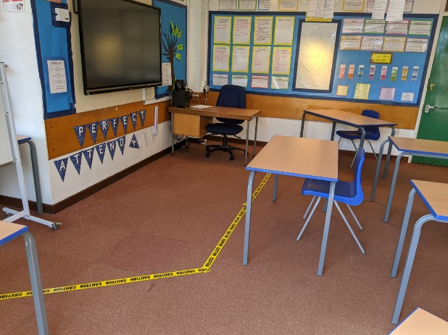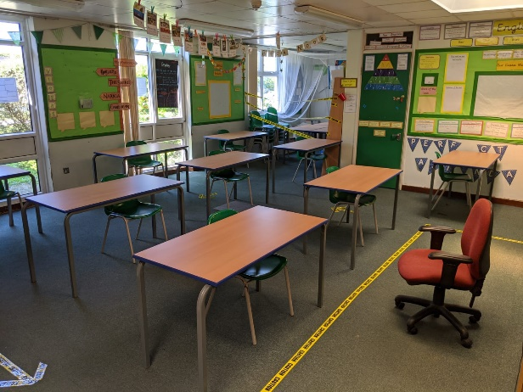

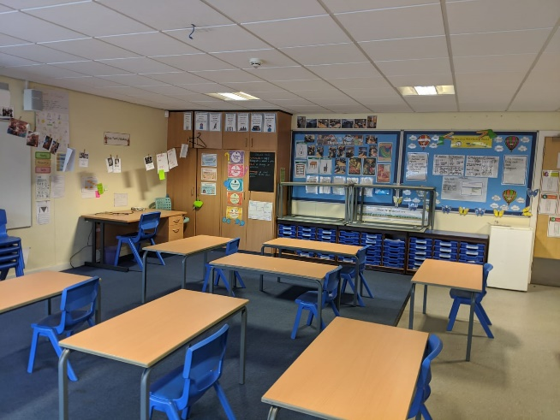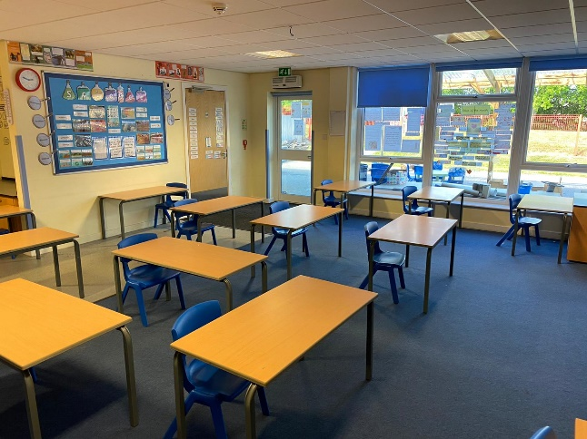

**Learning provision:**

|  |  |
| --- | --- |
| **We can:** | **We are not able to:** |
| * Teach your children about how to socially distance and why this is important * Put your child in a group of up to 15 children * Provide a dedicated area on the school playground for them to play * Provide a packet of resources that will be theirs * Ensure that equipment is cleaned each day * Provide (subject to illness and absence) the same adult to supervise your child’s group * Provide access to the home learning platforms in school, to ensure we are fair to children unable to attend and support staff unfamiliar to the year group they are supervising * We can provide verbal feedback to children on the work they have completed (we are unable to mark work) * Ensure the school is deep cleaned before children return after half term * Clean the school at the start and the end of the day * Provide hand sanitisers at the entrances and in each classroom * Ensure children and adults wash their hands regularly in line with guidance * We will provide lunches for FSM and UFSM pupils * Ensure tissues are available to catch, bin and kill germs from coughs and sneezes * Provide lidded bins to support hygiene * Ensure routines for using toilets are carefully managed to support distancing and hygiene * Provide first aid, subject to access to appropriate PPE stocks (the government has told us to source this ourselves) | * We are not able to provide a 2-metre distance between seats. Our rooms are too small. * We are not able to provide individual desks for children. * We are not able to ensure that pupils will socially distance at all times; we can’t stop children mixing with each other on the way to and from school and after school. * We can’t police pupil activity on the way home or to school if they are not supervised, therefore we cannot ensure that there won’t be mixing across the bubbles if parent won’t / can’t supervise their children. * We are unable to physically intervene in behaviour incidents * We are unable to offer a place to your child unless they are toilet trained. * If your child has an toileting accident you will need to come into school to take your child off site, change them, and return them (This statement does not apply to pupils with intimate care plans as a result of an EHCP). * We are unable to physically comfort upset children, or carry children into school if they don’t want to leave parents. * We can’t provide the usual play opportunities or play centred learning; children in the younger years will be taught at desks in a formal way at times to support social distancing. * We can’t prevent children from picking up other children’s resources * We are unable to send home any reading books * We are unable to allow access to reading books in school but children will have opportunities to read. * We can’t provide a hot lunch: children not eligible for FSM and UFSM may bring in **packed lunches in disposable wrapping only. No lunch boxes will be allowed in school.** * We can’t allow any flexibility in the groupings: once your child is in a group they must stay in that group * Numbers dictate that we are unable to provide a teacher to every group: classes of 15 mean there are not enough staff. Therefore, your child may or may not have a teacher, however the work set will be appropriate to their age group. |

**Timings and expectations – This will be set out in detail on your child’s invitation to return**

Children will have a dedicated gate and door to enter and exit the building. Each group will have a start and finish time that may be different to the traditional school day, which must be strictly adhered to by parents to ensure we can stagger access to the site.

No parents will be allowed into the school buildings **for any reason**. We cannot hold face to face meetings, discussions etc on site. You will not be allowed into the reception area. All contact must be by either email in the first instance or by phone. We will respond, please be patient as the volume of enquires could be high.

Whilst parents are on site, they must remain socially distant at all times. It is important to do this to model this for the children. In order to help you, markers will be on the ground to support you to remain 2 metres apart when dropping off and picking up. Please only enter the site to drop off at the required time, then immediately exit the site to make space for the next group dropping off.

Children will not be allowed to bring any equipment, instruments or personal possessions on site. This includes any bags, except for those children who require a packed lunch as above. This will be in a disposable carrier bag, all items will need to be consumable or disposable e.g. foil, not Tupperware. There are no fridges to store these. Water bottles should be taken home each night and washed and filled ready for the next day. Cloakrooms are out of bounds, and so only a coat that has a name in it and can be stored on the back of a chair can be brought into school. Pupils should wear their school uniform. **This should be washed each night.** PE kits will not be required.

We will be asking parents of those groups involved in the wider opening whether they will be taking up the place offered to them. Once we have a clear view of numbers and also once the government have confirmed that the 5 tests have been met, we will then contact you to give you your child’s starting date. This will include information on their group, staff, gate, door and start and finish times.

The detailed Risk Assessment and policies agreed by the Trust is available for you to view on our website.

We hope you feel you can now make an informed decision, with the facts as set out for our school.

Thank you for your ongoing support and patience.

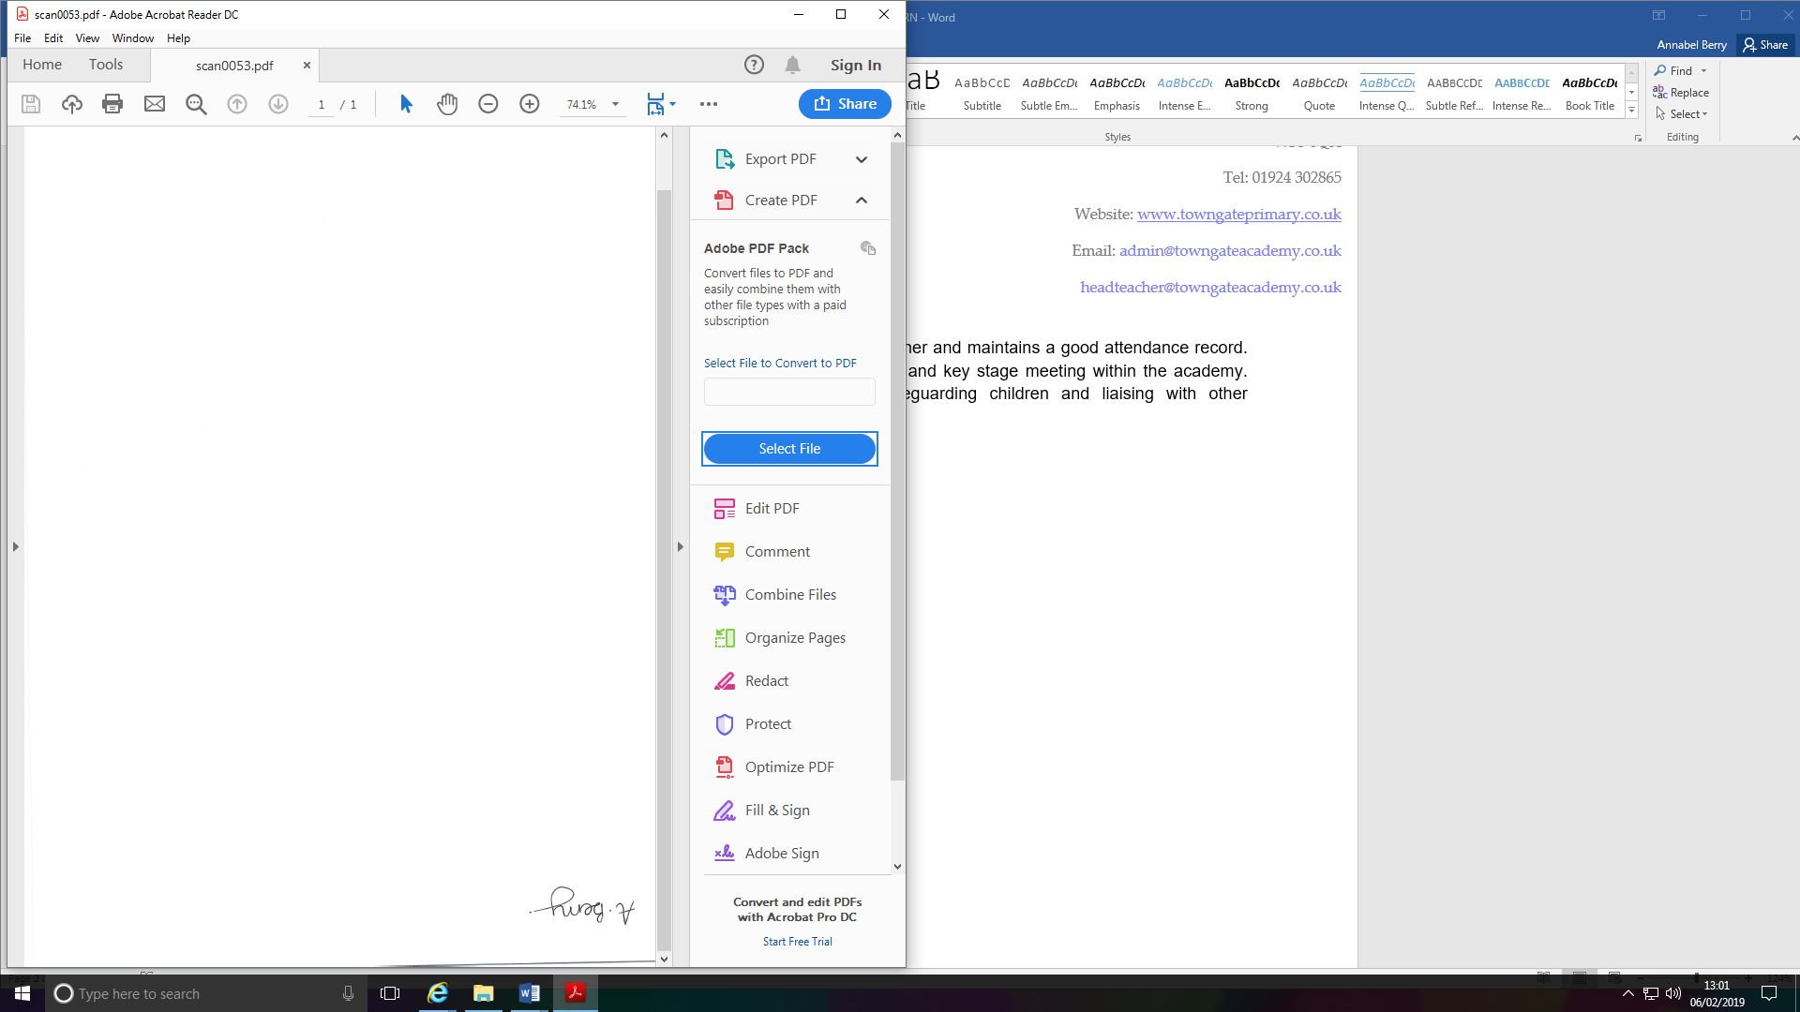

**Mrs A Berry**

**Headteacher**