Charanga Music 2017/18
Scheme
Scheme Overview
The Charanga Musical School Scheme provides teachers with week-by-week lesson support for each year group in the school. It is ideal for specialist and non-specialist teachers and provides lesson plans, assessment, clear progression, and engaging and exciting whiteboard resources to support every lesson. The Scheme supports all the requirements of the national curriculum.
In line with the curriculum for music and guidance from Ofsted, this Scheme moves away from the previous levels and learning objective/outcome concepts to an integrated, practical, exploratory and child-led approach to musical learning.
Ofsted have stated that “We will not always know the learning outcomes” so segregated learning objectives at the start of each lesson are not appropriate. Instead the interrelated dimensions of music weave through the units to encourage the development of musical skills as the learning progresses through listening and appraising, differing musical activities (including creating and exploring) and performing.
How the Scheme is structured
Each Unit of Work comprises the of strands of musical learning which correspond with the national curriculum for music:
- Listening and Appraising
- Musical Activities
  - Warm-up Games
  - Optional Flexible Games
  - Singing
  - Playing instruments
  - Improvisation
  - Composition
- Performing
The Activity Manual
This manual will give you knowledge, understanding and support when preparing and delivering your music lessons. It will explain the supporting ideas and methodology and how each strand of musical learning within the Units of Work correspond with the national curriculum. Use it as a handbook, a teaching companion.
Mastery in your music lessons
Charanga Musical School Units of Work enable children to understand musical concepts through a repetition-based approach to learning. Learning about the same musical concept through different musical activities enables a more secure, deeper learning and mastery of musical skills. The Activity Manual guides you through each strand of musical learning from Reception to Upper Key Stage 2 in order for you, as a teacher, to plan for your teaching and to see the opportunity to embed a deeper learning, knowledge, understanding and skills.
Musical teaching and learning is not neat or linear. The strands of musical learning, presented within the lesson plans and the on-screen resources, are part of the learning spiral. Over time, children can both develop new musical skills and concepts, and re-visit established musical skills and concepts. Repeating a musical skill doesn’t necessarily mean their progress is slowing down or their development is moving backwards! It's just shifting within the spiral. Mastery means both a deeper understanding of musical skills and concepts and learning something new.
Scheme Progression Overview With Teaching And Learning Outcomes (see documents, right) is a new document that can be used for a teaching and learning overview of each unit, year and Key Stage. This document brings all the possible musical learning outcomes together for the end of year and Key Stage, linking to the Progressive Teacher and Childrens’ Statements within the Assessment Framework. It highlights differentiated and deeper learning for each child, that constantly builds through each step/lesson, unit and year.
Resources/Instruments
- A class set or half a class set of glockenspiels - this is the most important resource along with any un-tuned percussion instruments you might have in school
- iPad app - glock or un-tuned percussion app can be used
- Recorders - use if you have experience playing and teaching this instrument
- If children play band/orchestral instruments, encourage them to use those instruments in the music lesson
- A combination of the above
Mixed Year Groups
If you are delivering the scheme in a school with mixed age or year groups, please do adapt it to suit your needs. Remember that the Units of Work are progressive but can also be delivered as stand-alone units due to the depth of learning and spiral progression methodology. This means you can choose a Unit of Work for your class by looking at the suitability of the main unit song for the age group that you are teaching.
Various ways/ideas to tackle the mixed-age group issue
- Deliver a two-year rolling programme - this will alleviate repetition.
- Build your own scheme from the Units of Work, topics and other resources in Freestyle. In order to do so you will need extra units if you have extra classes so:
  - You could deliver less Units of Work in each year so perhaps you might deliver something different in Autumn 2 linked to what is taking place at Christmas time - perhaps use one of the productions. This means that you will have some spare units.
  - Use Summer 2 for revision and practise for a concert. Summer is notoriously difficult anyway due to SATS, Sports Day etc. Again, you will have spare units.

Learning Progression

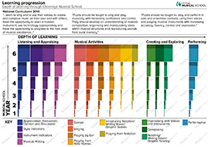
Learning Progression

The diagram above depicts the depth of learning that occurs as the children move through the year groups. As they progress, the colour deepens and the learning widens:

Interrelated Dimensions

All musical learning in this scheme is built around the Interrelated Dimensions of Music: pulse, rhythm, pitch, tempo, dynamics, timbre, texture, structure and notation. These dimensions are at the centre of all the learning.
From Reception to Year 6, the learning consists of six half-termly Units of Work. The final unit in each year - Reflect, Rewind and Replay - allows for revision and more extension activities.
What is included in each Unit of Work?
- Listen and Appraise
- Musical Activities include Games, Singing, Playing, Improvising and Composing
- Perform/Share
Each lesson in the Scheme is designed to last for one hour but can be taught in 45 minutes if there are time constraints. It is difficult to teach a credible music lesson in less than 45 minutes. If you are in this situation you may prefer to use the Musical School Freestyle approach where you can build your own lessons to suit your circumstances (click the Freestyle tab at the top of this page).
How to structure an hour long lesson:
Listen and Appraise - 20 mins
Musical Activities - 25 mins
Perform/Share - 15 mins
How to structure a 45 minute lesson:
Listen and Appraise - 15 mins
Musical Activities - 20 mins
Perform/Share - 10 mins
1. Listen and Appraise

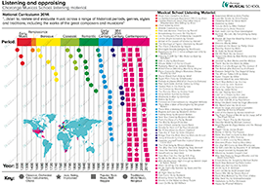
Listen and Appraise

This overview diagram includes all the listening opportunities in this Scheme through historical periods to present day.

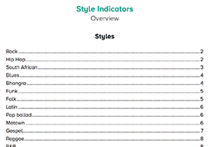
Style Indicator Guide

This Style Indicator guide will support learning and is printable
2. Musical Activities
All activities are based around a song. The Activity Manual provided is to support the teaching and learning here.
- Games embed the Interrelated Dimensions of Music through repetition
- Singing is at the heart of all the musical learning
- Playing instruments with the song to be learnt - tuned/un-tuned classroom percussion and an option to play any band instrument. A sound-before-symbol approach is used but scores are provided as an understanding of notation is introduced to the children
- Improvising with the song using voices and instruments occurs in some Units of Work
- Composing with the song using instruments occurs in some Units of Work
3. Perform/Share
Share what has taken place during the lesson and work towards performing to an audience.
Musical Progression
The musical progression through KS1 and KS2 is demonstrated in the diagram below. The instrumental work is differentiated allowing children to move through the relevant parts as they need to. Remember that an integrated approach to musical learning means that the whole musical experience is important, children are learning music through these activities.

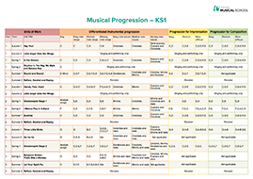
Musical Progression KS1

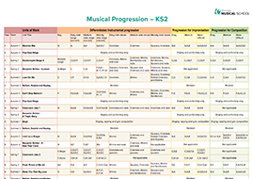
Musical Progression KS2

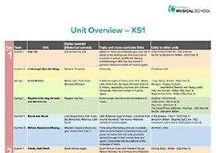
Unit Overview KS1

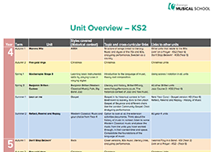
Unit Overview KS2

Assessment
The Musical School Assessment Framework uses a Plan-Do-Check-Review approach and is supported by planning and assessment documentation, with the facility for you to upload and store digital evidence.
Visit ‘Assessment’ in the ‘My Workspace’ tab to use the full Musical School Assessment Framework (you can refer to the assessment documentation on the right hand side of this page too).

