

Schools must use the funding to make additional and sustainable improvements to the quality of PE and sport they offer. This means that you should use the Primary PE and Sport Premium to:

- develop or add to the PE and sport activities that your school already offers
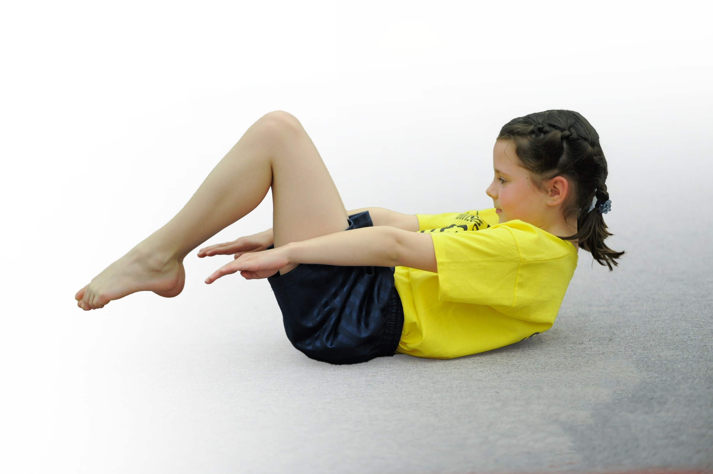
- build capacity and capability within the school to ensure that improvements made now will benefit pupils joining the school in future years

Please visit gov.uk for the revised DfE guidance including the 5 key indicators across which schools should demonstrate an improvement. This document will help you to review your provision and to report your spend. DfE encourages schools to use this template as an effective way of meeting the reporting requirements of the Primary PE and Sport Premium.

We recommend you start by reflecting on the impact of current provision and reviewing the previous spend.
Under the Ofsted Schools Inspection Framework, inspectors will assess how effectively leaders use
the Primary PE and Sport Premium and measure its impact on outcomes for pupils, and how effectively governors hold them to account
for this.

Schools are required to publish details of how they spend this funding as well as on the impact it has on pupils’ PE
and sport participation and attainment.
We recommend regularly updating the table and
publishing it on your website as evidence
of your ongoing review into how you are using the money
to secure maximum, sustainable impact. To see an example of how to complete the table please click HERE.
Support for review and reflection - considering the 5 key indicators from DfE, what development needs are a priority for your setting and your students now and why? Use the space below to reflect on previous spend, identify current need and priorities for the future.

Key achievements to date: | Areas for further improvement and baseline evidence of need:
Children having lessons delivered by PE specialists and staff being upskilled.  Children taking part in more intra and inter school activities than ever before. (stats to be uploaded) | A wider range of activities throughout the curriculum.  Further develop staff confidence in delivery of a variety of areas.  Implement new tracking process.

Meeting national curriculum requirements for swimming and water safety | Please complete all of the below:
What percentage of your Year 6 pupils could swim competently, confidently and proficiently over a distance of at least 25 metres when they left your primary school at the end of last academic year? | 86% last year 91% predicted this year. At the end of the year achieved 87%.
What percentage of your Year 6 pupils could use a range of strokes effectively [for example, front crawl, backstroke and breaststroke] when they left your primary school at the end of last academic year? | 86% last year 91% predicted this year. At the end of the year achieved 87%.
What percentage of your Year 6 pupils could perform safe self-rescue in different water-based situations when they left your primary school at the end of last academic year? | This year – 83%
Schools can choose to use the Primary PE and Sport Premium to provide additional provision for swimming but this must be for activity over and above the national curriculum requirements. Have you used it in this way? | No

Action Plan and Budget Tracking
Capture your intended annual spend against the 5 key indicators. Clarify the success criteria and evidence of impact that you intend to measure to evaluate for students today and for the future.

Academic Year: 2017/18 | Total fund allocated: £18,120 | Date Updated:28.3.18 and August 2018
Key indicator 1: The engagement of all pupils in regular physical activity – Chief Medical Officer guidelines recommend that primary school children undertake at least 30 minutes of physical activity a day in school |  |  |  | Percentage of total allocation:
 |  |  |  | %
School focus with clarity on intended impact on pupils: | Actions to achieve: | Funding allocated: | Evidence and impact | Sustainability and suggested next steps: To be completed July2018
To enhance playground facilities and resources to improve behaviour of an identified group and give all the children a chance to get an extra 45 minutes of exercise a day, through an active lunch time.  To further develop the range of extracurricular activities to give children extra opportunities to take part in physical activity. | Senior lunch time supervisor to be trained up as well as new lunch staff.  Employ additional sports coach to work through lunch time.  Employ specialist sports coach to run 2 additional multi sports clubs  To continue to employ Huddersfield Football Club to run an after school club for pupils to attend.  To run more extra-curricular clubs run by staff within the academy | £3,937.72 | More children getting involved with high impact sport at lunch time.  F2: ~10 children per game, majority boys when playing ball games (e.g Dodgeball), girls more likely to participate in Scarf Bulldog or skipping games.  Key Stage 1: ~30 children per game, 1:4 Girl:Boy ratio, most popular game is Scarf Bulldog, also high participation numbers for Dodgeball and small Rugby drills.  Key Stage 2: Numbers differ greatly depending on activity. For games such as Dodgeball and Scarf Bulldog, I estimate around 20 children per game, 1:2 Girl:Boy ratio.  Boys participate more in traditionally recognised sports (Rugby, Football) Girls prefer to participate in game-style activities, as well as skipping games. Most diversity tends to happen when playing Kick Cricket.  In Kick Cricket, I would expect upwards of 15 children, with a high number of girls. Many children play to be on the same team as classmates.  Ks1 multi sports: 13  Girls attendance: 3  Boys attendance: 10  KS2 multi sports:  Girls attendance:  Boys attendance:  Attendance: 14  Boys: 13  Girls: 1  Children provided with extra active time after school and continued to develop their skills.  Netball club ran this year where the children were able to compete in out of school competitions. | To continue with good practice established this year.  To continue providing a variety of activities for children to participate in.  Look at how we can get more girls involved in these active lunch times.  Look at other outside agencies for next year that can provide a lunch time club.  KS1 multi sports to continue 18/19.  Contact Huddersfield Football Club to continue running this club after school.  Develop the skill set off staff next year to run more after school clubs:  - KS1 multi sports  - Netball  - UKS2 Football  Also, employ specialist dance and acrobat teachers to run after school clubs for both key stages.
Key indicator 2: The profile of PE and sport being raised across the school as a tool for whole school improvement |  |  |  | Percentage of total allocation:
 |  |  |  | %
School focus with clarity on intended impact on pupils: | Actions to achieve: | Funding allocated: | Evidence and impact: FURTHER STATS TO BE ADDED JULY | Sustainability and suggested next steps:
Develop two new PE notice boards in  One relating to national/world events.  Both school and community based. Create interest in PE and sport. Learn about events that are happening.  To embed the good practice we have established we have decided to appoint a part-time sports development coach to work alongside experienced practitioners to develop their own skills and disseminate good practice regarding health and fitness. | Deliver CPD to teachers across school. Regular discussion around good practice.  A full programme of progression will be set up including skills, using and applying, health, social and evaluation to make it easier for teachers to plan and deliver their lessons. | N/A  £4,000 | Children eager to enter competitions on display on the board.  A discussion point for children and staff. Children commented on the board.  Number of activities out of school:  in school:  see documents  Programme of study has been set up by an experienced PE leader within the MAT. | To relaunch the PE notice boards within the Academy and create an extra-curricular board. To ensure Parents are aware of events that are happening within the Academy and wider community.  This will be disseminated to staff in the Autumn term 2018 where an assessment tool has been created to use across the MAT.

Key indicator 3: Increased confidence, knowledge and skills of all staff in teaching PE and sport |  |  |  | Percentage of total allocation:
 |  |  |  | %
School focus with clarity on intended  impact on pupils: | Actions to achieve: | Funding  allocated: | Evidence and impact:  FURTHER STATS TO BE ADDED JULY | Sustainability and suggested  next steps: To be completed July2018
Continued use of gym, kidnetics and dance specialist to upskill staff and build a bank of ideas ensuring the children are receiving the highest quality.  .  Establish an assessment tool to monitor the progress of all children and see where the gaps are. | Ensure monitoring of gym, kinetics and dance specialist- speak to the staff regularly and observe lessons.  At least 2 staff meetings for sports leader to implement additional training.  Ensure time for staff to work together.  Time given to fill out, staff training on how to use it. | £7,412.28 | Core strength and understanding of core strength has improved as seen in PE lessons and speaking to children.  Clear progression within in lessons and year groups.  Staff confident in completing assessment and using it as a planning tool for further lessons. | To continue this practice in the following academic year to continue to upskill staff.  See if any CPD can be offered.  Continue to use this in the following academic year. PE coordinator to liaise with other teachers in the MAT.  Staff meeting arranged in 18/19 to be run by PE coordinator.
Key indicator 4: Broader experience of a range of sports and activities offered to all pupils |  |  |  | Percentage of total allocation:
 |  |  |  | 13%
School focus with clarity on intended  impact on pupils: | Actions to achieve: | Funding  allocated: | Evidence and impact: | Sustainability and suggested  next steps:
Specialist coach to deliver a variety of activities across classes and lunch time.  Develop a wider range of activities and sports to engage all pupils. The aim is to do this through the curriculum but also through after school clubs. | Consult with children on which activities they would be interested in.  Purchase some additional resources.  Take up offers from Ossett Academy and school games.  Staff meeting to upskill all staff on ideas. | £1,000 | Specialist coaches have delivered high quality provision for all year groups within the academy. Leading to pupil enjoyment, engagement, and upskilling staff.  Additional resources have been purchased enabling staff to offer a wide range of sporting activities.  - KS2 Trampoling  - Y5 Handball at Ossett Academy  - Y3 Scatterball  - KS2 EOCT Netball Tournament  - KS1 EOCT Potted Sports  - Y1 and Y2 Mini Olympics at Thornes Park (organized by the MAT) | To continue to employ high quality sports coaches in 2018/2019.  Carry out a another audit September 2018 to ensure required equipment is available.  Continue to liasise with Ossett Academy, EOCT and the MAT to arrange sporting events.  Y1 and Y2 Mini Olympics already set to run in July 2019.  Matches to be held between ourselves and Gawthorpe for our after school clubs (Netball and Football)
Key indicator 5: Increased participation in competitive sport |  |  |  | Percentage of total allocation:
 |  |  |  | 8%
School focus with clarity on intended  impact on pupils: | Actions to achieve: | Funding  allocated: | Evidence and impact: FURTHER STATS TO BE ADDED JULY | Sustainability and suggested  next steps:
Introduce further competitive fixtures. To allow those who do not always get opportunity at clubs.  Offer additional competition for KS1children to develop confidence and implement skills they have learnt.  Attend and contribute half-termly events organised by the local high school. | 2 intra sports events for the whole school. Discuss themes to be taken. KS1 to participate in MAT event at Thornes co-hosted by MAT schools.  Book transport.  Towngate to attend annual potted sports for KS1. Y1 AND Y2 alll attend with 9 other schools.  Book after school fixtures Spring and Summer term v 9 local schools. | £1,770 | Engagement of all Y1 (45) and Y2 (45) children with other children from other school. Build competition, sporting behaviours and a chance to perform at venues on a large scale.  Children taking ownership and putting skills learnt in lessons into action. Highlighting British Values and school values.  KS2 children attend sporting events organised by the high school. | This will continue next year in July 2019.  Looking at the possibility of holding a LKS2 event.  Take our own sports leaders to this event through the primary leaders scheme.  To continue this next year, continuing to develop children’s skill set, sportsmanship and values.  To continue to provide this opportunities next year.

