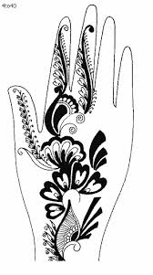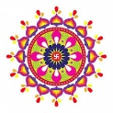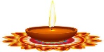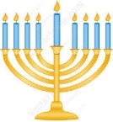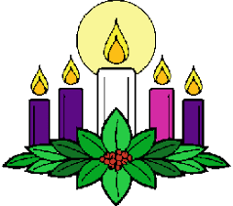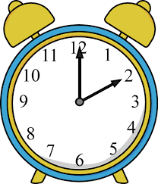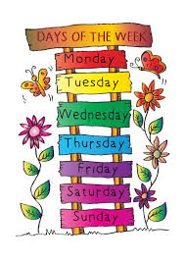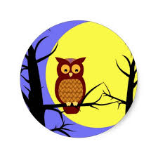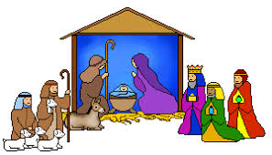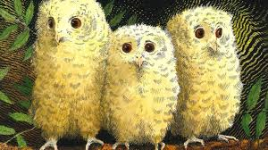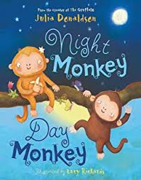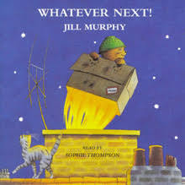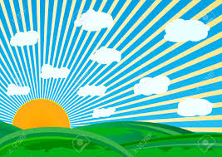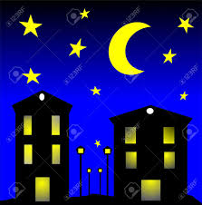

Festivals and Light 

**Reading**

Owl Babies

Whatever Next

Night Monkey Day Monkey

Non-fiction books – Light and Dark

* Festivals and Celebrations

**Time**

Days of the week

Months of the year

Today Yesterday Tomorrow

o’clock

**Light and Dark**

Day Night

Light Dark

Sun Moon

**Light sources** candle torch lamp sun streetlights

**Nocturnal**

**Festivals and Celebrations**

**Diwali**  Hindu diva rangoli mhendi

**Hannukah** Jewish Menorah

**Christmas** Christian Advent Church

Jesus Mary Joseph shepherds

3 Kings Angels Bethlehem

**What can you do at home?**

Find out about different light sources – how many do you have in your home?

Find out about nocturnal animals.

Which is your favourite day of the week? Why?

Can you keep a diary?

Tell someone the time.

Look at the moon – What shape is it? Is it the same every night?

What do you like to celebrate with your family?

Can you find out about a different celebration or festival?

What did you learn about at home? Bring your work into school to share with your friends.

Festivals and Light 