

What was the Gunpowder Plot and who is Guy Fawkes?

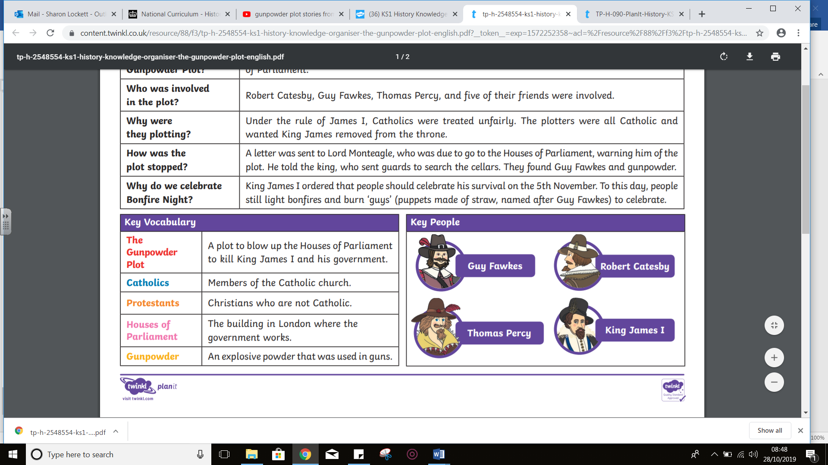

**Key Questions**

* Who is Guy Fawkes?
* What is the Gunpowder Plot?
* Where did it all happen?
* Did the plot work?
* Would it have changed our British history?
* How do I plan a route?



