

**Key Questions**

* What is a material?
* What are the properties of each material?
* Can we tell which material an object is made from?
* Can we use the same material for different objects?
* How do we decide which material to use for different objects?
* Can we change the shape and properties of a particular material?
* How can we look after the environment with our material choices?
* What can we do with certain materials once we have used them?

KS1 Science – Everyday Materials

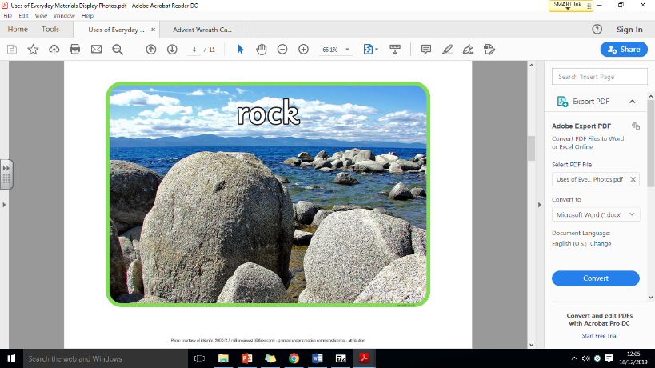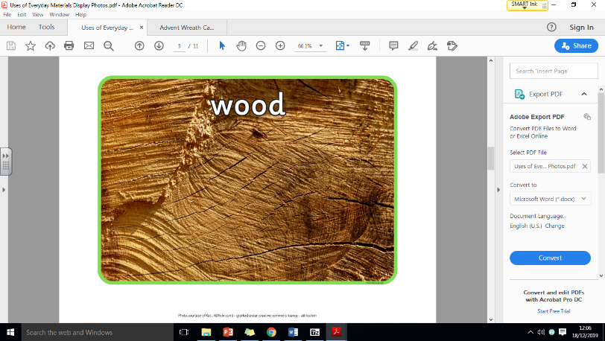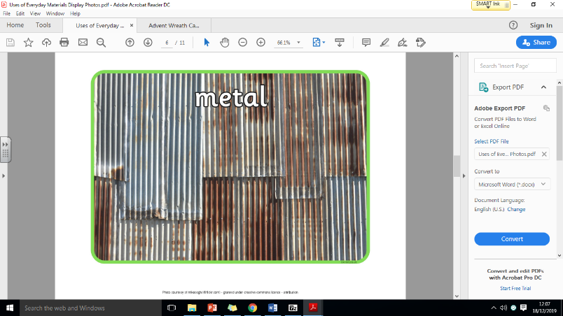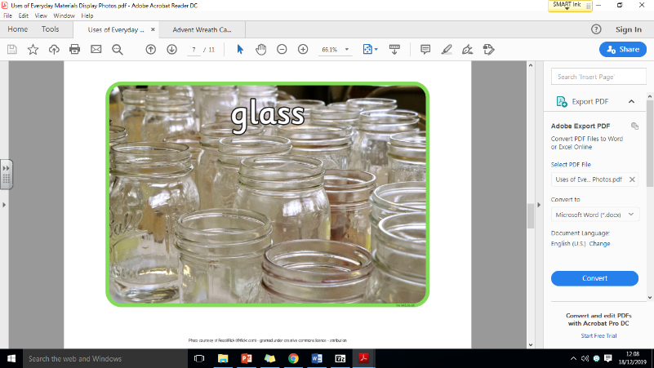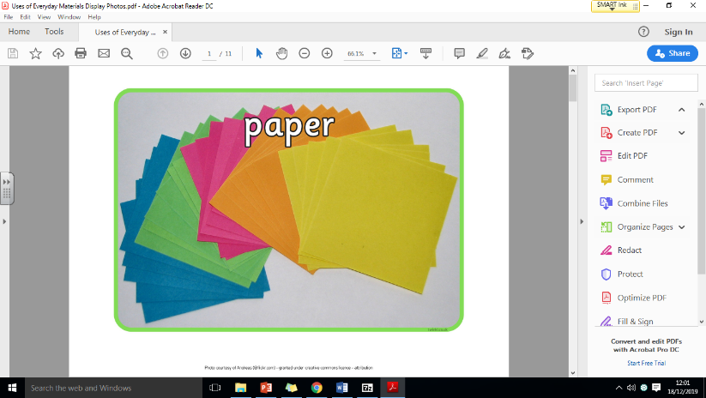**Different Types of Everyday Materials**

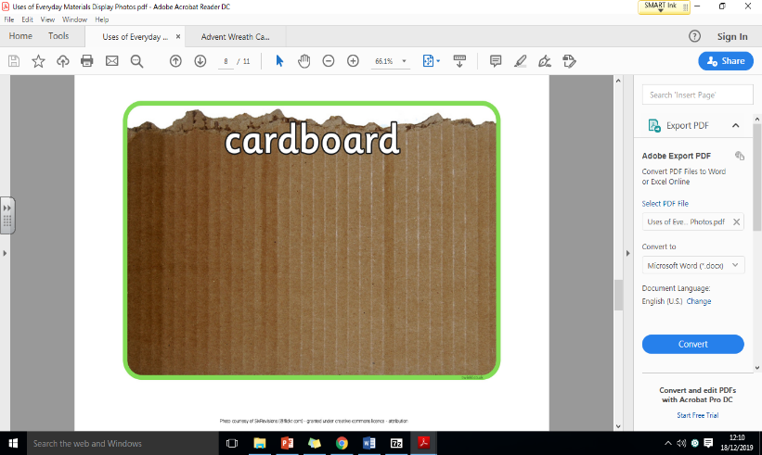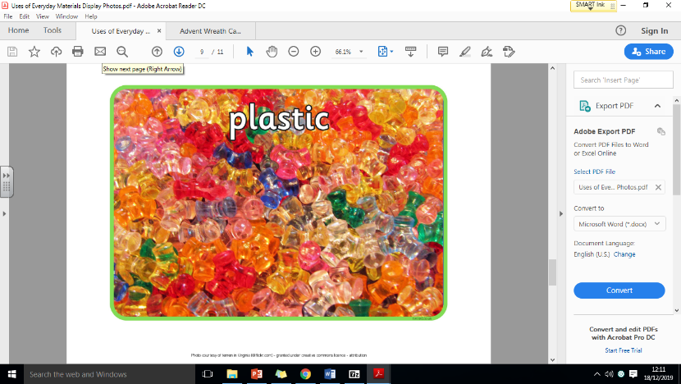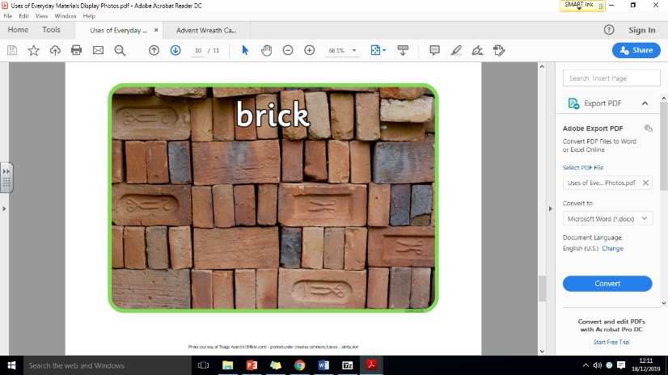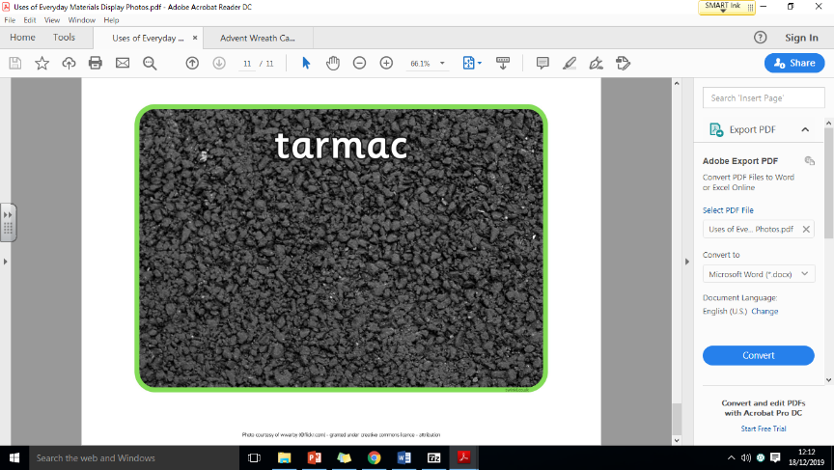

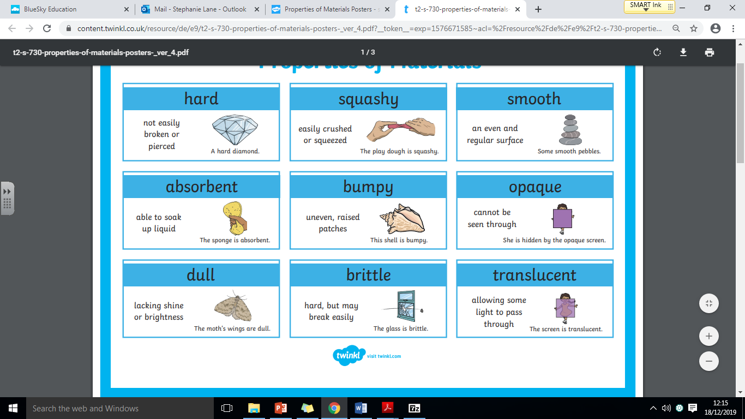 **Properties of Everyday Materials**

**Working Scientifically**

**To be a super scientist can you do these things below:**

* Observe things closely and use equipment to help me.
* Use my observations to answer questions.
* Gather and record data to help me answer questions
* Perform a test and record my ideas.
* Understand that scientific questions can be answered in different ways.

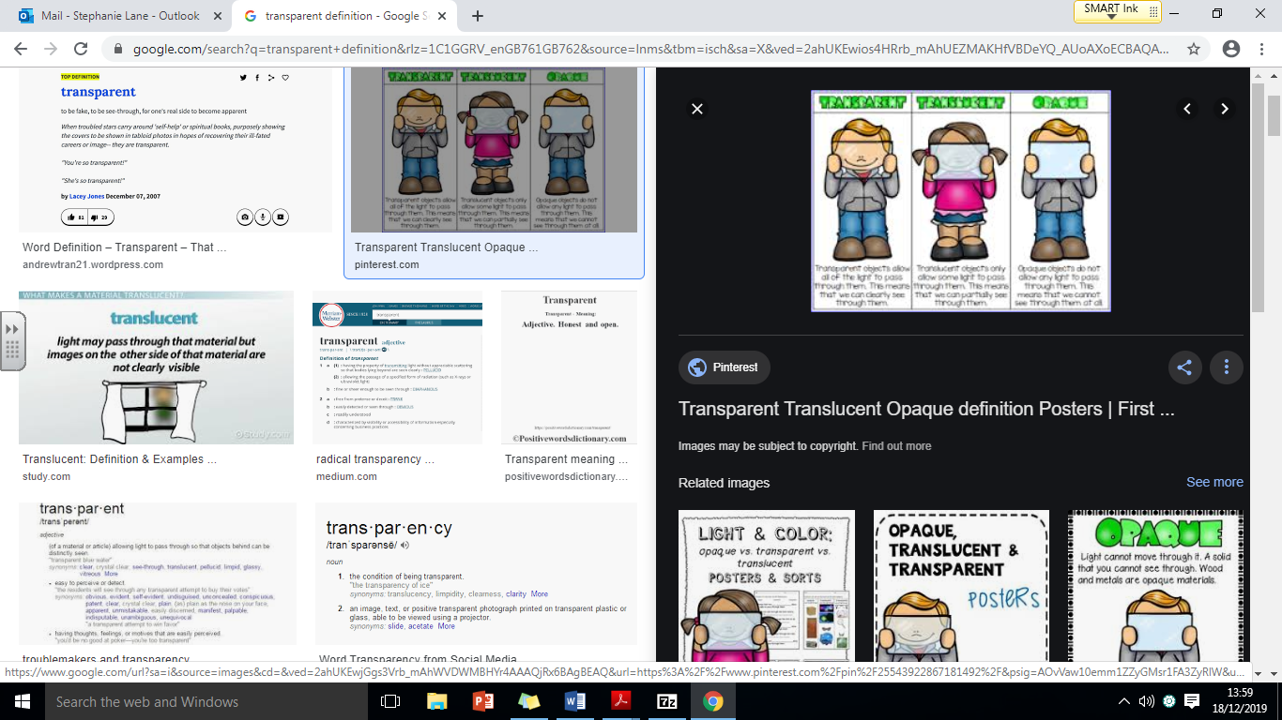

**soft**

easy to mould, not

hard to touch**.**

**transparent**

allows light to

pass through.

**flexible**

**Capable of bending**

**easily without breaking**

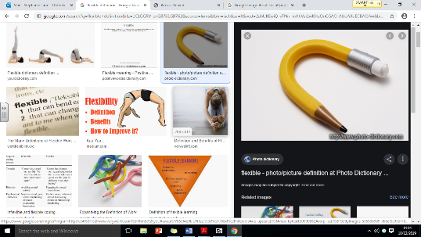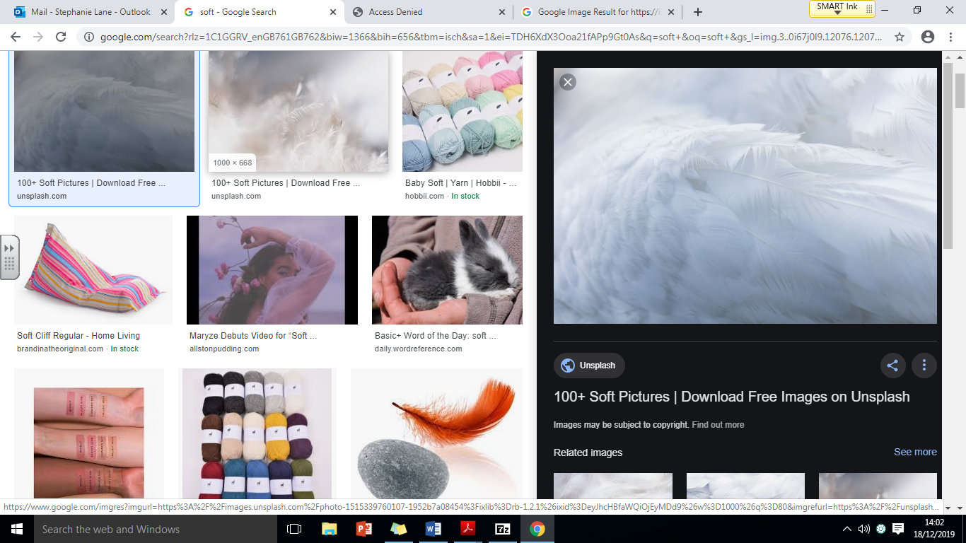

**The Recycling Process**

1) Your household recycling is collected and taken to a recycling depot.

2) The bottles are separated from other rubbish by people, machines or a mix of both.