Classroom discussions

We enjoy debating with our peers and expressing our opinions in an open and respectful environment.

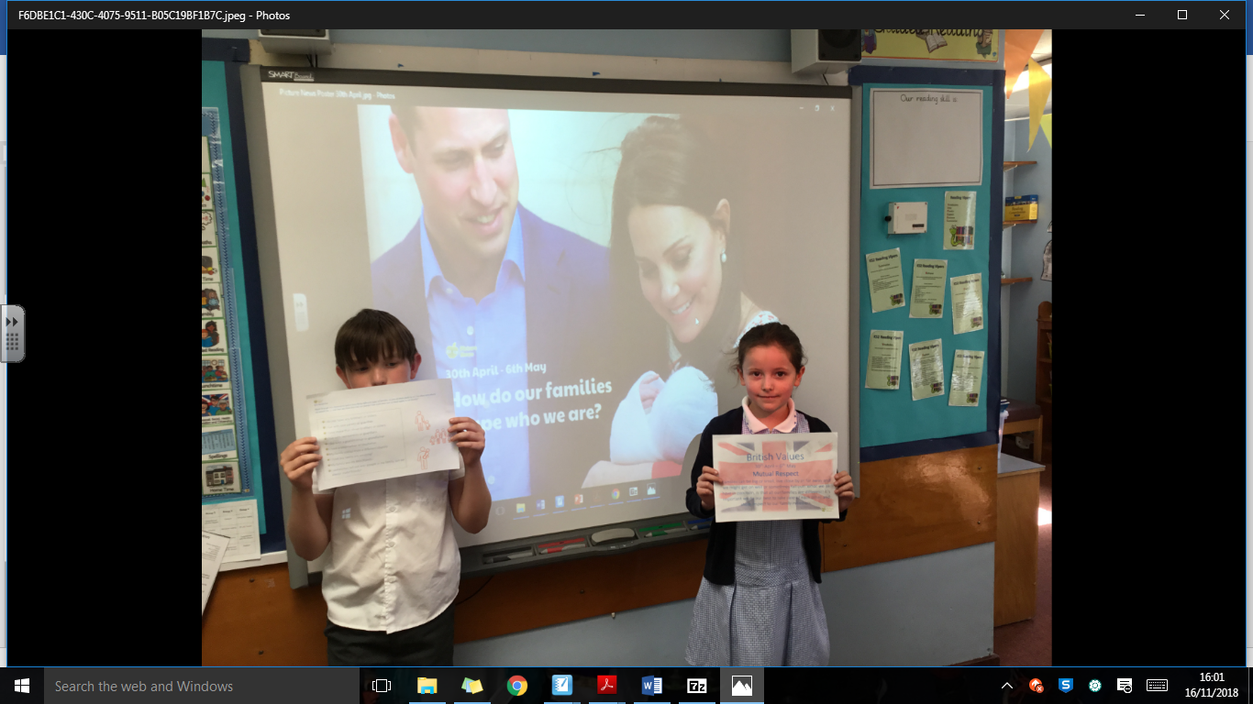

Twitter

We regularly post evidence of our discussions to Twitter to share with our parents and the wider community.

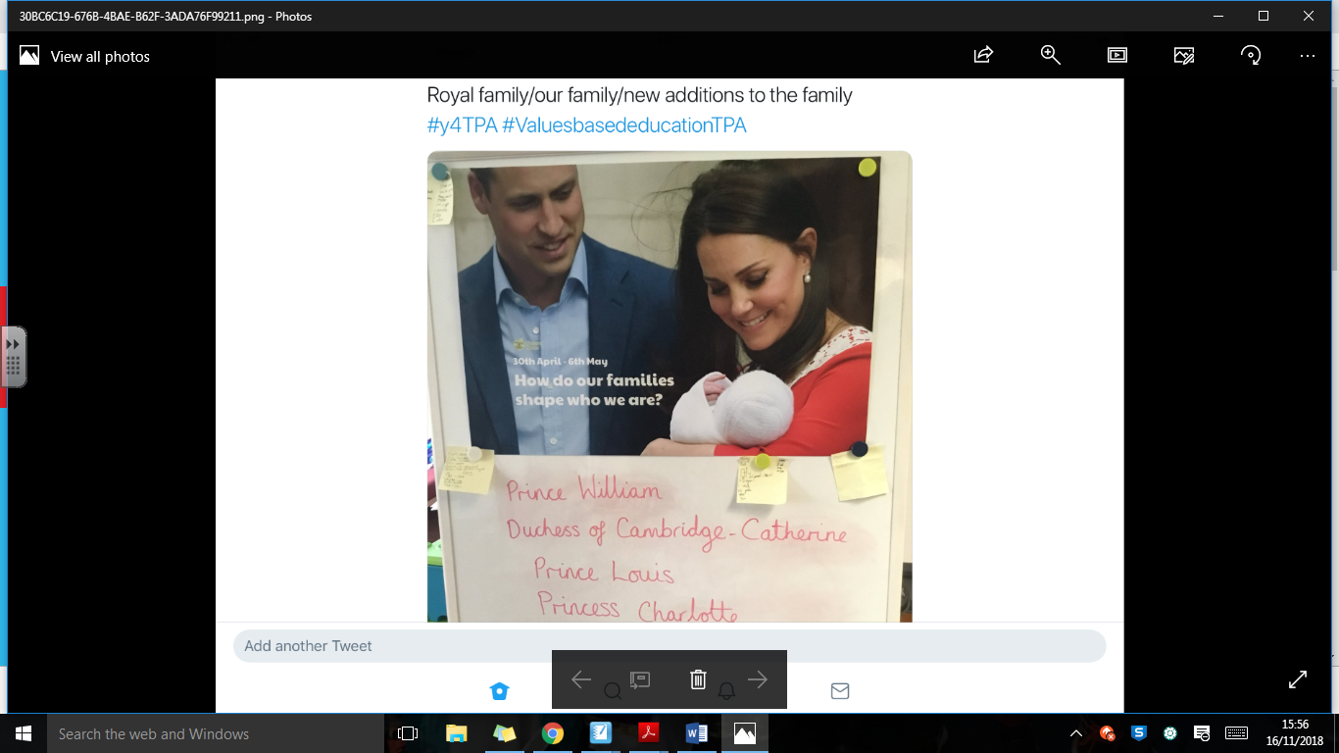

**Key Stage 2 - Towngate Primary Academy**

Cross-curricular links

We regularly record our discussions, opinions and research into our books to evidence our learning.

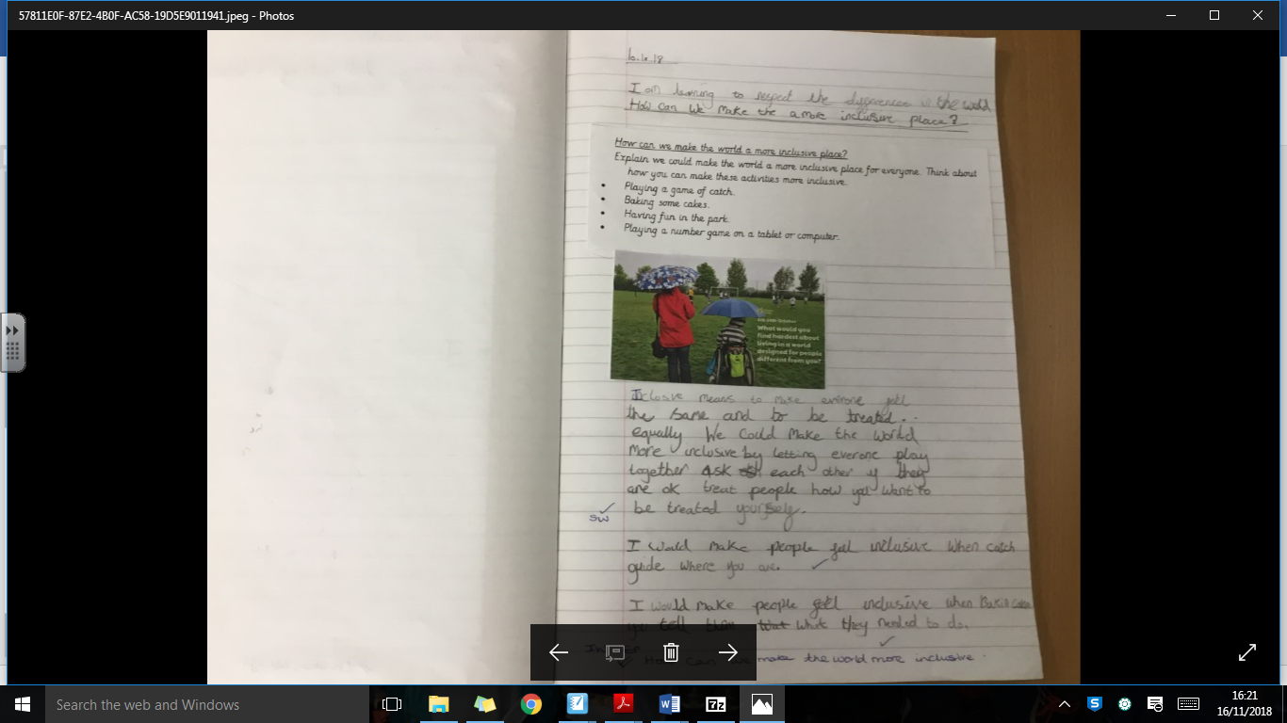

Student Voice

Our British values ambassadors have collected pupils’ views on Picture News.

*‘I enjoy picture news because I enjoy learning about the world’*

*‘I like to learn about interesting issues from across the world and having discussions and debates’*

In Key Stage 2, children are encouraged to form their own opinions about each topic. We link these ideas closely with British Value and learn about life in modern Britain. Each week we are introduced to provoking, open-ended questions, linked to current events and British values to allow us to relate to the wider world around us.