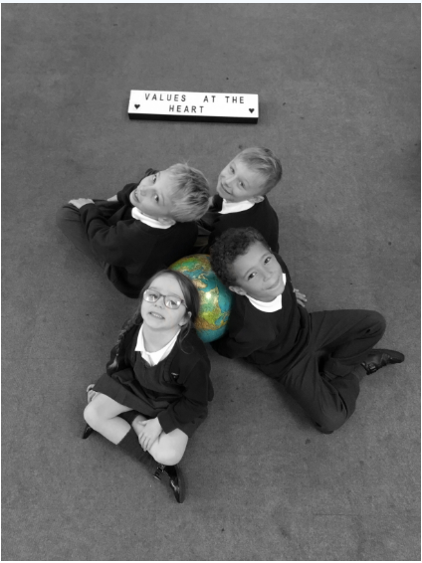Key Stage 1 – Towngate Primary Academy

Picture News in KS1

Each week in KS1 we look forward to our picture news activity. Picture News helps us to be aware of our wider world and acquire new skills of reflecting on things we might never have thought about or experience before. We link it to our value based learning and are really beginning to show greater respect, tolerance and empathy for people with differences. We are beginning to understand we all unique and all different. .

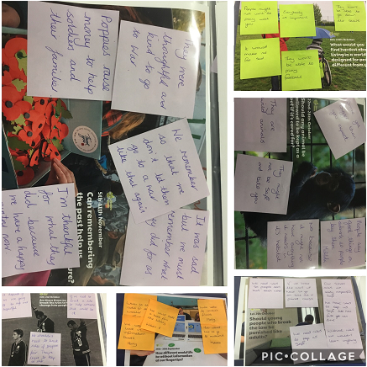

Children’s Quotes:

When thinking about Remembrance children said:

* I am thankful for what they did because we have a happy country now.
* They are so thoughtful and kind to go to war for us, I wish I could say thank you.

When thinking about whether animals

Should be kept as pets children said:

-We need to remember animals have

feelings too.

- People say good things no adverts so that people buy them.

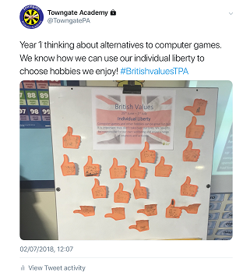

Twitter:

We enjoy sharing our views and opinions regarding out picture news each week. This helps to share our thoughts with our wider community.