|  |  |  |  |  |
| --- | --- | --- | --- | --- |
|  | **TOWNGATE PRIMARY ACADEMY**  **EOCT_logo** | | | C:\Users\cthomas\Downloads\FINAL AGREED LOGO for MAT.jpg |
| Chief Executive Officer:  Mrs Sue Vickerman  Headteacher:  Mrs Annabel Berry  cid:941ce1ce-629a-4490-899b-0f67f774eb4a | |  | Whitley Spring Road  Ossett  WF5 0QA  Tel: 01924 302865  Website: [www.towngateprimary.co.uk](http://www.towngateprimary.co.uk)  Email: admin@towngateacademy.co.uk  headteacher@towngateacademy.co.uk | |

**Wednesday 15th July, 2020**

Dear Parents and Carers,

I hope you and your families are staying safe and well. We are coming to the end of what has been a very unusual year. Before the Summer Term ends, I would like to update you on how we intend to manage the full return of all children in September. Below are our initial plans for how things will operate in September using the most recent guidance issued by the Department for Education. As a Trust, Inspire have decided to go further than the DfE guidance requires in order to ensure that we are protecting our children, families and staff. Towards the end of the summer holiday we will issue our updated risk assessment for all parents and carers to see. This will be on our website and will be kept updated as the Autumn Term progresses. There are lots of aspects we needed to plan for and no doubt, as we start to implement this way of working, we may come across things that will need to be amended and improved further.

**School Day Timings**

The start and end of the school day will continue to be staggered for each bubble. Break times and lunchtimes will also be staggered. The grid below highlights the start and finish time which applies for your child. It is important that you adhere to the times you are given to avoid crossing into another bubble. Please note, the times have been set based upon staggering entrances into the school cloakrooms and toilet facilities for handwashing upon arrival.

**Please note: If you have children in different classes, please opt for arriving and collecting at the latest time, this will alleviate parents having to wait for extended periods of time on the school grounds.**

| **Class** | **Start time and Entrance** | **Finish time** | **Access point** |
| --- | --- | --- | --- |
| Nursery  Mornings | Doors open at 8.35am.  Nursery will start at 8.40am.  Doors close at 8.45am. | 11.50am | Whitley Spring Road |
| Nursery Afternoons | Doors open at 12.30pm. | 3.30pm | Whitley Spring Road |
| Reception | Doors open at 8.50am.  Reception will start at 8.55am.  Doors close at 8.45am. | Children will be lined up in their Reception playground at 3.20pm. | Whitley Spring Road |
| Year 1 | Doors open at 8.40am.  Year 1 will start at 8.45am.  Doors close at 8.50am. | Children will be lined up in the Key Stage One area at 3.10pm. | Whitley Spring Road |
| Year 2 | Doors open at 8.50am.  Year 2 will start at 8.55am.  Doors close at 9.00am. | Children will be lined up in the Key Stage One area at 3.20pm. | Whitley Spring Road |
| Year 3 | Doors open at 8.40am.  Year 3 will start at 8.45am.  Doors close at 8.50am. | Children will be lined up on the lower playground at 3.10pm. | Whitley Spring Road |
| Year 3/4 | Doors open at 8.50am.  Year 3/4 will start at 8.55am.  Doors close at 9.00am. | Children will be lined up on the lower playground at 3.20pm. | Whitley Spring Road |
| Year 4 | Doors open at 8.50am.  Year 4 will start at 8.55am.  Doors close at 9.00am. | Children will be lined up on the upper playground at 3.20pm. | Tumbling Close |
| Year 5 | Doors open at 8.40am.  Year 5 will start at 8.45am.  Doors close at 8.50am. | Children will be lined up on the upper playground at 3.10pm. | Tumbling Close |
| Year 5/6 | Doors open at 8.50am.  Year 5/6 will start at 8.55am.  Doors close at 9.00am. | Children will be lined up on the upper playground at 3.20pm. | Tumbling Close |
| Year 6 | Doors open at 8.40am.  Year 6 will start at 8.45am.  Doors close at 8.50am. | Children will be lined up on the upper playground at 3.10pm. | Tumbling Close |

**Please note**: during this period of time, to avoid congestion on the playground, children will be invited to come directly into their classroom / cloakroom where a member of staff will be situated to greet the children. All children will be asked to wash their hands thoroughly on entry to school.

Families will continue to have designated entry gates into and out of the site. At the end of the school day, children will be lined up on markings as set out above for collection by **one** parent or carer/family member. We do need to ask that parents continue to operate an immediate drop off and collection protocol to avoid congestion on the site. Unfortunately, parents will still not be permitted on site other than to drop off and collect pupils. If you need to talk with a member of staff, this will be by telephone/email appointment.

**Bubbles**

Children will continue to be grouped in bubbles to minimise contact with others. Bubbles will operate in phases. So, for example Y3 and Y4 (lower key stage two) will be a bubble. Classes within a bubble will operate separately at almost all times, but the staffing in a bubble may move between those classes to support curriculum delivery.

**Classrooms**

All classes will have desks in rows facing the front. All classes will have a ‘teacher zone’ where staff can socially distance from pupils. All pupils will have a wallet with their own equipment for daily use, as is the case now. All doors and windows will be open, please ensure your child wears a jumper or cardigan to school each day.

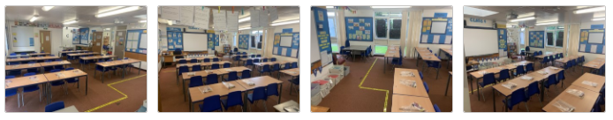

**Breakfast and After School Club**

Unfortunately, we will not be running breakfast club or after school club in the first half term to reduce the contamination and mixing of groups. If virus levels continue to decline, the school will survey parental needs during September and explore setting up provision that is bubble specific, if possible, as quickly as possible as we know this will support many families.

**Extra-Curricular Clubs**

There will no extra-curricular clubs taking place in Autumn term 1; as above we will continue to assess this and notify parents when they are safe to again commence.

**School Lunch**

For the first half term, lunches will continue to be in classrooms with an outdoor play afterwards. Grab bags will continue for pupils requiring a school lunch until half term, and then be reviewed as hopefully restrictions ease and we can reintroduce the use of the dinner hall. We will again keep you informed about this. Children opting to bring a packed lunch are to continue to bring a packed lunch in a disposable bag to eliminate unnecessary items being brought in the academy.

**Meet the Teacher Meetings**

Meet the Teacher meetings will take place virtually on the dates listed below. Meetings will take place via Microsoft Teams therefore please can we ask that any parents/carers wishing to join these meetings provide an appropriate email address to the school office on [admin@towngateacademy.co.uk](mailto:admin@towngateacademy.co.uk) by **Thursday 3rd September** to allow these meetings to be set up and invites sent.

|  |  |
| --- | --- |
| **Meet the Teacher** | |
| Nursery | Monday 14th September 3.30pm |
| Reception | Monday 14th September 3.30pm |
| Year 1 | Thursday 17th September 3.30pm |
| Year 2 | Thursday 17th September 3.30pm |
| Year 3 | Wednesday 16th September 3.30pm |
| Year 3/4 | Wednesday 16th September 3.30pm |
| Year 4 | Wednesday 16th September 3.30pm |
| Year 5 | Tuesday 15th September 3.30pm |
| Year 5/6 | Tuesday 15th September 3.30pm |
| Year 6 | Tuesday 15th September 3.30pm |

**Curriculum**

The normal curriculum will be taught with some exceptions and/or amendments. PE will only be taught outside in the first instance. Each bubble will have an allocated afternoon for PE and have PE sessions at the same time in their allocated section of the playground. Equipment will be used but will not be shared between classes.

**PE days**

|  |  |
| --- | --- |
| **PE Kits** | |
| Reception | Wednesday |
| Year 1 | Monday |
| Year 2 | Thursday |
| Year 3 | Tuesday |
| Year 3/4 | Wednesday |
| Year 4 | Tuesday |
| Year 5 | Wednesday |
| Year 5/6 | Thursday |
| Year 6 | Monday |

Please see the attached information for when children will be participating in PE during the week. We would ask that children arrive in school on their designated days as set out below wearing their PE kits – this will alleviate the need for children to get changed in school. Please ensure pupils wear their outdoor PE kits and suitable footwear on this day.

**Homework**

In September, homework will continue to be provided through the school website. Pupils will be encouraged to complete this work at home as this will support them in their learning throughout the week. Children will also bring home a reading book each week. It is really important that they read at home with an adult each day in addition to their in-school reading to support them to catch up where needed and make progress. Each read should be recorded in their reading record. This will be checked each week by the teacher. Children will be able to bring in a school book bag with only their book and reading record in it.

**Information Updates**

You will be sent a form for your children that details the individual information for each child in your family. Along with this will be a copy of the home school agreement that must be acknowledged before your child can return to school. All pupils and families are expected, by the government, to use the Test, Track and Trace facility. **No pupil with symptoms related to coronavirus should attend school**. If a person in the household has symptoms, pupils should be kept at home to self-isolate for 14 days. If your child becomes ill at school, staff will contact you immediately to collect them. They will be kept isolated from others until they are collected.

**Additional information**

We ask that pupils do not bring anything into school other than a coat, that can be kept on the back of their chair. If they are not having a school lunch, lunches should be in a disposable bag. Pupils may bring in a school water bottle.

Closer to the children’s return date in September we will send out more specific guidance and information as well as the risk assessment. We are all very much looking forward to all of the children returning to school in September. The first day of school for children is **Tuesday 8th September** when staff will be ready to welcome you and show the children their new classrooms and routines. If you have any questions regarding any of this information, please do contact the school office who will be able to help you at [admin@towngateacademy.co.uk](mailto:admin@towngateacademy.co.uk). We all want to do as much as possible to make the return to school as successful as we can.

We hope you all have a lovely summer and return safe in September.

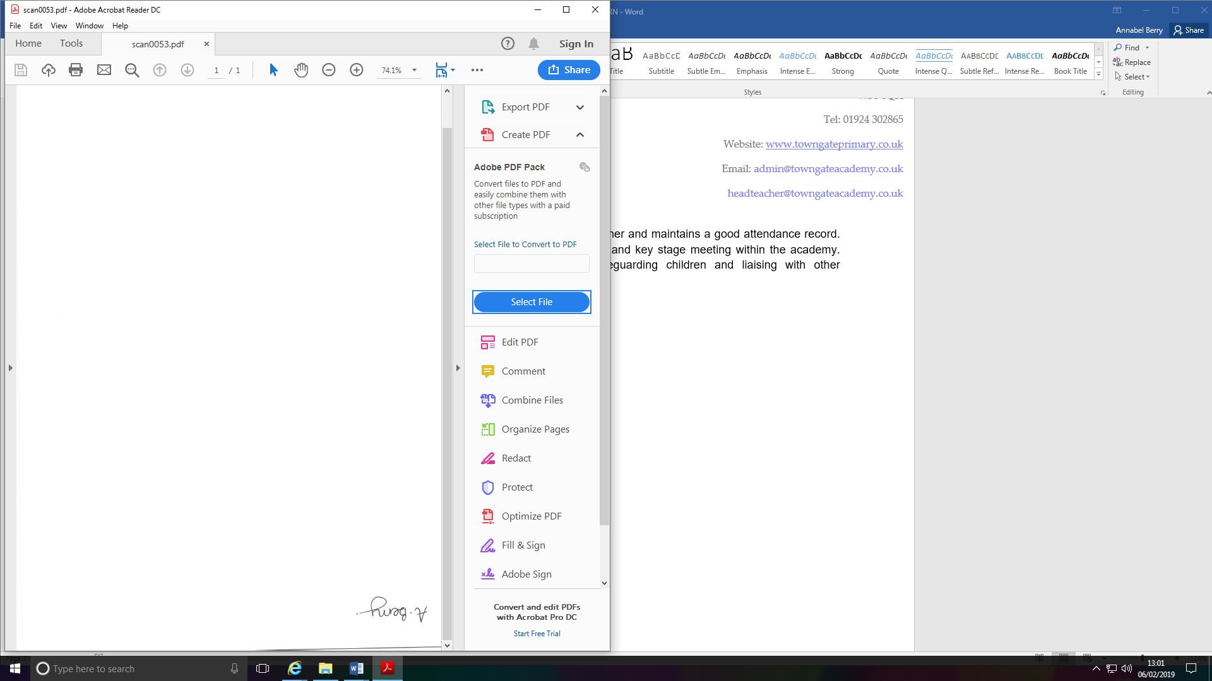

**Mrs A Berry**

**Headteacher**