

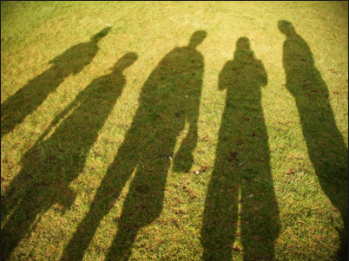 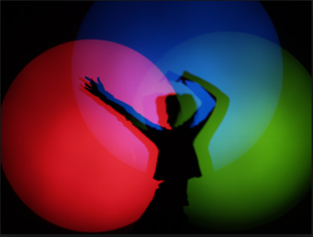

Light and Shadows

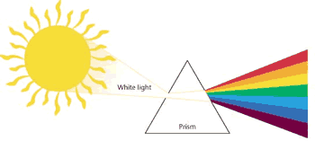

When white light passes through a glass prism, it is refracted. The light changes direction and is then dispersed (spread out) as it exits the prism. Depending on the shape of the prism and the angle of the light, we can often see the spectrum of colours.

|  |  |
| --- | --- |
| **Key facts** | |
| *1* | Light travels in a straight line |
| *2* | Light travels faster than sound. |
| *3* | A light year is a unit of measurement for distance. It is the distance light can travel in a year. |
| *4* | The size and shape of a shadow changes based on the distance and angle compared to the light source. |
| *5* | Darkness is caused by the absence of light. |
| *6* | The moon does **not** emit its own light – it reflects the sun. |
| *7* | Ultraviolet (UV) light is a type of radiation which you can’t see but can be dangerous. UV rays can come from the sun. |

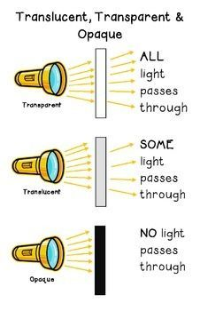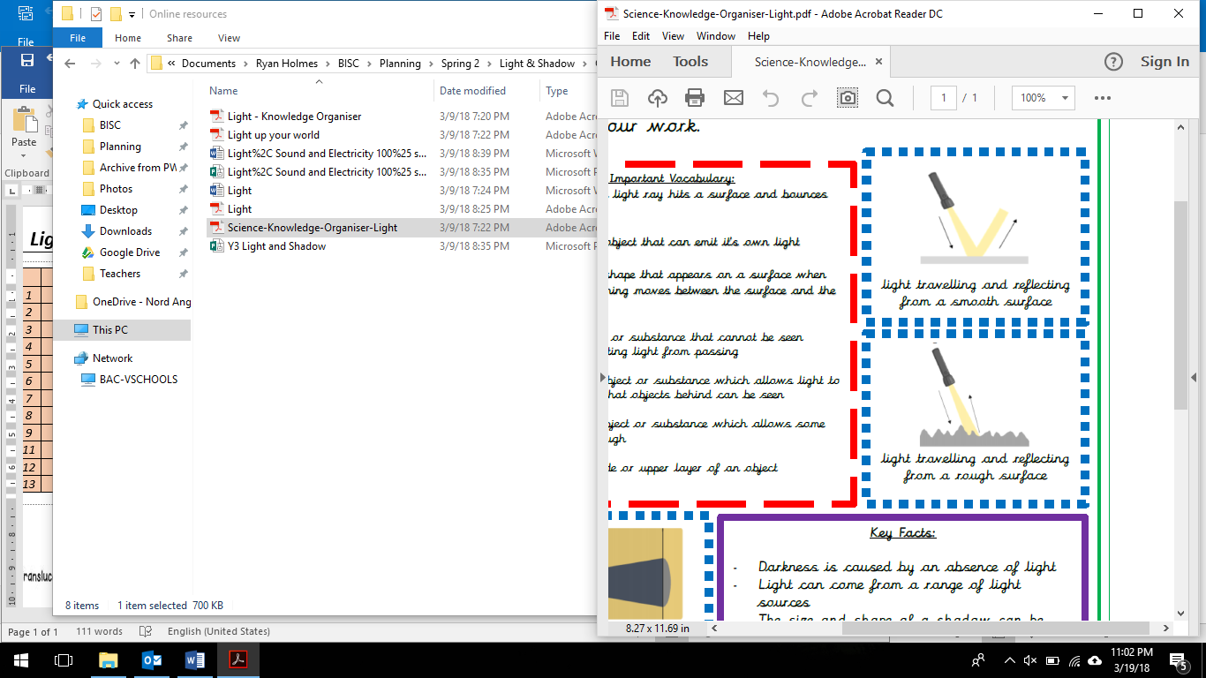

Left: Light travelling and reflecting off a smooth surface

Right: Light travelling and reflecting off a rough surface

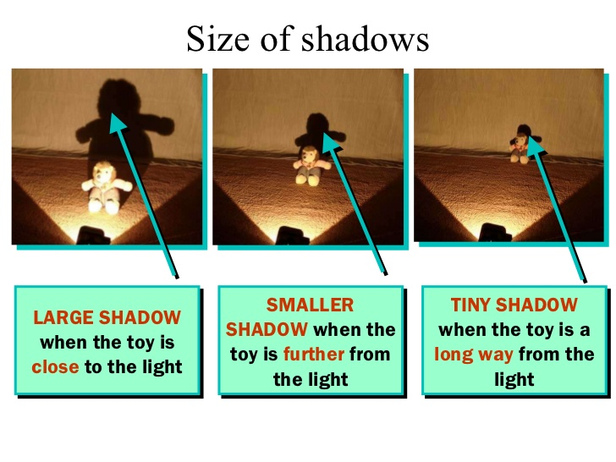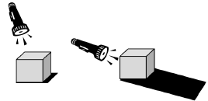

As the **light source** moves **higher** in relation to the **object**, the **shadow** gets **shorter**. As the **light source** moves **lower,**  the **shadow** gets **longer**.

|  |  |  |
| --- | --- | --- |
|  | **Term** | **Definition** |
| *1* | Light source | An object that produces its own light (e.g. sun, fire). |
| *2* | Reflection | When a light hits a surface and ‘bounces’ off. |
| *3* | Refraction | When light passes through a different object and its direction changes. |
| *4* | Opaque | An object which **does not allow** light to pass through it (e.g. wood). |
| *5* | Translucent | An object which **allows some** light to pass through it. It may be possible to see some unclear images through the object (e.g. tissue paper). |
| *6* | Transparent | An object which **allows** light to pass through it so that objects behind it can be easily seen (e.g. glass). |
| *7* | Spectrum | A range of colours caused when white light is refracted. A rainbow shows a spectrum of colours. |
| *8* | Rainbow | An arch of colour caused by the refraction of light on water droplets in the air, usually rain (**R**ed, **O**range, **Y**ellow, **G**reen, **B**lue, **I**ndigo, **V**iolet). |
| *9* | Prism | A solid 3D shape where two end faces are similar and parallel. |
| *10* | Shadow | A dark area or shape caused by the blockage of light. |