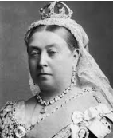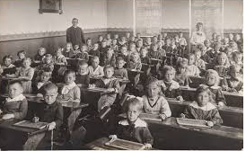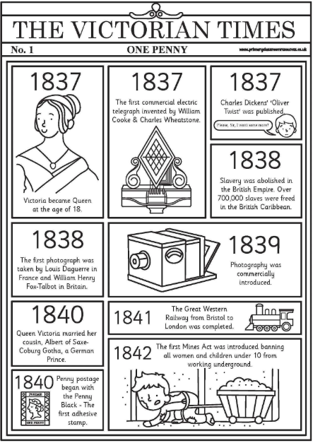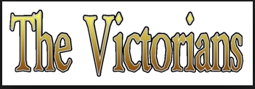

The Victorian period is named after Queen Victoria who reigned over Britain and a world Empire from her coronation in 1837 to her death in 1901 (64 years).

Life in Victorian England was very different to today. It was a time of great wealth and poverty, as well as invention and scientific discovery.

Key people

Queen Victoria – Queen of England from 1837 - 1901

Dr Barnardo – founder of homes for poor people

Charles Dickens – famous author. He wrote Oliver Twist.

Lord Shaftesbury – MP who worked hard to reform the laws about children and work in factories.

Key vocabulary

Coronation - the formal service of making someone a king or queen.

Factory Acts - the laws passed by government to protect people working in the dangerous factories.

Laws - rules passed by the government that people living in that country have to follow.

Paupers - very poor people that had no way of feeding or supporting themselves.

Poverty - people living in poverty do not have enough money to feed or clothe themselves.

Ragged Schools - schools set up to teach poor children.

Reign - the length of time a king or queen rules a country.

Wealthy - having a lot of money.

Workhouse - places set up by the government where poor people could go to work, have a bed and food. They had to follow very harsh rules.