

Towngate Primary Academy
Online Safety Policy

Date | Review Date | Coordinator | Nominated Governor
January 2020 | January 2021 | SLT | Mrs Jo Crook

Schedule for Development / Monitoring / Review:
5
This Online Safety policy was approved by the Local Governing Board.

The implementation of this Online Safety policy will be monitored by the Online Safety Leader, Miss Laura Eke.
Monitoring will take place at regular intervals:
The Online Safety Policy will be reviewed annually, or more regularly in the light of any significant new developments in the use of the technologies, new threats to online safety or incidents that have taken place. The next anticipated review date will be:
January, 2021

Should serious online safety incidents take place, the academy will use their safeguarding procedures to report any such incidents.
The academy will monitor the impact of the policy using:
- Logs of reported incidents
- Monitoring logs of internet activity (including sites visited) / filtering
- Internal monitoring data for network activity
- Surveys / questionnaires of
  - students / pupils
  - parents / carers
  - staff
6

Policy
This policy applies to all members of the Towngate Primary Academy community (including staff, students / pupils, volunteers, parents / carers, visitors, community users) who have access to and are users of the academy’s digital technology systems, both in and out of the site.

The Education and Inspections Act 2006 empowers Headteachers to such extent as is reasonable, to regulate the behaviour of pupils when they are off the academy site and empowers members of staff to impose disciplinary penalties for inappropriate behaviour. This is pertinent to incidents of online-bullying or other Online Safety incidents covered by this policy, which may take place outside of the academy, but is linked to membership of the academy. The 2011 Education Act increased these powers with regard to the searching for and of electronic devices and the deletion of data in serious circumstances (see appendix for template policy). In the case of both acts, action can only be taken over issues covered by the academy Behaviour Policy.

The academy will deal with such incidents within this policy and associated behaviour and anti-bullying policies and will, where known, inform parents / carers of incidents of inappropriate Online Safety behaviour that take place out of academy.

Towngate Primary Academy understands that the use of technology has become a significant component of many safeguarding issues. Child sexual exploitation; radicalisation; sexual predation: technology often provides the platform that facilitates harm. We work together to deliver an effective approach to online safety empowers the academy to protect and educate the whole school community in their use of technology and establishes mechanisms to identify, intervene in, and escalate any incident where appropriate.

Roles and Responsibilities
7
The following section outlines the online safety roles and responsibilities of individuals and groups within the academy:

Governors
The Local Governing Board are responsible for the approval of the Online Safety Policy and for reviewing the effectiveness of the policy. This will be carried out by the Local Governing Board receiving regular information about online safety incidents and monitoring reports. A member of the Local Governing Board has taken on the role of Online Safety Governor: Mr D Robson.

The role of the Online Safety Governor is as follows:
- meetings with the Online Safety Co-ordinators / team
- attendance at Online Safety Group meetings (where possible)
- regular monitoring of online safety incident logs
- regular monitoring of filtering / change control logs
- reporting to relevant Local Governing Board

Headteacher and Senior Leaders
- The Headteacher has a duty of care for ensuring the safety (including online safety) of members of the academy community, though the day-to-day responsibility for online safety will be delegated to the Online Safety Lead – Miss L Eke.
- The Headteacher and the Senior Leadership Team should be aware of the procedures to be followed in the event of a serious online safety allegation being made against a member of staff. (See flow chart on dealing with online safety incidents – included in a later section – “Responding to incidents of misuse” and relevant Multi Academy Trust (IPMAT).
- The Senior Leaders are responsible for ensuring that the Online Safety Lead and other relevant staff receive suitable training to enable them to carry out their online safety roles and to train other colleagues, as relevant.
- The Senior Leaders will ensure that there is a system in place to allow for monitoring and support of those in academy who carry out the internal online safety-monitoring role. This is to provide a safety net and also support to those colleagues who take on important monitoring roles.
- The Senior Leadership Team will receive regular monitoring reports from the Online Safety Lead, ensuring that any incidents or breaches of the online safety policy are investigated and recorded accurately.
- Designated Safeguarding Leads receive relevant training, including online safety.

Online Safety Lead - Miss L Eke
- leads the Online Safety Group
- takes day to day responsibility for online safety issues and has a leading role in establishing and reviewing the academy online safety policies and reporting documentation.
- ensures that all staff are aware of the procedures that need to be followed in the event of an online safety incident taking place.
- provides training and advice for staff
- liaises with the Multi Academy Trust
- liaises with academy technical staff, Alamo to ensure the network and devices are appropriate for school.
- receives reports of online safety incidents and creates a log of incidents to inform future online safety developments
- meets and communicates with Online Safety Governor to discuss current issues, review incident logs and filtering / change control logs
- reports regularly to Senior Leadership Team

Network Manager / Technical staff - Alamo

The Network Manager / Technical Staff are responsible for ensuring:

- that the academy’s technical infrastructure is secure and is not open to misuse or malicious attack
- that the academy meets required online safety technical requirements and any Multi-Academy Trust Online Safety Policy.
- that users may only access the networks and devices through a properly enforced password protection policy, in which passwords are regularly changed
- that they keep up to date with online safety technical information in order to effectively carry out their online safety role and to inform and update others as relevant
- that the use of the network / internet / Learning Platform / remote access / email is regularly monitored in order that any misuse / attempted misuse can be reported to the Headteacher and the Online Safety Lead for investigation / action / sanction

Teaching and Support Staff

Are responsible for ensuring that:

- they have an up to date awareness of online safety matters and of the current academy Online Safety Policy and practices
- they have read, understood and signed the Staff Acceptable Use Agreement
- they report any suspected misuse or problem to the Headteacher, Online Safety Lead for investigation / action / sanction.
- all digital communications with pupils, parents and carers should be on a professional level and only carried out using official academy systems in specific roles e.g. SENCO, Phase Leader, Pastoral Support.
- online safety issues are embedded in all aspects of the curriculum and other activities; dedicated lessons should be delivered, teaching children about online safety and behaviour when accessing the online world both in and out of school – this should be woven into the Computing, PSHE and wider curriculum at an age-appropriate level.
- pupils understand and follow the Online Safety Policy and acceptable use policies
- pupils have a good understanding of research skills and the need to avoid plagiarism and uphold copyright regulations
- they monitor the use of digital technologies, ipads, cameras etc in lessons and other academy activities and implement current policies with regard to these devices
- in lessons where internet use is pre-planned pupils should be guided to sites checked as suitable for their use and that processes are in place for dealing with any unsuitable material that is found in internet searches

Designated Safeguarding Lead

Should be trained in Online Safety issues and be aware of the potential for serious child protection / safeguarding issues to arise from:
- sharing of personal data
- access to illegal / inappropriate materials
- inappropriate on-line contact with adults / strangers
- potential or actual incidents of grooming
- online-bullying

E-Safety Team / Online Safety Group
The Online Safety Team is formed from multiple pupils from varied years across school. The Digital Leaders will meet regularly to prepare assemblies / newsletter updates and work to further raise the profile of online safety within the academy.

Members of the Online Safety Team will assist the Online Safety Lead
with:
- Raising the profile of online safety through the preparation and delivery of assemblies to the whole school;
- Conducting pupil voice to gain an understanding of pupils’ views and understanding of key online safety issues;
- consulting stakeholders – including parents / carers and the students / pupils about the online safety provision in school via the academy newsletter;
- monitoring improvement actions identified from pupil voice.

Pupils:

- are responsible for using the academy digital technology systems in accordance with the Pupil Acceptable Use Agreement
- have a good understanding of research skills and the need to avoid plagiarism and uphold copyright regulations
- need to understand the importance of reporting abuse, misuse or access to inappropriate materials and know how to do so
- will be expected to know and understand policies on the use of mobile devices within the academy, completing a permission form before bringing a mobile phone to school. They should also know and understand policies on the taking / use of images and on online-bullying.
- should understand the importance of adopting good online safety practice when using digital technologies out of academy and realise that the academy’s Online Safety Policy covers their actions out of academy.

Parents / Carers

Parents / Carers play a crucial role in ensuring that their children understand the need to use the internet in an appropriate way. The academy will take every opportunity to help parents understand these issues through parents’ evenings, newsletters, letters, website and information about national / local online safety campaigns via the academy newsletter or twitter feed.

Parents and carers will be encouraged to support the academy in promoting good online safety practice and to follow guidelines on the appropriate use of:

- digital and video images taken at academy events
- access to parents’ sections of the website and on-line student / pupil records

Parents will ensure they sign and return the parent / carer acceptable use agreement.

Mobile Technologies

Mobile technology devices for use within the academy will be provided and might include: mobile phone (headteacher / pastoral), tablet, notebook / laptop or other technology that usually has the capability of utilising the academy’s wireless network. The device then has access to the wider internet, which includes the academy’s learning platform and other cloud based services such as email and data storage.

All users should understand that the primary purpose of the use of mobile devices in an academy context is educational. The mobile technologies policy should be consistent with and inter-related to other relevant academy polices including but not limited to the Safeguarding Policy, Behaviour Policy, Bullying Policy, Acceptable Use Policy.
Teaching about the safe and appropriate use of mobile technologies is be an integral part of the academy’s Online Safety education.

The academy Acceptable Use Agreements for staff and pupils will give consideration to the use of mobile technologies, in conjunction with the Academy Mobile Phone Policy.

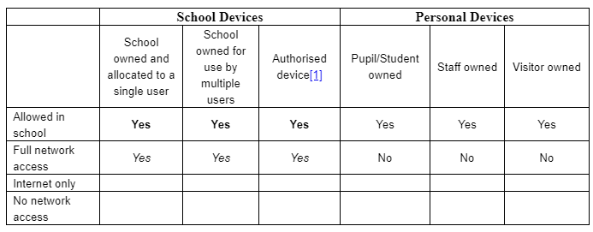

Use of digital and video images
The development of digital imaging technologies has created significant benefits to learning, allowing staff and pupils instant use of images that they have recorded themselves or downloaded from the internet. However, staff, parents / carers and pupils need to be aware of the risks associated with publishing digital images on the internet. Such images may provide avenues for cyberbullying to take place. Digital images may remain available on the internet forever and may cause harm or embarrassment to individuals in the short or longer term. It is common for employers to carry out internet searches for information about potential and existing employees.

The academy will inform and educate users about these risks and will implement policies to reduce the likelihood of the potential for harm:

- When using digital images, staff should inform and educate pupils about the risks associated with the taking, use, sharing, publication and distribution of images. In particular they should recognise the risks attached to publishing their own images on the internet e.g. on social networking sites.
- Written permission from parents or carers will be obtained before photographs of students / pupils are published on the academy website / social media / local press – permission slips to be held centrally in the academy office.
- In accordance with guidance from the Information Commissioner’s Office, parents / carers are welcome to take digital images of their own child/ren at academy events for their own personal use (as such use in not covered by the Data Protection Act) and must not take photographs of other children; parents are reminded of these procedures during concerts and other parental events. To respect everyone’s privacy and in some cases protection, these images should not be published / made publicly available on social networking sites, nor should parents / carers comment on any activities involving other pupils in the digital / video images.
- Staff and volunteers are allowed to take digital images to support educational aims using classroom iPads, but must follow academy policies concerning the sharing, distribution and publication of those images. Those images should only be taken on academy equipment, the personal equipment of staff should not be used for such purposes.
- Care should be taken when taking digital / video images that students / pupils are appropriately dressed and are not participating in activities that might bring the individuals or the academy into disrepute.
- Pupils must not take, use, share, publish or distribute images of others without their permission.
- Photographs published on the website, or elsewhere that include students / pupils will be selected carefully and will comply with good practice guidance on the use of such images.
- Pupils’ full names will not be used anywhere on a website or blog, particularly in association with photographs.

Data Protection

Personal data will be recorded, processed, transferred and made available according to the current data protection legislation.

The academy ensures that:

- It has a Data Protection Policy.
- It has appointed a Data Protection Officer (DPO).
- It will hold the minimum personal data necessary to enable it to perform its function and it will not hold it for longer than necessary for the purposes it was collected for.
- Data held must be accurate and up to date. Inaccuracies are corrected without unnecessary delay.
- The lawful basis for processing personal data (including, where relevant, consent) has been identified and documented and details provided in a Privacy Notice.
- Where special category data is processed, a lawful basis and a separate condition for processing have been identified.
- Data Protection Impact Assessments (DPIA) are carried out.
- It has clear and understood arrangements for access to and the security, storage and transfer of personal data, including, where necessary, adequate contractual clauses or safeguards where personal data is passed to third parties e.g. cloud service providers.
- Procedures must be in place to deal with the individual rights of the data subject i.e. a Subject Access Requests to see all or a part of their personal data held by the data controller.
- There are clear and understood data retention policies and routines for the deletion and disposal of data.
- There is a policy for reporting, logging, managing and recovering from an information risk incident which recognises the requirement to report relevant data breaches to the DPO within 72 hours of the breach, where feasible.
- Consideration has been given to the protection of personal data when accessed using any remote access solutions.
- All academies must have a Freedom of Information Policy which sets out how it will deal with FOI requests.
- All staff receive data handling awareness / data protection training and are made aware of their responsibilities.
Staff must ensure that they:

- At all times take care to ensure the safe keeping of personal data in accordance with the academy policy, minimising the risk of its loss or misuse.
- Use personal data only on secure password protected computers and other devices, ensuring that they are properly “logged-off” at the end of any session in which they are using personal data.
- Ensure that laptops / devices are locked when they are not being used.
- Transfer data using encryption and secure password protected devices.

Communications
A wide range of rapidly developing communications technologies has the potential to enhance learning. The following table shows how the academy currently considers the benefit of using these technologies for education outweighs their risks / disadvantages:

When using communication technologies, the academy considers the following as good practice:

- The official academy email service may be regarded as safe and secure and is monitored. Users should be aware that email communications are monitored. Staff should therefore use only the academy email service to communicate with others when in academy, or on academy systems / devices (e.g. by remote access).
- Users must immediately report - to the nominated person – in accordance with the academy policy, the receipt of any communication that makes them feel uncomfortable, is offensive, discriminatory, threatening or bullying in nature and must not respond to any such communication.
- Any digital communication between staff and/or parents / carers (email or when sharing school images / messages via the academy Twitter feed): These communications may only take place on official (monitored) academy systems. Personal email addresses, text messaging or social media must not be used for these communications.
- Pupils will be taught about online safety issues, such as the risks attached to the sharing of personal details. They should also be taught strategies to deal with inappropriate communications and be reminded of the need to communicate appropriately when using digital technologies.
- Personal information should not be posted on the academy website and only official email addresses should be used to identify members of staff in roles including Headteacher, SENCO, LAC Teacher, Pastoral Support.

Social Media - Protecting Professional Identity

The academy provides the following measures to ensure reasonable steps are in place to minimise risk of harm to pupils, staff and the academy through:

- Ensuring that personal information is not published
- Training is provided including: acceptable use; social media risks; checking of settings; data protection; reporting issues.
- Clear reporting guidance, including responsibilities, procedures and sanctions
- Risk assessment, including legal risk
Academy staff should ensure that:

- No reference should be made in social media to pupils, parents / careers or academy staff
- They do not engage in online discussion on personal matters relating to members of the academy community
- Personal opinions must not be attributed to the academy, local authority or MAT
- Security settings on personal social media profiles are regularly checked and privacy held as a priority to minimise risk of loss of personal information
When official academy social media accounts are established there should be:

- A process for approval by senior leaders.
- Clear processes for the administration and monitoring of these accounts – involving two members of staff – one of whom is L Eke.
- A code of behaviour for users of the accounts, including systems for reporting and dealing with abuse and misuse and a clear understanding of how incidents may be dealt with under academy disciplinary procedures
Personal Use:
- Personal communications are those made via a personal social media accounts. In all cases, where a personal account is used which associates itself with the academy or impacts on the academy, it must be made clear that the member of staff is not communicating on behalf of the academy with an appropriate disclaimer. Staff must not discuss any matter regarding the academy, it’s community or pupils using social media.
- Where excessive personal use of social media in academy is suspected, and considered to be interfering with relevant duties, disciplinary action may be taken.
Monitoring of Public Social Media
- As part of active social media engagement, it is considered good practice to pro-actively monitor the Internet for public postings about the academy
- The academy should effectively respond to social media comments made by others according to a defined policy or process – Social Media policy.

Dealing with unsuitable / inappropriate activities
Some internet activity e.g. accessing child abuse images or distributing racist material is illegal and would obviously be banned from academy and all other technical systems. Other activities e.g. cyber-bullying would be banned and could lead to criminal prosecution. There are however a range of activities which may, generally, be legal but would be inappropriate in an academy context, either because of the age of the users or the nature of those activities.

The academy believes that the activities referred to in the following section would be inappropriate in an academy context and that users, as defined below, should not engage in these activities in / or outside the academy when using academy equipment or systems. The academy policy restricts usage as follows:

Responding to incidents of misuse
This guidance is intended for use when staff need to manage incidents that involve the use of online services. It encourages a safe and secure approach to the management of the incident. Incidents might involve illegal or inappropriate activities.

Illegal Incidents
If there is any suspicion that the web site(s) concerned may contain child abuse images, or if there is any other suspected illegal activity, refer to the right hand side of the Flowchart (below and appendix) for responding to online safety incidents and report immediately to the police.
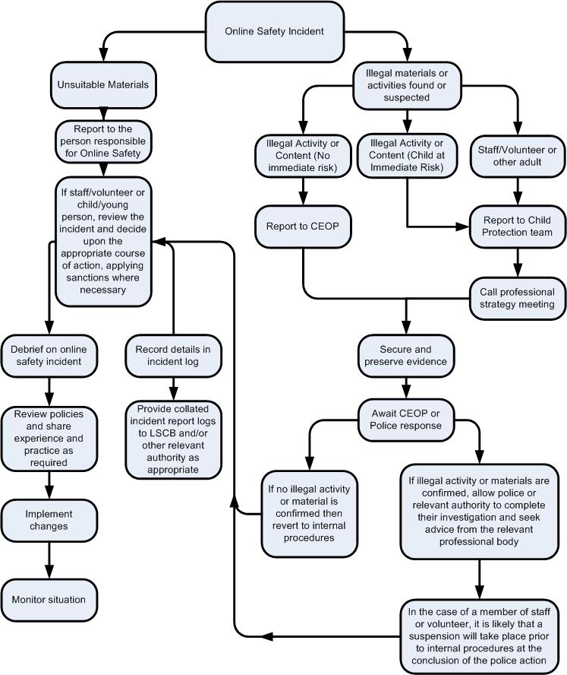

Other Incidents
It is hoped that all members of the academy community will be responsible users of digital technologies, who understand and follow academy policy. However, there may be times when infringements of the policy could take place, through careless or irresponsible or, very rarely, through deliberate misuse.

In the event of suspicion, all steps in this procedure should be followed:
- Have more than one senior member of staff involved in this process. This is vital to protect individuals if accusations are subsequently reported.
- Conduct the procedure using a designated computer that will not be used by young people and if necessary can be taken off site by the police should the need arise. Use the same computer for the duration of the procedure.
- It is important to ensure that the relevant staff should have appropriate internet access to conduct the procedure, but also that the sites and content visited are closely monitored and recorded (to provide further protection).
- Record the URL of any site containing the alleged misuse and describe the nature of the content causing concern. It may also be necessary to record and store screenshots of the content on the machine being used for investigation. These may be printed, signed and attached to the form (except in the case of images of child sexual abuse – see below)
- Once this has been completed and fully investigated the group will need to judge whether this concern has substance or not. If it does then appropriate action will be required and could include the following:
  - Internal response or discipline procedures
  - Involvement by the MAT (as relevant).
  - Police involvement and/or action
- If content being reviewed includes images of child abuse then the monitoring should be halted and referred to the Designated Safeguarding Lead and the Police immediately. Other instances to report to the police would include:
  - incidents of ‘grooming’ behaviour
  - the sending of obscene materials to a child
  - adult material which potentially breaches the Obscene Publications Act
  - criminally racist material
  - promotion of terrorism or extremism
  - other criminal conduct, activity or materials
- Isolate the computer in question as best you can. Any change to its state may hinder a later police investigation.
It is important that all of the above steps are taken as they will provide an evidence trail for the academy and possibly the police and demonstrate that visits to these sites were carried out for safeguarding purposes. The completed form should be retained by the group for evidence and reference purposes.

Academy Actions & Sanctions
It is more likely that the academy will need to deal with incidents that involve inappropriate rather than illegal misuse. It is important that any incidents are dealt with as soon as possible in a proportionate manner, and that members of the academy community are aware that incidents have been dealt with. It is intended that incidents of misuse will be dealt with through normal behaviour / disciplinary procedures.

Glossary of Terms

AUP / AUA Acceptable Use Policy / Agreement – see templates earlier in this document
CEOP Child Exploitation and Online Protection Centre (part of UK Police, dedicated to protecting children from sexual abuse, providers of the Think U Know programmes.
CPD Continuous Professional Development
FOSI Family Online Safety Institute
ES Education Scotland
HWB Health and Wellbeing
ICO Information Commissioners Office
ICT Information and Communications Technology
ICTMark Quality standard for schools provided by NAACE
INSET In Service Education and Training
IP address The label that identifies each computer to other computers using the IP (internet protocol)
ISP Internet Service Provider
ISPA Internet Service Providers’ Association
IWF Internet Watch Foundation
LA Local Authority
LAN Local Area Network
MIS Management Information System
NEN National Education Network – works with the Regional Broadband Consortia (e.g. SWGfL) to provide the safe broadband provision to schools across Britain.
55
Ofcom Office of Communications (Independent communications sector regulator)
SWGfL South West Grid for Learning Trust – the Regional Broadband Consortium of SW Local Authorities – is the provider of broadband and other services for schools and other organisations in the SW
TUK Think U Know – educational online safety programmes for schools, young people and parents.
VLE Virtual Learning Environment (a software system designed to support teaching and learning in an educational setting,
WAP Wireless Application Protocol
54
57
56

UKSIC UK Safer Internet Centre – EU funded centre. Main partners are SWGfL, Childnet and Internet Watch Foundation.

22

Headteacher
Chair of Governors

Appendices



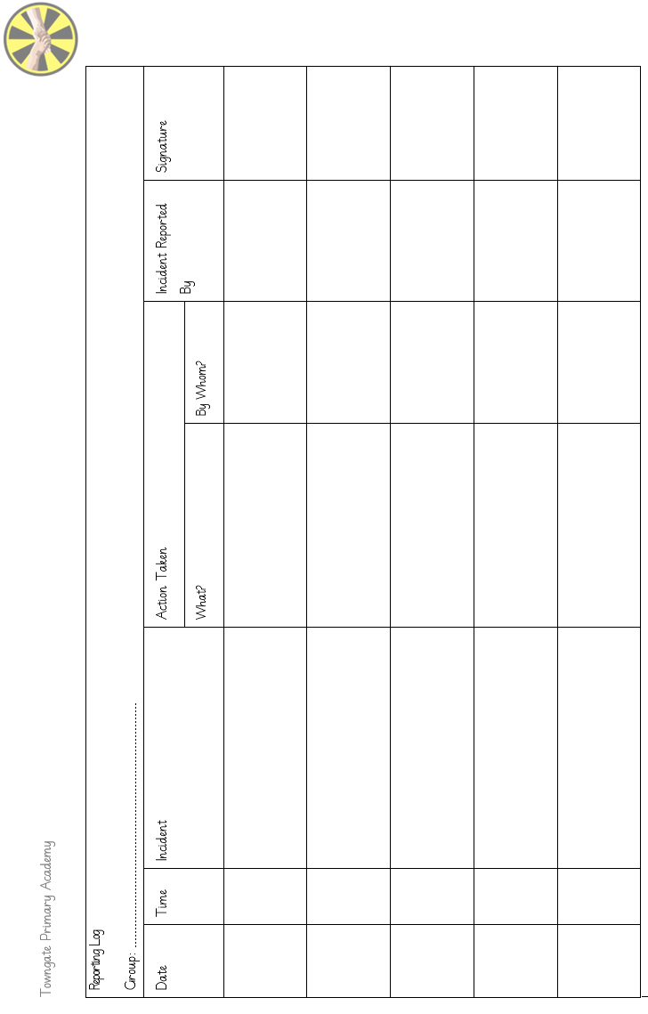
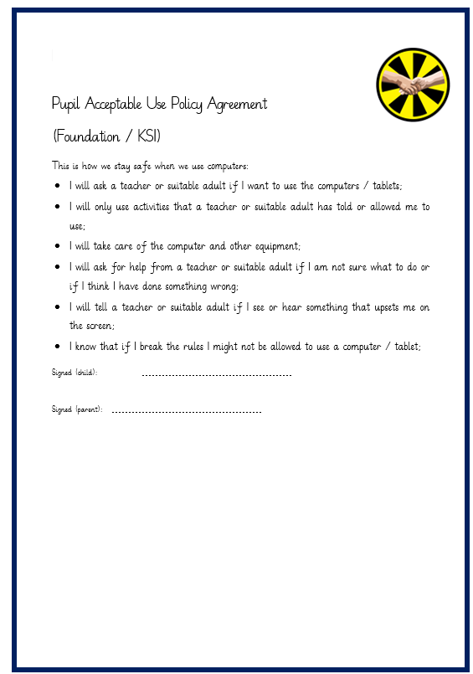
Appendix 1: Incident Reporting Log
Actable Use Agreement
Appendix 2: Acceptable Use Agreement: EY/KS1
Appendix 3: Acceptable Use Agreement: KS2
Pupil Acceptable Use Agreement Template – UKS2

Academy Policy
Digital technologies have become integral to the lives of children and young people, both within schools and outside school. These technologies are powerful tools, which open up new opportunities for everyone. These technologies can stimulate discussion, promote creativity and stimulate awareness of context to promote effective learning. Young people should have an entitlement to safe internet access at all times.

This Acceptable Use Agreement is intended to ensure:
- that young people will be responsible users and stay safe while using the internet and other digital technologies for educational, personal and recreational use.
- that school systems and users are protected from accidental or deliberate misuse that could put the security of the systems and will have good access to digital technologies to enhance their learning and will, in return, expect the pupils to agree to be responsible users.
Acceptable Use Policy Agreement
I understand that I must use school systems in a responsible way, to ensure that there is no risk to my safety or to the safety and security of the systems and other users.

For my own personal safety:
- I understand that the academy will monitor my use of the systems, devices and digital communications.
- I will keep my username and password safe and secure – I will not share it, nor will I try to use any other person’s username and password. I understand that I should not write down or store a password where it is possible that someone may steal it.
- I will be aware of “stranger danger”, when I am using online devices.
- I will not disclose or share personal information about myself or others when on-line (this could include names, addresses, email addresses, telephone numbers, age, gender, educational details, financial details etc.)
- I will immediately report any unpleasant or inappropriate material or messages or anything that makes me feel uncomfortable when I see it on-line.

I understand that everyone has equal rights to use technology as a resource and:
- I understand that the academy systems and devices are primarily intended for educational use and that I will not use them for personal or recreational use unless I have permission.
- I will not try (unless I have permission) to make large downloads or uploads that might take up internet capacity and prevent other users from being able to carry out their work.
- I will not use the academy systems or devices for on-line gaming etc. file sharing, or video broadcasting (eg YouTube).

I will act as I expect others to act toward me:
- I will respect others’ work and property and will not access, copy, remove or otherwise alter any other user’s files, without the owner’s knowledge and permission.
- I will be polite and responsible when I communicate with others, I will not use strong, aggressive or inappropriate language and I appreciate that others may have different opinions.
- I will not take or distribute images of anyone without their permission.

I recognise that the school has a responsibility to maintain the security and integrity of the technology it offers me and to ensure the smooth running of the academy:
- I understand the risks and will not try to upload, download or access any materials which are illegal or inappropriate or may cause harm or distress to others, nor will I try to use any programmes or software that might allow me to bypass the filtering / security systems in place to prevent access to such materials.
- I will immediately report any damage or faults involving equipment or software, however this may have happened.
- I will not install or attempt to install or store programmes of any type on any school device, nor will I try to alter computer settings.

When using the internet for research or recreation, I recognise that:
- I should ensure that I have permission to use the original work of others in my own work
- Where work is protected by copyright, I will not try to download copies (including music and videos)
- When I am using the internet to find information, I should take care to check that the information that I access is accurate, as I understand that the work of others may not be truthful and may be a deliberate attempt to mislead me.

I understand that I am responsible for my actions, both in and out of school

Please complete the sections on the next page to show that you have read, understood and agree to the rules included in the Acceptable Use Agreement. If you do not sign and return this agreement, access will not be granted to school systems and devices.
Pupil Acceptable Use Agreement Form: KS2

This form relates to the pupil Acceptable Use Agreement, to which it is attached.

Please complete the sections below to show that you have read, understood and agree to the rules included in the Acceptable Use Agreement. If you do not sign and return this agreement, access will not be granted to school systems.

I have read and understand the above and agree to follow these guidelines when:
- I use the academy systems and devices (both in and out of school)
- I use my own equipment out of the academy in a way that is related to me being a member of Towngate Primary Academy.

Name of Student / Pupil:
Class:
Signed:
Date:

Parent / Carer Countersignature: …………………………………………………..

Appendix 4: Staff (and Volunteer) Acceptable Use Policy Agreement

Academy Policy
New technologies have become integral to the lives of children and young people in today’s society, both within academies and in their lives outside school. The internet and other digital information and communications technologies are powerful tools, which open up new opportunities for everyone. These technologies can stimulate discussion, promote creativity and stimulate awareness of context to promote effective learning. They also bring opportunities for staff to be more creative and productive in their work. All users should have an entitlement to safe access to the internet and digital technologies at all times.

This Acceptable Use Policy is intended to ensure:
- that staff and volunteers will be responsible users and stay safe while using the internet and other communications technologies for educational, personal and recreational use.
- that school / academy systems and users are protected from accidental or deliberate misuse that could put the security of the systems and users at risk.
- that staff are protected from potential risk in their use of technology in their everyday work.
The school will try to ensure that staff and volunteers will have good access to digital technology to enhance their work, to enhance learning opportunities for pupils learning and will, in return, expect staff and volunteers to agree to be responsible users.

Acceptable Use Policy Agreement
I understand that I must use school systems in a responsible way, to ensure that there is no risk to my safety or to the safety and security of the systems and other users. I recognise the value of the use of digital technology for enhancing learning and will ensure that students / pupils receive opportunities to gain from the use of digital technology. I will, where possible, educate the young people in my care in the safe use of digital technology and embed online safety in my work with young people.

For my professional and personal safety:
- I understand that the academy will monitor my use of the school digital technology and communications systems.
- I understand that the rules set out in this agreement also apply to use of these technologies (e.g. laptops, email etc.) out of school, and to the transfer of personal data (digital or paper based) out of school
- I understand that the school digital technology systems are primarily intended for educational use and that I will only use the systems for personal or recreational use within the policies and rules set down by the school.
- I will not disclose my username or password to anyone else, nor will I try to use any other person’s username and password. I understand that I should not write down or store a password where it is possible that someone may steal it.
- I will immediately report any illegal, inappropriate or harmful material or incident; I become aware of, to the appropriate person.
28
- When receiving an email from parents it is permissible to acknowledge receipt. Follow up should be a face to face contact, telephone call or letter on letter head sent through the post as appropriate, rather than an email exchange.

I will be professional in my communications and actions when using academy ICT systems:
- I will not access, copy, remove or otherwise alter any other user’s files, without their express permission.
- I will communicate with others in a professional manner, I will not use aggressive or inappropriate language and I appreciate that others may have different opinions.
- I will ensure that when I take and / or publish images of others I will do so with their permission and in accordance with the school’s policy on the use of digital / video images. I will not use my personal equipment to record these images. Where these images are published (eg on the school website) it will not be possible to identify by name, or other personal information, those who are featured.
- I will only use social networking sites in school in accordance with the school’s policies.
- Any communication will be professional in tone and manner.
- I will not use my personal email addresses / mobile phone / social networking sites for such communications with pupils, parents or carers.
- I will not engage in any on-line activity that may compromise my professional responsibilities.

The school and the local authority have the responsibility to provide safe and secure access to technologies and ensure the smooth running of the academy:
- When I use my mobile devices (laptops / tablets / mobile phones / USB devices etc) in school, I will follow the rules set out in this agreement, in the same way as if I was using academy equipment. I will also follow any additional rules set by the academy about such use. I will ensure that any such devices are protected by up to date anti-virus software and are free from viruses.
- I will not use my personal apple ID on the work IPAD at any time.
- I will not connect any personal devices (mobiles etc) to the school wifi systems.
- I will not use personal email addresses on the academy ICT systems for example logging into googlemail or Hotmail accounts.
- I will not open any hyperlinks in emails or any attachments to emails, unless the source is known and trusted , or if I have any concerns about the validity of the email (due to the risk of the attachment containing viruses or other harmful programmes)
- I will not try to upload, download or access any materials which are illegal (child sexual abuse images, criminally racist material, adult pornography covered by the Obscene Publications Act) or inappropriate or may cause harm or distress to others. I will not try to use any programmes or software that might allow me to bypass the filtering / security systems in place to prevent access to such materials.
- I will not install or attempt to install programmes of any type on a machine, or store programmes on a computer, nor will I try to alter computer settings, unless this is allowed in school / academy policies.
- I will not disable or cause any damage to academy equipment, or the equipment belonging to others.
- I will only transport, hold, disclose or share personal information about myself or others, as outlined in the Academy Data Policy (or other relevant policy). Where digital personal data is transferred outside the secure local network, it must be encrypted. Paper based Protected and restricted data must be held in lockable storage.
- I understand that data protection policy requires that any staff or pupil data to which I have access, will be kept private and confidential, except when it is deemed necessary that I am required by law or by academy policy to disclose such information to an appropriate authority.
- I will immediately report any damage or faults involving equipment or software, however this may have happened.

When using the internet in my professional capacity or for school sanctioned personal use:
- I will ensure that I have permission to use the original work of others in my own work
- Where work is protected by copyright, I will not download or distribute copies (including music and videos).

I understand that I am responsible for my actions in and out of the academy:
- I understand that this Acceptable Use Policy applies not only to my work and use of academy digital technology equipment in school, but also applies to my use of academy systems and equipment off the premises and my use of personal equipment on the premises or in situations related to my employment by the academy
- I understand that if I fail to comply with this Acceptable Use Policy Agreement, I could be subject to disciplinary action.

I have read and understand the above and agree to use the school digital technology systems (both in and out of school) and my own devices (in school and when carrying out communications related to the school) within these guidelines.

Staff / Volunteer Name:

Signed:

Date:

Appendix 5: Parent / Carer Acceptable Use Agreement EY/KS1

Digital technologies have become integral to the lives of children and young people, both within schools and outside school. These technologies provide powerful tools, which open up new opportunities for everyone. They can stimulate discussion, promote creativity and stimulate awareness of context to promote effective learning. Young people should have an entitlement to safe internet access at all times.

This Acceptable Use Policy is intended to ensure:
- that young people will be responsible users and stay safe while using the internet and other communications technologies for educational, personal and recreational use.
- that academy systems and users are protected from accidental or deliberate misuse that could put the security of the systems and users at risk.
- that parents and carers are aware of the importance of online safety and are involved in the education and guidance of young people with regard to their on-line behaviour.
I understand that the school has discussed the Acceptable Use Agreement with my son / daughter and that they have received, or will receive, online safety education to help them understand the importance of safe use of technology and the internet – both in and out of school.
I understand that the school will take every reasonable precaution, including monitoring and filtering systems, to ensure that young people will be safe when they use the internet and systems. I also understand that the school cannot ultimately be held responsible for the nature and content of materials accessed on the internet and using mobile technologies.
I understand that my son’s / daughter’s activity on the systems will be monitored and that the school will contact me if they have concerns about any possible breaches of the Acceptable Use Policy.
I will encourage my child to adopt safe use of the internet and digital technologies at home and will inform the school if I have concerns over my child’s online safety.

Parents are requested to sign the permission form below to show their support of the school in this important aspect of the school’s work.

Parent / Carers Name:
Pupil Name:

As the parent / carer of the above pupil, I give permission for my son / daughter to have access to the internet and to ICT systems at school.
I know that my son / daughter has signed an Acceptable Use Agreement and has received, or will receive, online safety education to help them understand the importance of safe use of technology and the internet – both in and out of school.

Signed:
Date:

Appendix 6: Parent / Carer Acceptable Use Agreement KS2

Digital technologies have become integral to the lives of children and young people, both within schools and outside school. These technologies provide powerful tools, which open up new opportunities for everyone. They can stimulate discussion, promote creativity and stimulate awareness of context to promote effective learning. Young people should have an entitlement to safe internet access at all times.

This Acceptable Use Policy is intended to ensure:
- that young people will be responsible users and stay safe while using the internet and other communications technologies for educational, personal and recreational use.
- that academy systems and users are protected from accidental or deliberate misuse that could put the security of the systems and users at risk.
- that parents and carers are aware of the importance of online safety and are involved in the education and guidance of young people with regard to their on-line behaviour.
The school will try to ensure that pupils will have good access to digital technologies to enhance their learning and will, in return, expect the pupils to agree to be responsible users. A copy of the Pupil Acceptable Use Policy is attached to this permission form, so that parents / carers will be aware of the school expectations of the young people in their care.
Parents are requested to sign the permission form below to show their support of the school in this important aspect of the school’s work.

Parent / Carers Name:
Pupil Name:

As the parent / carer of the above pupil, I give permission for my son / daughter to have access to the internet and to ICT systems at school.

I know that my son / daughter has signed an Acceptable Use Agreement and has received, or will receive, online safety education to help them understand the importance of safe use of technology and the internet – both in and out of school.

Signed:
Date:

