

Schools must use the funding to make additional and sustainable improvements to the quality of PE and sport they offer. This means that you should use the Primary PE and Sport Premium to:

- develop or add to the PE and sport activities that your school already offers
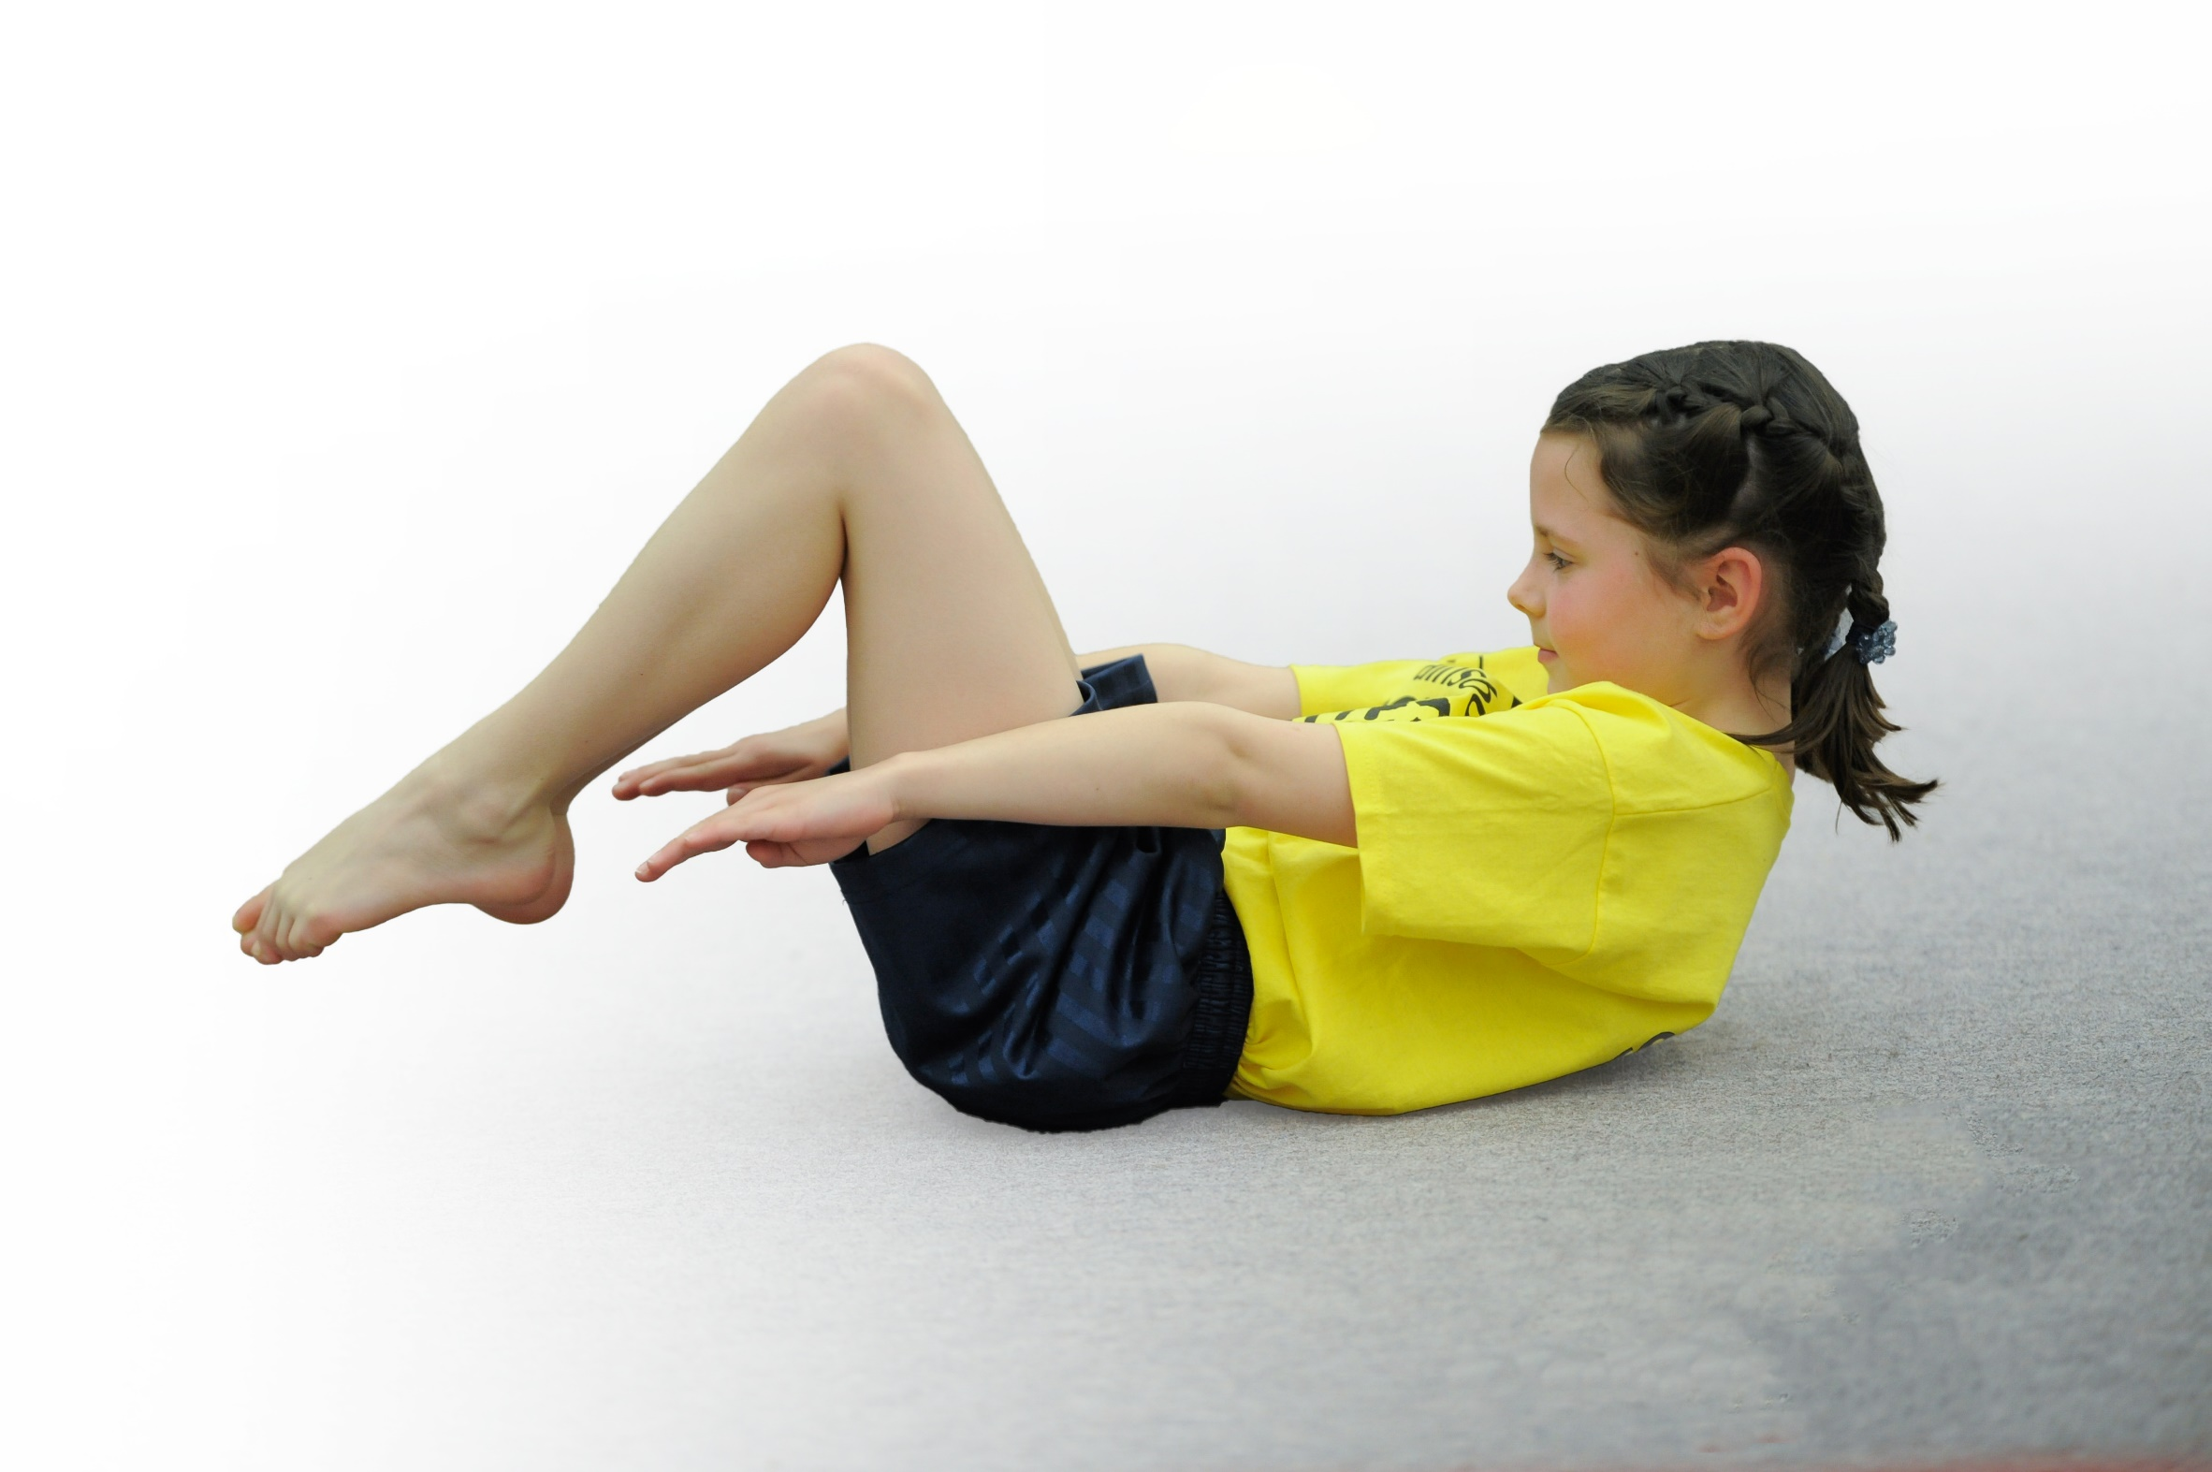
- build capacity and capability within the school to ensure that improvements made now will benefit pupils joining the school in future years

Please visit gov.uk for the revised DfE guidance including the 5 key indicators across which schools should demonstrate an improvement. This document will help you to review your provision and to report your spend. DfE encourages schools to use this template as an effective way of meeting the reporting requirements of the Primary PE and Sport Premium.

We recommend you start by reflecting on the impact of current provision and reviewing the previous spend.
Under the Ofsted Schools Inspection Framework, inspectors will assess how effectively leaders use
the Primary PE and Sport Premium and measure its impact on outcomes for pupils, and how effectively governors hold them to account
for this.

Schools are required to publish details of how they spend this funding as well as on the impact it has on pupils’ PE
and sport participation and attainment.
We recommend regularly updating the table and
publishing it on your website as evidence
of your ongoing review into how you are using the money
to secure maximum, sustainable impact. To see an example of how to complete the table please click HERE.

Support for review and reflection - considering the 5 key indicators from DfE, what development needs are a priority for your setting and your students now and why? Use the space below to reflect on previous spend, identify current need and priorities for the future.

Key achievements to date: | Areas for further improvement and baseline evidence of need:
Children having lessons delivered by PE and Dance specialists.  The development of staff confidence in teaching through specialists and assessment through new assessment tool created by PE coordinator.  Practical workshop delivered by a GB athlete.  Whole School trip to Huddersfield Giants raised the profile of PE and sport.  An increase of activity at lunch times and play times through TSS sports coaches and sports leaders.  An increase in before and after school clubs allowing children to gain 30 minutes of daily exercise.  The profile of PE, sport and exercise has raised with children eager to bring out of school achievements into our weekly Friday celebration assembly.  Partnership with Huddersfield giants has seen an increase in GDS children and confidence in staff CPD. Partnership has created morning/breakfast club opportunities and raised the profile of sport through trips.  KS1 have been able to participate in a local potted sports tournament and a MAT event at Thornes co-hosted by MAT schools. Using the premium to purchase transport has made this possible to further the opportunities for KS1.  Swimming attainment. | Continue with our partnership with Huddersfield Giants where we can further raise the profile of PE and Sport and continue to develop the confidence of staff members (new members of staff to develop CPD).  Encourage more children to attend clubs by reviewing the clubs we deliver now and offering a bigger range (see document of extra curriculum clubs of whole school, pupil voice documents)  Develop the profile of PE further with a display in the school hall (to raise the profile with parents).  Establish further fixtures to attend throughout the year within the MAT and local high school.

Meeting national curriculum requirements for swimming and water safety | Please complete all of the below*:
What percentage of your current Year 6 cohort swim competently, confidently and proficiently over a distance of at least 25 metres? | 87% last year  18/19 predictions: 100%
What percentage of your current Year 6 cohort use a range of strokes effectively [for example, front crawl, backstroke and breaststroke]? | 87% last year  18/19 predictions: 100%
What percentage of your current Year 6 cohort perform safe self-rescue in different water-based situations? | 83% last year  18/19 predictions: 100%
Schools can choose to use the Primary PE and Sport Premium to provide additional provision for swimming but this must be for activity over and above the national curriculum requirements. Have you used it in this way? | No – not at this point.
*Schools may wish to provide this information in April, just before the publication deadline.

Action Plan and Budget Tracking
Capture your intended annual spend against the 5 key indicators. Clarify the success criteria and evidence of impact that you intend to measure to evaluate for students today and for the future.

Academic Year: 2018/19 | Total fund allocated: £ | Date Updated:
Key indicator 1: The engagement of all pupils in regular physical activity – Chief Medical Officer guidelines recommend that primary school children undertake at least 30 minutes of physical activity a day in school |  |  |  | Percentage of total allocation:
 |  |  |  | %
School focus with clarity on intended impact on pupils: | Actions to achieve: | Funding allocated: | Evidence and impact: | Sustainability and suggested next steps:
Develop the level of activity at lunch times.  Introduce and implement the 1k a day. | Year 5 children to take part in Sport Leaders training to be given the opportunity to lead activities during lunch time.  Out of school partnership with Huddersfield Giants who are in school 1 day a week delivering a lunchtime club.  Member of TSS to deliver sporting activities each lunchtime.  Staff to work together in the organisation and running of this. | £115  £4800  £7980 | Children selected and completed a series of tasks such as:  Pupil voice – what games/activities would they like to see on the playground? With this information the leaders developed a timetable of activities. Found more children engaging in a different range of activities. Collect pupil voice in summer to measure impact.  Evidence of increased participants during lunchtimes, offering a range of activities.  Wakefield sports council coming in Summer to deliver this and kick start. Sports leaders then to carry on. | Y5 sports leaders moving into Y6 to continue their role. This has had an impact on the KS1 playground with more children (both boys and girls) joining in team games.  19/20 train more Y5 children to be sports leaders and continue to deliver sporting activities at lunch times. Look at the sports leaders running the daily mile next academic year.  Both Huddersfield Giants and TSS have provided CPD for lunch time staff, liaised with lunch time supervisor who will be providing LTS with a lunch timetable where staff deliver activities.  PE lead and LTS received CPD on daily mile, this has been tested in summer term and impact measured.
Key indicator 2: The profile of PE and sport being raised across the school as a tool for whole school improvement |  |  |  | Percentage of total allocation:
 |  |  |  | %
School focus with clarity on intended impact on pupils: | Actions to achieve: | Funding allocated: | Evidence and impact: | Sustainability and suggested next steps:
Continue to develop a PE notice board to create an interest in PE and sport. Keep up to date with events and clubs.  Whole school topical assemblies led by Huddersfield Giants.  Focus week around health and wellbeing (links with science) to raise awareness and give ideas, inspiration and motivation to children.  Dance specialist teacher to offer a scholarship to their dance school.  UKS2 & EY children and teachers to work alongside dance specialist teacher to create an end of term dance production for parents, children and staff. | Role of PE coordinator.  Liase with coach from Huddersfield Giants with the topics we would like discussing in assemblies.  Invite guests into school.  Discuss Liquidance coming in and doing a performance?  Huddersfield giants assesmbly.  Specialist teacher to present this scholarship to the children to motivate and inspire them.  Regular weekly lessons to teach inspire and motivate children and enable them to have the skills and confidence to perform in front of an audience. | In school resources used.  Included in the £4800. | PE board displayed in LKS2 corridors show the benefits of physical education and sport. Clubs and pupil voice is displayed.  Assembly promoted the morning multi sports club and lunch time clubs – leading to increased participation in activities.  Assemblies every half term – using sport to demonstrate our VBE & BV.  GB Athlete has been arranged to come deliver an assembly and workshops. Pupil voice taken to measure impact. Many children signed up to after school events after this.  F2 dance show performance –17.10.18  Y5/6 performance – 18.10.18  PE coordinator to collect pupil voice from chn in performances.  Developed staff skill set.  Pupil voice showed 97% of children enjoyed learning their routine and performing. | Next year look at moving these displays into the hall where it is accessible for all children and parents. Out of school clubs can be advertised also for community links.  Strong relationships built between sports coach and children. This has had an increased impact on the amount of children attending the clubs. Next year, timetable in the different clubs to suit all children following pupil voice.  Inspired children, look at running something similar next year through our Huddersfield Giants Partnetship.

Key indicator 3: Increased confidence, knowledge and skills of all staff in teaching PE and sport |  |  |  | Percentage of total allocation:
 |  |  |  | %
School focus with clarity on intended  impact on pupils: | Actions to achieve: | Funding  allocated: | Evidence and impact: | Sustainability and suggested  next steps:
Continued use of kidnetics and dance specialists to upskill all staff . PE coordinator to build a bank of ideas to develop staff CPD, to ensure children are receiving the highest quality.  Establish an assessment tool to monitor the progress of all children and see where the gaps are.  Huddersfield Giants partnership offer staff CPD and an away day to a game. | Ensure monitoring of kidnetics and dance specialist – speak to staff regularly and observe lessons.  Time given to fill out, staff training and meeting led by PE coordinator on how to fill this out.  Look at PE Passport (an app used by another school in our MAT)  PE coordinator to send out staff questionnaire and see what areas are of need for staff. | £3900  Included in £4800 | Planning shared between specialists and teachers has increased staff confidence. Staff questionnaire sent out shows this impact.  A range of staff in EY, KS1 and KS2 observed and develop their teaching and CPD.  Staff meeting held in Spring Term, where an assessment tool made by PE coordinator was shared. This has been used to assess children in different sporting activities and provided a consistent approach across school, showing where we can challenge children further.  Staff becoming more confident in completing assessment and using it as a tool to stretch, challenge and plan further lessons.  CPD held 17.5.19  Discussion of planning, differentiation and challenges discussed. Shared with staff. | Planning shared between specialists and teachers – continue this practice.  Work alongside staff and specialist coaches to ensure next year our curriculum shows progression.  Continue to share assessment tool and measure impact during staff meeting, ensure all staff are still confident with this.
Key indicator 4: Broader experience of a range of sports and activities offered to all pupils |  |  |  | Percentage of total allocation:
 |  |  |  | %
School focus with clarity on intended  impact on pupils: | Actions to achieve: | Funding  allocated: | Evidence and impact: | Sustainability and suggested  next steps:
Specialist coach from Huddersfield Giants to deliver a variety of sporting activities across classes, morning clubs, lunchtime clubs and an after school club.  Develop a wider range of activities and sports through after school clubs to engage pupils.  Liquidance – specialist dance and acrobat teachers to run after school clubs. | Work alongside specialist coach deciding on what topics to be taught to different classes from the curriculum.  Pupil voice to establish an appropriate after school club to engage and motivate children. | £4800 | 30 children from across school attending morning multi skills club.  Lunch time club offers a broad range of activities resulting in consistent high numbers each lunchtime. Both boys and girls participating in different events.  Coach identified girls enjoyed skipping activities, so this was introduced on the playground to ensure they are keeping active.  Pupil voice collected to see which children attended clubs both in school and out of school. Data collected showed gaps within KS1 clubs offered. Therefore, dance/acro and multisports was put in place Autumn Term.  High numbers still attending. | Continue with this practice next year.  Lunch time staff have observed this practice as part of their CPD and they will be running different activities next year.  Look into more out of school companies delivering a wider range of activities. E.g. disco dodgeball, zorbing with xreme sports.  Continue to offer these clubs next year.  Following pupil voice and club data, a wider range of clubs to be available next year delivered by staff.  Carry out a survey to increase participation of girls.
Key indicator 5: Increased participation in competitive sport |  |  |  | Percentage of total allocation:
 |  |  |  | %
School focus with clarity on intended  impact on pupils: | Actions to achieve: | Funding  allocated: | Evidence and impact: | Sustainability and suggested  next steps:
Introduce further competitive fixtures. To allow those who do not always get opportunities at clubs to take part.  Offer competitions for KS1 children to develop confidence and implement skills they have learnt.  Attend and contribute to half termly events organized by the local high school. | TBC. To discuss at MAT network meetings and PE coordinator meetings at Ossett Academy.  Towngate host an event in Summer term and invite local schools? PE coordinator and sports leaders to organise.  Keep up to date with event dates in the MAT and EOCT. | Look into cost of coaches & venues.  - Approx. £400 | Netball game arranged: 7/1/1/18  Football game arranged: 8/11/18  Y1&2 Olympics – July 2019  Looking into a Y3&4 olympic date.  KS2 – hockey and trampolining events held at ossett academy.  Sports leaders and PE coordinator hosting a playground challenge at school.  Attending competitive event within the local community June.  Attended these each term with a range of KS2 children. | Games across the EOCT resulted in an increase of children joining after school clubs. Continue to liaise with other PE leaders across local community to arrange a game each half term.  Raised the profile of sport. Look into arranging an event next year within the local community.  Continue to establish further fixtures throughout the year, ensuring all year groups are given an opportunity.

