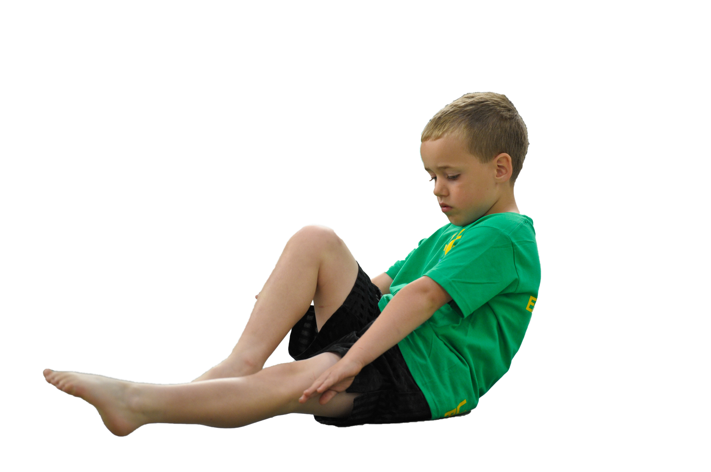
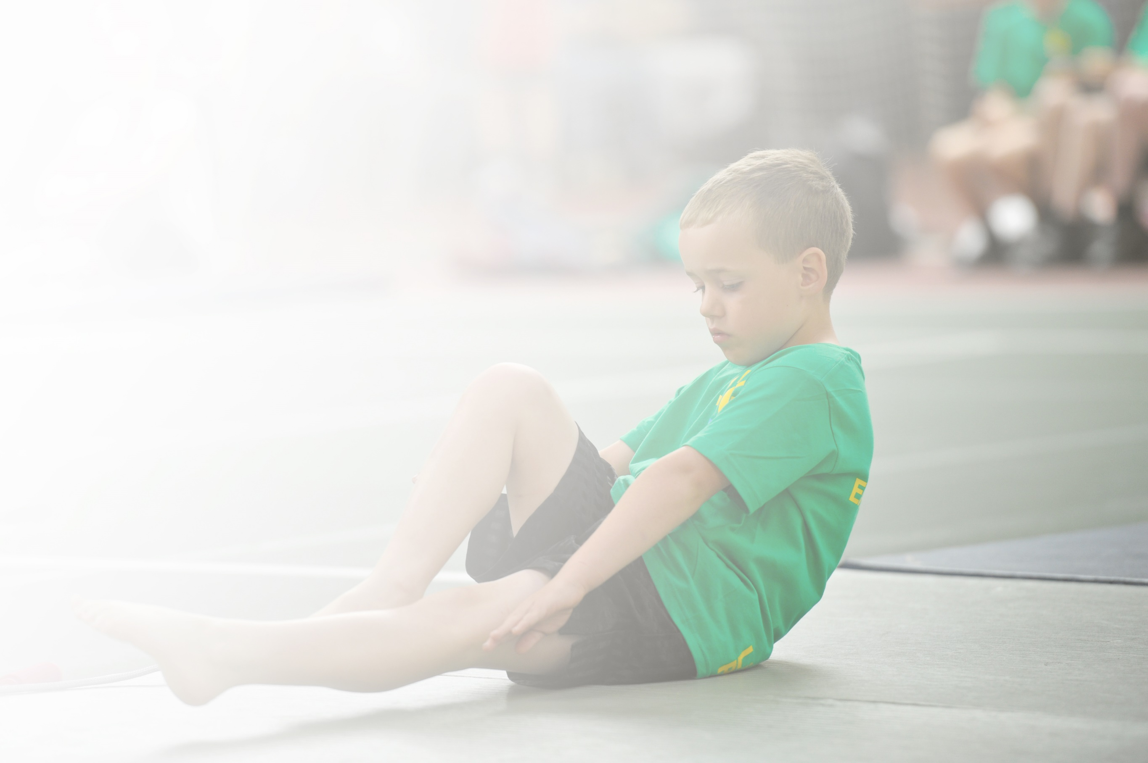
Schools must use the funding to make additional and sustainable improvements to the quality of Physical Education, Sport and Physical Activity (PESPA) they offer. This means that you should use the Primary PE and Sport Premium to:

- Develop or add to the PESPA activities that your school already offer
- Build capacity and capability within the school to ensure that improvements made now will benefit pupils joining the school in future years

Please visit gov.uk for the revised DfE guidance including the 5 key indicators across which schools should demonstrate an improvement. This document will help you to review your provision and to report
your spend. DfE encourages schools to use this template as an effective way of meeting the reporting requirements of the Primary PE and Sport Premium.

We recommend you start by reflecting on the impact of current provision and reviewing the previous
spend. Under the Ofsted Schools Inspection Framework, inspectors will assess how effectively leaders use the Primary PE and Sport Premium and measure its impact on outcomes for pupils, and how effectively governors hold them to account for this.

Schools are required to publish details of how they spend this funding as well as on the impact it has on pupils’ PE and sport participation and attainment by the end of the summer term or by 31 July 2019 at the
latest.
We recommend regularly updating the table and publishing it
on your website throughout the year, as evidence of your
ongoing review into how you are using the money to
secure maximum, sustainable impact. To see an
example of how to complete the table please
click HERE.

Support for review and reflection - considering the 5 key indicators from DfE, what development needs are a priority for your setting and your students now and why? Use the space below to reflect on previous spend, identify current need and priorities for the future.

Key achievements to date: | Areas for further improvement and baseline evidence of need:
Children having lessons delivered by PE and Dance specialists.  The development of staff confidence in teaching through specialists and assessment through new assessment tool created by PE coordinator.  Practical workshop delivered by a GB athlete.  Whole School trip to Huddersfield Giants raised the profile of PE and sport.  An increase of activity at lunch times and play times through TSS sports coaches and sports leaders.  An increase in before and after school clubs allowing children to gain 30 minutes of daily exercise.  The profile of PE, sport and exercise has raised with children eager to bring out of school achievements into our weekly Friday celebration assembly.  Partnership with Huddersfield giants has seen an increase in GDS children and confidence in staff CPD. Partnership has created morning/breakfast club opportunities and raised the profile of sport through trips.  KS1 have been able to participate in a local potted sports tournament and a MAT event at Thornes co-hosted by MAT schools. Using the premium to purchase transport has made this possible to further the opportunities for KS1.  Swimming attainment. | Engagement of all pupils in regular activity throughout the day – improve the ratio of girls to boys in the engagement of activities during playtimes.  Continue to deliver a high level of provision by sports specialists to enhance the CPD of staff.  An increase in the number of children attending school clubs – look at the capacity to create lunchtime clubs alongside sports leaders to encourage more children to gain their 30 minutes of daily exercise.  Continue to develop sporting events as a school to raise the profile of PE and build on lifelong learning skills such as; team work, cooperation etc.

Meeting national curriculum requirements for swimming and water safety | Please complete all of the below:
What percentage of your current Year 6 cohort swim competently, confidently and proficiently over a distance of at least 25 metres?  N.B. Even though your children may swim in another year please report on their attainment on leaving  primary school. | 18/19 cohort = 90%  Predictions for 19/20 =
What percentage of your current Year 6 cohort use a range of strokes effectively [for example, front crawl, backstroke and breaststroke]? | 18/19 cohort = 90%  Predictions for 19/20 =
What percentage of your current Year 6 cohort perform safe self-rescue in different water-based situations? | 18/19 cohort = 90%  Predictions for 19/20 =
Schools can choose to use the Primary PE and Sport Premium to provide additional provision for swimming but this must be for activity over and above the national curriculum requirements. Have you used it in this way? | No

Action Plan and Budget Tracking
Capture your intended annual spend against the 5 key indicators. Clarify the success criteria and evidence of impact that you intend to measure to evaluate for students today and for the future.

Academic Year: 2019/20 | Total fund allocated: £18350 | Date Updated:
Key indicator 1: The engagement of all pupils in regular physical activity – Chief Medical Officer guidelines recommend that primary school children undertake at least 30 minutes of physical activity a day in school |  |  |  | Percentage of total allocation:
 |  |  |  | %
School focus with clarity on intended impact on pupils: | Actions to achieve: | Funding allocated: | Evidence and impact: | Sustainability and suggested next steps:
Continue to develop the activities at lunch times.  Develop an active teaching approach throughout the day.  A range of PE and sporting equipment available for lessons, lunch times and break times to ensure activities.  All children to take part in 2 hour, weekly outdoor learning sessions. | Deploy more sports leaders from new Y5 cohort to deliver a broad range of activities during lunch times and break times.  Continue with lunchtime staff CPD – observing specialist coach from Huddersfield Giants. From this, they can deliver activities during lunchtime.  Set up an activity timetable for each class to fill in. Use a range of resources: Go noodle; wake up shake up, cosmic yoga.  Record how many minutes on the timetable and have a weekly ‘active class’ winner in celebration assembly.  Purchase class pedometers, different children chosen to wear the pedometer each day and calculate each classes steps at the end of the week.  PE coordinator to complete equipment audit.  Pupil voice of EY, KS1 and KS2 children (range of boys, girls and disadvantaged) to see what activities they are interested in.  Outside agency (Planting Seeds) to deliver a sequence of lessons to a class.  Support staff to observe and develop CPD in order to run their own sessions. | £115  £5700 – included in our Huddersfield Giants partnership.  Approx £96 for pedometers – TTS.  To match audit.  £3000 | Autumn & Spring term: Children selected and worked alongside PE leader to identify what activities children would like to see on the playground. Sports leaders are delivering a range of activities each lunch time, which has resulted in more children being active during this period.  Specialist coaches are offering skill specific activities on the playground and delivering CPD to lunch time staff for the days the coaches are not in.  Activity timetable and resources shared with staff by PE leader.  Equipment ordered and providing high quality resources for lessons.  PE leader worked alongside specialist coaches to create an audit of equipment. Resources ordered to ensure suitable equipment to deliver a range of high quality PE lessons.  Children are receiving an extra 2 hours of activity weekly through this programme. CPD of support staff to ensure they can deliver this session when the outside agency isn’t present. | Next steps:  - Work alongside LTS, allocation of staff to work alongside these sports leaders to ensure variety of activities on a daily basis and that they are promoting their provision.  - Work alongside LTS to develop a rota, where LTS are running an activity that encourages children to participate in physical activities. E.g. parachute, setting up obstacle courses for bikes (KS1) etc.  - Sports leaders to take on responsibility of monitoring the ‘activity timetable’ and finding out the winner for each week. PE leader to promote this again at the beginning of the year.  - PE equipment to be audited again September. Create a bag of equipment for LTS to use and share with sports leaders. This is separate to equipment used for lessons. No LTS or sports leaders should be taking lesson equipment to use outside. Monitored by curriculum leader.  - Developed life skills alongside an active learning approach, continue with this next year.
Key indicator 2: The profile of PESSPA being raised across the school as a tool for whole school improvement |  |  |  | Percentage of total allocation:
 |  |  |  | %
School focus with clarity on intended impact on pupils: | Actions to achieve: | Funding allocated: | Evidence and impact: | Sustainability and suggested next steps:
Whole school topical assemblies delivered half-termly by Huddersfield Giants Coach. | Liaise with sports coaches from Huddersfield Giants for the appropriate topics to be discussed. Link with our VB curriculum.  Examples:  - Cooperation  - Team work | Included in the £5700 partnership. | Coaches delivering assemblies to engage children in the benefits of being active and taking part in a range of sporting activities. | - Continue with this next year, curriculum leader to sit with sports coach at the beginning of the year and timetable assemblies.

Key indicator 3: Increased confidence, knowledge and skills of all staff in teaching PE and sport |  |  |  | Percentage of total allocation:
 |  |  |  | %
School focus with clarity on intended  impact on pupils: | Actions to achieve: | Funding  allocated: | Evidence and impact: | Sustainability and suggested  next steps:
Partnership with Huddersfield Giants, delivering high quality lessons across year groups.  CPD offered by Huddersfield Giants Partnership  CPD event held by Yorkshire Sport Foundation.  Local Dance School (Liquidance) delivering high quality dance lessons across year groups. | Plan alongside specialist coach to ensure a broad range of activities are delivered. Staff observe this high quality practice.  Whole school to show progression throughout the years through our skill based approach.  PE coordinator to attend and deliver staff meeting to develop knowledge of all teaching staff.  PE coordinator to attend and deliver staff meeting to develop knowledge of all teaching staff.  Regular weekly lessons to teach inspire and motivate children and enable them to have the skills and confidence to perform in front of an audience.  Staff to observe and develop their CPD. | Included in £5700 partnership.  Included in £5700 partnership.  £100  £3900 | Specialist coaches are sharing and planning alongside staff to develop CPD. Through staff evaluations, there has been a clear impact where staff feel more confident in the teaching and delivery of an effective PE lesson that allows for progression and challenge.  Summer term.  Summer term.  Specialist coaches are sharing and planning alongside staff to develop CPD. Through staff evaluations, there has been a clear impact where staff feel more confident in the teaching and delivery of an effective PE lesson that allows for progression and challenge. | - Through monitoring and staff CPD evaluations, this is having a clear impact on staff. Next year, ensure all staff experience this CPD (including support staff) and ensure evaluations and planning are completed.  - Through monitoring and staff CPD evaluations, this is having a clear impact on staff. Next year, ensure all staff experience this CPD (including support staff) and ensure evaluations and planning are completed.
Key indicator 4: Broader experience of a range of sports and activities offered to all pupils |  |  |  | Percentage of total allocation:
 |  |  |  | %
School focus with clarity on intended  impact on pupils: | Actions to achieve: | Funding  allocated: | Evidence and impact: | Sustainability and suggested  next steps:
Offer a range of clubs, available to all children across school.  Specialist sports coaches delivering after school clubs.  Year 6 weekly swimming sessions at local high school. | PE coordinator to audit PE equipment and create a timetable of clubs to be delivered by both staff and specialists.  Extra-curricular data to be collected and analysed by PE coordinator to gauge interests of children.  Specialist skilled teachers to deliver high quality clubs and promote participation across school. E.g. host an assembly.  Coaches to and from.  PE coordinator to attend a session to check provision provided. | To match audit.  Dance: Included in £3900  Sports: Included in £5700  £1500 | Multisports club: 30 chn attend.  Acro club: 20 children attend.  Football club: 30 children attend  Rugby club: 30 children attend.  More clubs to be added in the summer term following pupil voice. | - Consider the capacity for lunchtime sports clubs alongside after school clubs to increase participation numbers. To be discussed at the beginning of the academic year with staff.
Key indicator 5: Increased participation in competitive sport |  |  |  | Percentage of total allocation:
 |  |  |  | %
School focus with clarity on intended  impact on pupils: | Actions to achieve: | Funding  allocated: | Evidence and impact: | Sustainability and suggested  next steps:
Attend annual Olympic event delivered by the MAT.  KS1 Potted Sports Event within the local community.  Attend competitive sporting events at local high school. | Attend PE leaders MAT network meetings and establish dates.  Look at the possibility of running this across different year groups  Liaise with PE leader from another local school, ensure all KS1 children are able to attend.  Keep up to date with event dates in the MAT and EOCT. | Approx £500 for coaches (if more than 1 day)  Approx £250 (if KS1)  Approx £150 for coach. | Summer term.  Summer term.  Events offered have allowed all age groups from Y1-Y6 to participate in competitive sports. | - Continue to work alongside PE leader at local high school to ensure maximum attendance of sporting events on offer.  - Continued MAT meetings with PE leaders to arrange fixtures with local school and tournaments.  - Ensure all age groups have been catered for in these events.

