**Movement/Dance –** When you hear music it is normal to want to move your body, wave your hands, jump or sway to the beat.   
Listen to the follow music and move however you feel like. Explain which you like and don’t like afterwards.

- <https://www.youtube.com/watch?v=OyQz1QfPrYQ> **– Smooth Jazz**- <https://www.classicfm.com/composers/brahms/> **- Classical**- <https://www.youtube.com/watch?v=p13yZAjhU0M> **– Old School Rock n Roll**- <https://www.youtube.com/watch?v=wOJeMv1zNDY> **– Smooth beach rock**- <https://www.youtube.com/watch?v=010KyIQjkTk> **– Clean Rap**- <https://www.youtube.com/watch?v=Wh5a4kKkAIc> **– Instrumental country**- <https://www.youtube.com/watch?v=e8RSFaRjOA4> **– Modern Pop music**- <https://www.youtube.com/watch?v=b-VAxGJdJeQ> **– Rock n Roll**- <https://www.youtube.com/watch?v=il4i_tRmqgc> **- EDM**

**Loud and quiet**See if you can decide which of these sounds will be loud or quiet.

**Towngate Academy subject knowledge organiser – Music – EYFS**

**Nursery rhymes**Nursery rhymes are a great way of being introduced to music. Follow the simple rhymes and flow which helps children to read and sing. Some rhymes they could learn are:

* Humpty Dumpty
* Hey Diddle Diddle
* Little Miss Muffet
* Incy wincy spider
* Head, Shoulders, Knees and Toes
* Hickory Dickory Dock
* Hot Cross Buns
* Pat-a-Cake
* Row, Row, Row Your Boat
* The Grand Old Duke of York
* Twinkle, Twinkle Little Star
* Three Blind Mice
* The Wheels on the Bus

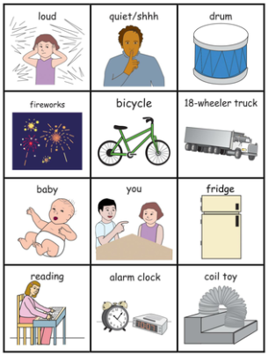

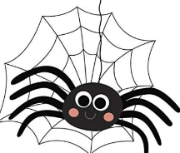

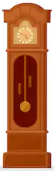

**Key Vocabulary**- Loud - Dance  
- Quiet - Patterns  
- Rhythm – A structured pattern of beats - Frog  
- Sound - Tadpole  
- Song - Beat  
- Instrument  
- Music  
- Movement

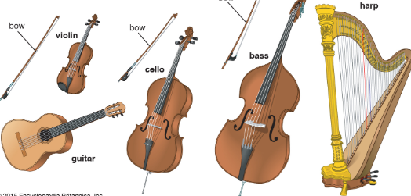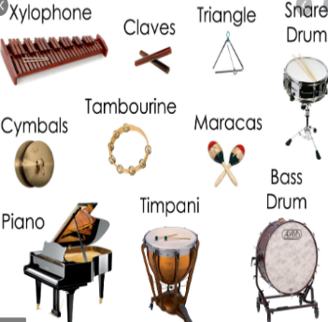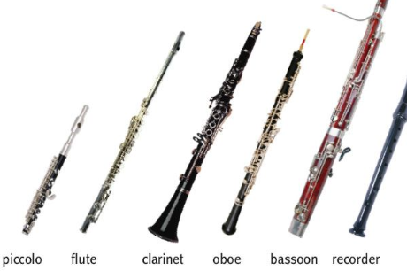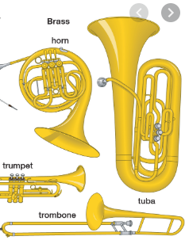

**Instruments/Questioning**There are lots of different instruments and they all fit into a certain family. See them below. What do you think they sound like? How would you play them? Listen to each instrument, which do you like and why? Which don’t you like? Experiment making different sounds with them.

**Strings Percussion Woodwind Brass**