**How does the music make you feel?**Music can make you feel a certain emotion like happy, sad, excited and scared. Listen to the songs below and explain what mood the song gives you.   
 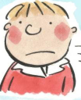

Happy Sad

-<https://www.youtube.com/watch?v=y6Sxv-sUYtM>

-<https://www.youtube.com/watch?v=aWIE0PX1uXk>

-<https://www.youtube.com/watch?v=OYMc7-NHgz4>

-<https://www.youtube.com/watch?v=mGx_FATyasQ>

**Identify and organise sounds**Different instruments make different sounds. Some are low pitch and sound very deep whereas some are high pitch and squeaky like a mouse. Some sounds are extremely loud like a trumpet or very quiet like a harp. Arrange these instruments thinking about volume and pitch.

**Towngate Academy subject knowledge organiser – Music – Y1**

**Variety of Composers**A composer is someone who creates music. It is important to listen to a wide range of composers as each offer something slightly different. Go away and look at some of the artists below. Do you like their songs?

The Beatles ABBA

Mozart Dave Koz

Stevie Wonder Michael Jackson

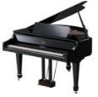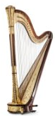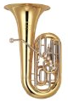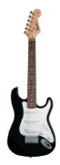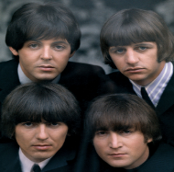

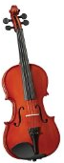

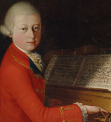

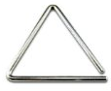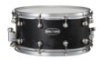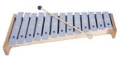

**Following small patterns and rhythms**We all know that when we clap rhythms we use our Frog and Tadpole. Look at the patterns below. Try and clap them. Or with a friend choose a rhythm each and take it in turns. Try to follow along. Saying the words frog and tadpole will help you follow along carefully.

Frog Tadpole Tadpole Frog Tadpole Frog Tadpole Frog

Tadpole Tadpole Frog Frog Frog Tadpole Tadpole Tadpole

**Key Vocabulary**- Pulse – Constant beat  
- Rhythm – A structured pattern of beats  
- Beat – A unit of rhythm  
- Perform  
- Ensamble  
- Pitch – High and Low  
- Volume  
- Tempo – Fast and Slow  
- Unison – Playing together.