**Controlling sound through singing and performing**When you are singing and performing it is important to think about several different things.   
**Audience**If you are playing in a large hall for lots of people you will probably need to be loud and powerful with your voice. You may need to sing with others to make sure the noise carries.   
**Occasion**  
If you are singing at a special event such as a wedding you would want happy songs and to be singing with a smile on your face.   
**The song**Think carefully about the song you are singing. If the chorus is very powerful and loud try singing quietly in the verse as a contrast. This can be very powerful and keep your performance interesting.

**Music for occasion**Music is suitable for every occasion. You can express feelings, thoughts and everything through music. Listen to the following songs and think about where they might be heard and explain why using musical words.

-<https://www.youtube.com/watch?v=Wxy80QvnMwA>

-<https://www.youtube.com/watch?v=1MzdQLTBPPo>  
  
-<https://www.youtube.com/watch?v=Z8FCGlwUyYQ>

**Towngate Academy subject knowledge organiser – Music – Y2**

**Variety of Composers**A composer is someone who creates music. It is important to listen to a wide range of composers as each offer something slightly different. Go away and look at some of the artists below. Write down what you like or dislike.   
 Elton John Elvis

Beethoven Take That

Madonna Aretha Franklin

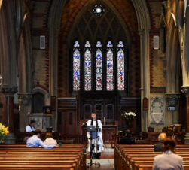



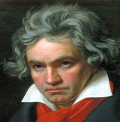

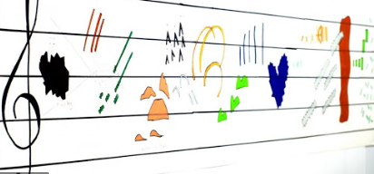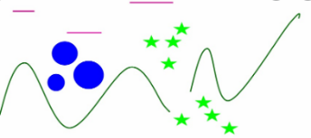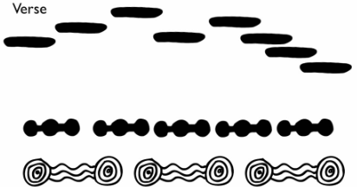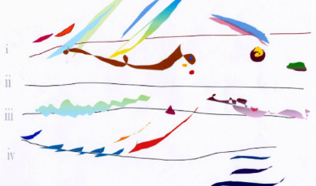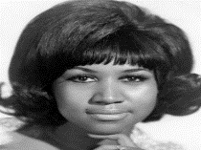

**Graphic score/written music**Music can be written in many different ways. Sometimes musicians use special notes and symbols to write music but anyone can write music. Have a look at the written music below. What do you think it sounds like? Explain why. Can you make up your own song following these musical scores?

**Key Vocabulary**- Express – Explain and give reasons.   
- Melody – A melodic tune in a song.  
- Tempo – The speed of the song.   
- Pulse – Steady heartbeat to the music.   
- Volume – How loud or quiet something is.   
- Beat – The pulse of the song.   
- Butterfly – Quick quaver rhythm.  
- Caterpillar – Semiquaver rhythm.   
- Rhythmical pattern – Patterns of rhythm