**Dynamics** - Dynamics are how loud or quiet a piece of music is. Dynamics like loud and quiet have special markings for musicians to read in their music. 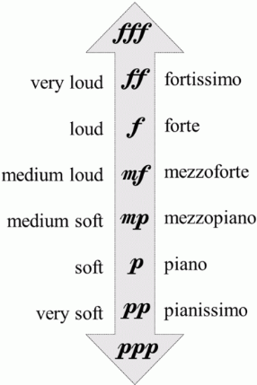

**Useful Websites**

-Charanga

-Classical FM online.

-BBC Bitesize music KS1/2

-Kids music corner

-Making music fun

- Classics for kids

**Listening and appraising**

**Key questions**  
What does the music sound like?  
What instruments can you hear?  
How does the song make you feel?  
What is the structure of the song?  
When do you think it was made?  
Does the song tell you a story?  
What are the Dynamics like?  
Did you like this song? Explain why.

**Towngate Academy subject knowledge organiser – Music – Year3**

**Composers of Romantic music (1830s/1900s)**The Romantic period started in 1830 and ended around 1900. In this time songs became expressive, passionate and inventive. Composers moved away from classical music and based songs around art and literature.   
**Key Composers:**  
 - **Ludwig Van Beethoven**  
Beethoven was the most famous  
Romantic composer. His famous pieces include, Fur Elise, Symphony No.9 and Symphony No.5.

-**Frederic Chopin**  
 Chopin was a Polish composer and   
 a virtuoso pianist. He wrote songs  
 mostly for **solo** piano.  
- **Pyotr Tchaikovsky**  
Tchaikovsky is a Russian composer  
and is the first truly famous   
Russian composer.

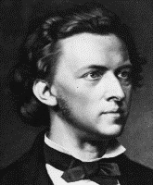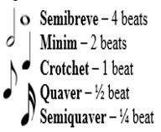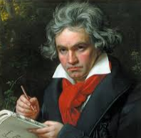

**Key Vocabulary**

* Dynamics – How loud and quiet music is. **Notes**
* Forte – F - Loud
* Piano – P - Quiet
* Solo – One person performing alone.
* Ostinato – A continuous repeated rhythm.
* Musical effect – happy songs are major/

Sad songs are minor.

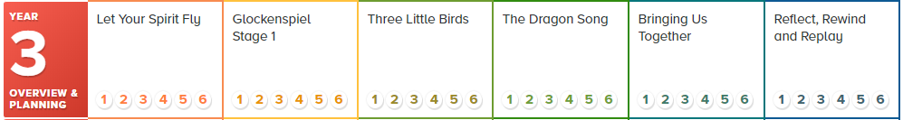

**Year 3 Djembe**In year 3 Mr Hellam and Mr Ellis like to teach all about African music. This mostly included African drumming with special instruments called Djembes. These tall, hollow drums make a big sound and are perfect for experimenting with rhythms. You can work as an ensemble and create layered rhythms and patterns. Can you remember any of these songs from year 3 Djembe lessons?

* Africa shhhhh the Djembe
* Tongo
* Unbuntu
* Jambo Bwana

The year 3 Charanga scheme progresses through the following songs. Find and listen at home.

