**Dynamics and markings**Remember dynamic markings are important in music. They give a piece character. You must say at the beginning of a song and throughout what volume to play.

**Towngate Academy subject knowledge organiser – Music – Year4**

**Composers of 20th Century 1901 - 2000**The 20th Century has seen many composers some specialising in orchestral music, some focusing on bands or pop.   
**Key Composers:**  
 - **The Beatles**Made up of John, Paul, George   
and Ringo, they are the most  
 influential band of all time. They began  
 in the 60s and were the ultimate rock and  
 roll group.   
<https://www.radio.net/s/beatlesradio>

* - **John Williams**  
  Williams is the most famous film composer. He has written music for films such as Star Wars, Jurassic Park and ET.

Listen to some of John Williams most famous pieces here. How many do you know? Are there some piece you know but didn’t know he composed?

<https://www.classicfm.com/composers/williams/>

**Appraisal**

When you are   
commenting on a   
piece of music   
remember the   
elements of music.   
As yourself a question  
about each of these  
elements to show you  
truly understand the  
music. Once you   
understand all these  
areas you can   
judge your own and   
others musical   
performances properly.

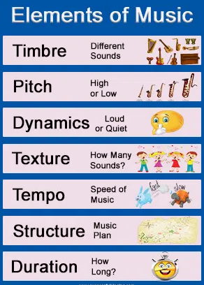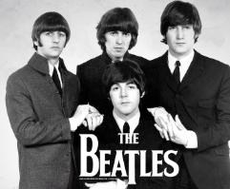

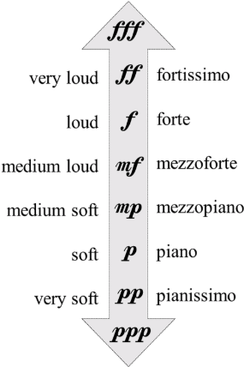

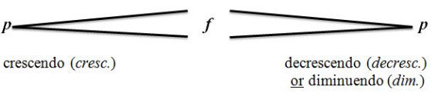

**Note values reminder**Remember each note has its own special note value. Combining these notes on a stave is how we make songs.

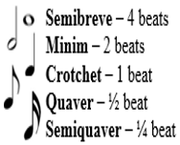

**Key Vocabulary**- Dynamics – How loud or quiet something is. – Crescendo – Gradually getting louder.  
- Forte – Loud - Diminuendo – Gradually getting quieter. - Piano – Quiet  
- Fortissimo - Very loud  
- Pianissimo – Very quiet