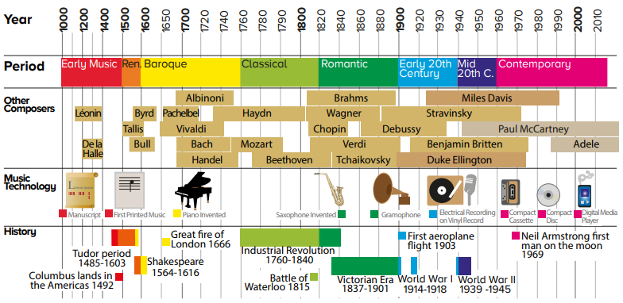

**Towngate Academy subject knowledge organiser – Music – Year5**

**Composers of Renaissance music 1400/1600**The Renaissance period began in 1400 and was named ‘Renaissance’ (Rebirth). This was a time for people to experiment and many people became interested in ancient culture such as Greece and Rome.   
**Key Composers:**  
 - **Claudio Monteverdi**  
Monteverdi was an Italian composer  
and a priest. He helped develop  
Opera and bridged late Renaissance   
into Baroque.   
<https://www.classicfm.com/composers/monteverdi/>

-**William Byrd**  
 Byrd produced sacred music for   
 Anglican and Roman Catholic   
 services. He was famous for using   
 many different forms of music.

You can hear some of Byrd’s most famous pieces here. Think about how this early music compares to other music you may have heard. https://www.classicfm.com/composers/byrd

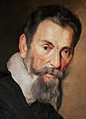

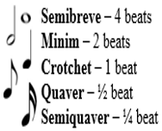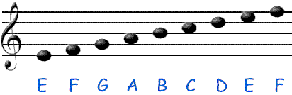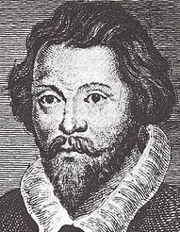

**Note values reminder**Remember each note has its own special note value. Combining these notes on a stave is how we make songs.

**Dynamic markings reminder**FF – Very loud - Fortissimo  
F – Loud - Forte  
P – Quiet - Piano  
PP – Very quiet – Pianissimo

**Introduction to stave notation**The Stave: Musical notes are written on the stave. Each stave has five lines and four spaces. Every line and space has a specific letter name.

**Key Vocabulary**- Diction – Pronouncing your words carefully and correctly. – Dynamics – Loud and quiet.  
- Ensemble – A music group. – Tempo – Fast and slow.  
- Stave notation – 5 Lines used to write music onto. - Time signature – How many beats in a bar.   
- Bar line – A line to separate a bar on a stave. – Texture – Layers of sound.  
- Rhythm – Long and short. – Pitch – High and low sounds.