**Note values reminder**Remember each note has its own special note value. Combining these notes on a stave is how we make songs.

**Towngate Academy subject knowledge organiser – Music – Year6**

**Year 6 Notation**The Stave: Musical notes are written on the stave. Each stave has five lines and four spaces. Every line and space has a specific letter name.

To remember the notes there are simple mnemonics/rhymes you can say. For example every note that sits on the line spells. Every Good Boy Deserves Football.

The letters of the notes in the four spaces spells the word FACE. Remember each note is ‘in’ the space, touching the lines but never going over.

**The musical alphabet:** In musicwe only use the first 7 letters of the alphabet, A-G. When we get to G, the next note will become A again.

**Composers of classical music (1750s/1850s)**The Classical period started in 1750 and ended around 1850. In this time there was a big importance on beauty, elegance and balance. In classical music melodies were short. Main kinds of music were symphonies, sonata and concerto.   
**Key Composers:**  
 - **Joseph Hayden**  
Hayden was an Austrian composer  
 specialising in chamber music. He   
was known as the father of the   
symphony and string quartet.

-**Wolfgang Mozart**  
 Mozart is widely known as the   
 most famous classical composer  
 of all time. His famous songs  
 include Symphony No.40,  
 Magic flute, Clarinet concerto.   
You can listen to some of Mozart’s most famous songs here. How many do you recognise?

<https://www.classicfm.com/composers/mozart/best-mozart-music-songs/>

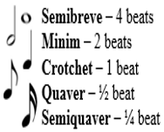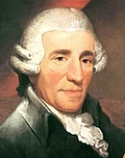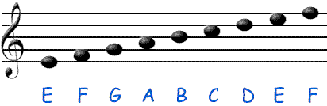

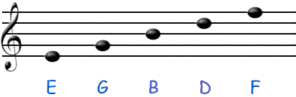

**Dimensions of music**Rhythm – Long and short  
Dynamics – Loud and quiet  
Tempo – Fast and slow  
Timbre – character of sound  
Texture – Layers of sound  
Structure – Ordering music.   
Pitch – High and low sounds

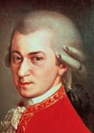

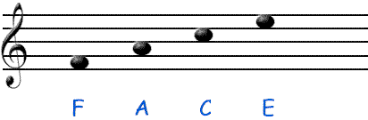

**Key Vocabulary**

* Musical phrase – Music built to form melodies and larger sections.
* Improvisation – Something created without any preparation.
* Internalise – To accept and take in the music/ideas.
* Culture – Characteristic of a certain group of people in music.
* Tradition – Music passed from person to person by example and imitation.

