Chronology Progression:
KS1 Time line.

By using this format, children can describe events based on the position and visually see where is lies in history. Numbers can be used to show this but ensure the children have the place value understanding before stressing this point. Year 2 can start to add one hundred year markers to the timeline when ready.

KS2 Timeline:
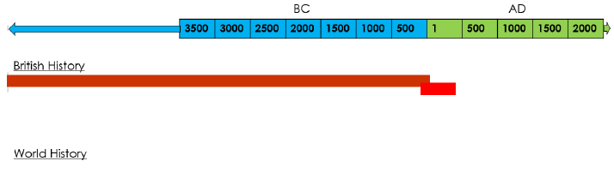
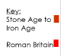

This allows them to understand how British and World History occurred concurrently and, very often, were interlinked.

Combining local, national and world history:
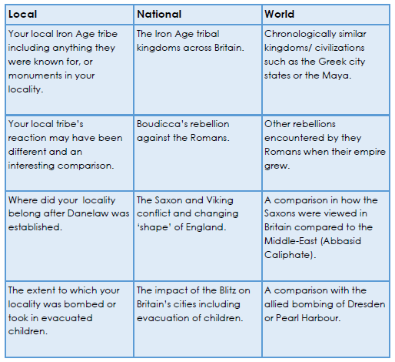

Chronological Vocabulary
KS1 | KS2
Yesterday  A week ago  Last month  Then  Next  After  Before  Past  Present  Living memory and (Beyond living memory)  Recent memory  Further in the past  Day  Week  Month  Year  Decade  Century* | Period of history  Duration*  Scale *  Interval*  AD/CE  BC/BCE  Century  Millenia  Millennium  Concurrence  Meanwhile
*During year 2, you may choose to introduce the chil-dren to a century if their understanding of place value is sufficient that they can identify the link a century with the concept of 100. | * these terms will have been encountered in KS1 but should be more actively taught in relation to the periods of history studied.
Key elements of Chronology:
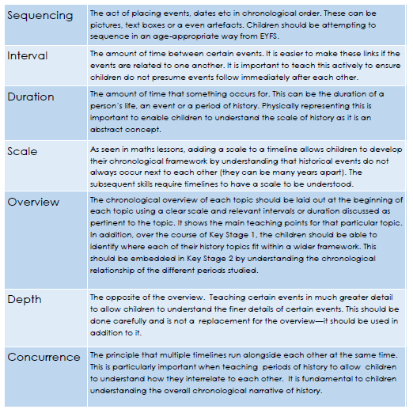
Progression through school:
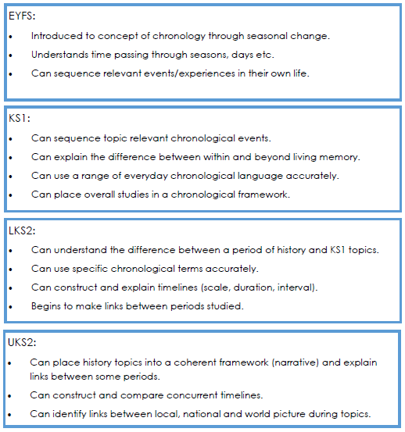
Resources:

Timemaps is amazing to help children understand both chronology as a concept but also how the human landscape of regions of Earth changed over time. It also contains scaled timelines underneath the main map.

Chronozoom is a great way to help children understand the concept of duration in a clear and visual way. It is simple coloured rectangles that adjust in size with a clear scale.

Meanwhile Elsewhere is a great blog to understand concurrence; initially intended for Ks3 and above, it does contain KS2 resources

