|  |  |  |  |  |
| --- | --- | --- | --- | --- |
|  | **TOWNGATE PRIMARY ACADEMY**  **EOCT_logo** | | | C:\Users\cthomas\Downloads\FINAL AGREED LOGO for MAT.jpg |
| Chief Executive Officer:  Mrs Sue Vickerman  Headteacher:  Mrs Annabel Berry  cid:941ce1ce-629a-4490-899b-0f67f774eb4a | |  | Whitley Spring Road  Ossett  WF5 0QA  Tel: 01924 302865  Website: [www.towngateprimary.co.uk](http://www.towngateprimary.co.uk)  Email: TGA-Enquiries@ipmat.co.uk  headteacher@ipmat.co.uk.co.uk | |

**Tuesday 7th September 2021**

Dear Parents and Carers

I hope you and your families have had a wonderful Summer, staying safe and well and having fun. We are very excited to welcome you and your children back into school from tomorrow. Things are slowly but surely returning to “normal”, but as they do, we would like to draw your attention to a few points detailed below:

**School Day Timings**

The start and end times for the school day have now returned to our original times of doors opening at 08:50 hours and closing at 09:00 hours, if you are for any reason running late, please bring your child to the office for signing in. All classes will finish at 15:15 hours and we would appreciate prompt collection of your child. If you are running late for any reason, please could you telephone the office to inform us of an estimated time of arrival.

**Please note**: To avoid congestion on the playground, children will be invited to come directly into their classroom / cloakroom where a member of staff will be situated to greet the children.

**Face Masks**

Whilst it is no longer a legal requirement to wear face masks in a public place, we encourage everyone to wear them whilst on site in congested areas.

**School Lunch**

School lunches will now be served in the school dining hall as before, with a full menu available. Please ensure that you have logged onto your School Grid / Live Kitchen account and made your child’s choices for the week ahead. Please contact the school office, should you require any help with this.

**Meet the Teacher Meetings**

Meet the Teacher meetings will take place virtually via Teams in the next week, dates to be advised shortly. These sessions will be recorded for any parents/carers who are unable to join us.

**PE days**

|  |  |
| --- | --- |
| **PE Kits** | |
| Reception | Wednesday |
| Year 1 | Tuesday |
| Year 2 | Tuesday |
| Year 3 | Thursday |
| Year 4a | Monday |
| Year 4b | Monday |
| Year 5 | Thursday |
| Year 5/6 | Wednesday |
| Year 6 | Wednesday |

Please see the attached information for when children will be participating in PE during the week. We would ask that children arrive in school on their designated days as set out below wearing their PE kits – this will alleviate the need for children to get changed in school. Please ensure pupils wear their correct PE kits and suitable footwear on this day. PE kits should comprise of black jumper, joggers or shorts and plain white crew neck t-shirt or navy jumper, joggers or shorts and plain white crew neck t-shirt.

**Further Information Updates**

You will be sent a form in due course for your children that details the individual information for each child in your family. Along with this there will be a copy of the home school agreement that must be acknowledged as soon as possible.

Please refer to our website for our updated Risk Assessment and a copy of our Outbreak Management Plan for the new school year. Can we please ask that parents/carers continue to refrain from approaching teachers at the classroom at drop off and pick up times or from coming into the office to speak to staff and please contact us through the enquiries email, [TGA-enquiries@ipmat.co.uk](mailto:TGA-enquiries@ipmat.co.uk) or by telephoning the office.

On behalf of all the staff and Governors at Towngate, we look forward to working together this year.

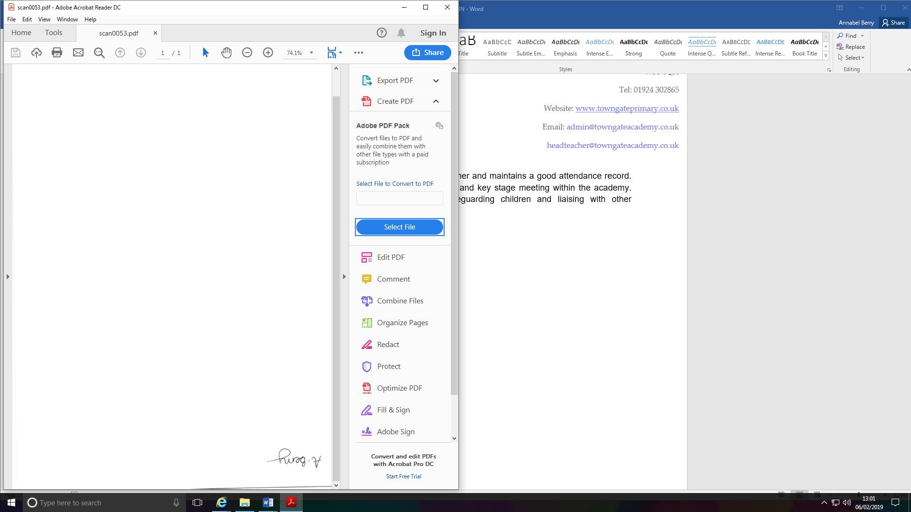

**Mrs A Berry**

**Headteacher**