Towngate Primary Academy
Music
Controlling sounds through singing and playing (Play and Perform) (As per COVID guidelines singing should not take place inside and only in open aired outdoor areas where children are stood 2 metres apart.)
EYFS | Year One | Year Two | Year Three | Year Four | Year Five | Year Six
- Sing to self and make up simple songs.  - Imitate sounds begin to do it spontaneously when adults aren’t there.  - Begin to choose sounds and make patterns.  - Express self through sound.  - Sing nursery rhymes together in a group.  - Children should know 8 nursery rhymes before the end of EYFS as this aids spelling and phonics in KS1. | - Use voices in different ways such as speaking, singing and chanting.  - To create and choose sounds To perform simple rhythmical patterns, beginning to show an awareness of pulse.  - To think about others when performing. | - Use voices expressively and creatively.  - To sing with the sense of shape of the melody.  - To create and choose sounds for a specific effect. To perform rhythmical patterns and accompaniments, keeping a steady pulse.  - To think about others while performing. | - To sing in unison, becoming aware of pitch.  - To perform simple rhythmic and musical parts, beginning to vary the pitch with a small range of notes.  - To think about others while performing. | - To sing in unison maintaining the correct pitch and using increasing expression.  - To play and perform parts with an increasing number of notes, beginning to show musical expression by changing dynamics.  - To think about others while performing. | - To sing in unison with clear diction, controlled pitch and sense of phrase.  - To play and perform parts in a range of solo and ensemble contexts with increasing accuracy and expression.  - To maintain my own part and be aware how the different parts fit together | - To sing in solo, unison and in parts with clear diction, controlled pitch and with sense of phrase.  - To play and perform with accuracy, fluency, control and expression.  - To think about the audience when performing and how to create a specific effect.
Creating and developing musical ideas (Create and Compose)
EYFS | Year One | Year Two | Year Three | Year Four | Year Five | Year Six
- To begin to experiment with sounds.  - Begin sorting different sounds by how loud or quiet they are. | - To know about and experiment with sounds.  - To recognise and explore how sounds can be organised,  - To identify and organise sounds using simple criteria e.g. loud, soft, high low.  - Introduce the use of graphic scores to notate music. Begin to explore and invent own symbols for recording music. See example: | - Repeat short rhythmic and melodic patterns.  - To begin to explore and choose and order sounds using the inter-related dimensions of music*.  - Develop the use of graphic scores as a way of recording composition. Begin to provide structure which resembles stave notation. | - To create simple rhythmical patterns that use a small range of notes.  - To begin to join simple layers of sound, e.g. a background rhythm and a solo melody.  - Sequences and rhythms can be written using informal symbols in a graphic score.  - Children begin to plot notes onto the stave thinking carefully about note value.  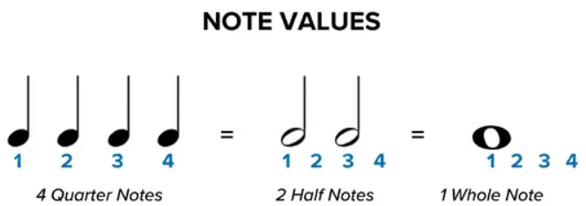 | - To create rhythmical and simple melodic patterns using an increased number of notes.  - To join layers of sound, thinking about musical dynamics of each layer and understanding the effect. | - To create increasingly complicated rhythmic and melodic phrases within given structures.  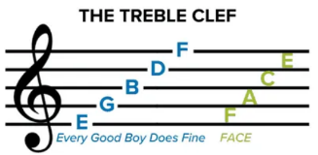  - Begin to read and compose using stave notation. | - To create and improvise melodic and rhythmic phrases as part of a group performance and compose by developing ideas within a range of given musical structures.  - Be able to read and record an octave on a stave from C to C.  (Standard chime bar)
 | Responding and reviewing (Appraising skills)
EYFS | Year One | Year Two | Year Three | Year Four | Year Five | Year Six
- Begin to say if you like a song and begin to explain why.  - Begin to explain what the music makes you do. | - To talk about how music makes you feel or want to move. E.g. it makes me want to jump/sleep/shout etc.  - To think about and make simple suggestions about what could make their own work better. E.g: play faster or louder. | - To respond to different moods in music and explain thinking about changes in sound.  - To identify what improvements could be made to own work and make these changes, including altering use of voice, playing of and choice of instruments. | - To explore and comment on the ways sounds can be used expressively.  - To comment on the effectiveness of own work, identifying and making improvements. | - To recognise and explore the ways sounds can be combined and used expressively and comment on this effect.  - To comment on the effectiveness of own work, identifying and making improvements based on its intended outcome. | - To describe, compare and evaluate different types of music beginning to use musical words.  - To comment on the success of own and others work, suggesting improvements based on intended outcomes. | - To describe, compare and evaluate different types of music using a range of musical vocabulary including the inter-related dimensions of music*.  - To evaluate the success of own and others work, suggesting specific improvements based on intended outcomes and comment on how this could be achieved.
 | Listening and applying knowledge and understanding
EYFS | Year One | Year Two | Year Three | Year Four | Year Five | Year Six
- Makes up own rhythms.  - Begin to experiment with different sounds and patterns.  - Create a movement in response to the music. | - To begin to identify simple repeated patterns and follow basic musical instructions.  - To begin to understand that musical elements can be used to create different moods and effects.  - To begin to represent sounds with simple sounds including shapes and marks.  - To listen to short, simple pieces of music and talk about when and why they may hear it. E.g: a lullaby or Wedding march.  - To listen and appraise different genres of music following the Charanga scheme of work.  - Listen to a variety of different composers.  - Listen to a range of music form across different musical traditions (Focus term)  See suggested songs/composers from year groups specific document provided by subject leader. | - To identify and recognise repeated patterns and follow a wider range of musical instructions.  - To understand how musical elements create different moods and effects.  - To confidently represent sounds with a range of symbols, shapes or marks.  - To listen to pieces of music and discuss where and when they may be heard explaining why using simple musical vocabulary. E.g. It’s quiet and smooth so it would be good for a lullaby.  - To listen and appraise different genres of music following the Charanga scheme of work.  - Listen to a variety of different composers.  - Listen to a range of music form across different musical traditions (Focus term)  See suggested songs/composers from year groups specific document provided by subject leader. | - To listen with attention and begin to recall sounds.  - To begin to understand how different musical elements are combined and used to create an effect.  - To begin to recognise simple notations to represent music, including pitch and volume.  - To listen to and begin to respond to music drawn from different traditions and great composers and musicians.  - To listen and appraise different genres of music following the Charanga scheme of work  - Listen to a range of music form across different musical traditions (Focus term)  - Listen to composers of Romantic music between 1830s and 1900s.  - Beethoven  - Tchaikovsky  - Brahms  See suggested songs/composers from year groups specific document provided by subject leader. | - To listen to and recall patterns of sounds with increasing accuracy.  - To understand how different musical elements are combined and used expressively.  - To understand and begin to use established and invented musical notations to represent music.  - To listen to, understand a wide range of high quality live and recorded music drawn from different traditions, great composers and musicians.  - To listen and appraise different genres of music following the Charanga scheme of work.  - Listen to composers of 20th century music from 1901 to 2000.  - Listen to a range of music form across different musical traditions (Focus term)  See suggested songs/composers from year groups specific document provided by subject leader. | - To listen to and recall a range of sounds and patterns of sounds confidently.  - To begin to identify the relationship between sounds and how music can reflect different meanings.  - To recognise and use a range of musical notations including staff notation.  - To listen to a range of high quality, live and recorded music from different traditions, composers and musicians and begin to discuss their differences and how music may have changed over time.  - To listen and appraise different genres of music following the Charanga scheme of work.  - Listen to a range of music form across different musical traditions (Focus term)  - Listen to composers of Rennaisance music 1400s and 1600s.  - Monteverdi  - Josquin Des Prez  See suggested songs/composers from year groups specific document provided by subject leader. | - To listen to, internalise and recall sounds and patterns of sounds with accuracy and confidence.  - To identify and explore the relationship between sounds and how music can reflect different meanings.  - To use and apply a range of musical notations including staff notation, to plan, revise and refine notation, to plan, revise and refine musical material.  - To develop an understanding of the history of music from different, cultures, traditions, composers and musicians evaluating how venue, occasion and purpose effects the way that music is created and performed.  - To listen and appraise different genres of music following the Charanga scheme of work as a result be able to confidently recognise and describe key features of each genre.  - Listen to a range of music form across different musical traditions (Focus term)  - Listen to composers from the classical period 1750 to 1825.  - Mozart  - Bach  - Clara Schumann  See suggested songs/composers from year groups specific document provided by subject leader.
Ensure children are listening to a range of music from different cultures, places and time periods, linking to curriculum topics where appropriate.

 |  |  |  |  |  | - E.G. Traditional war songs.
 | Vocabulary
EYFS | Year One | Year Two | Year Three | Year Four | Year Five | Year Six
Tier 1 - Blue  Tier 2 - Green  Tier 3 - Red  Loud  Quiet  Rhythm – a structured pattern of beats  Sound  Song  Instrument  Music  Movement  Dance  Patterns  Frog  Tadpole  Beat (Linking to heartbeat) | Tier 1 - Blue  Tier 2 - Green  Tier 3 - Red  Pulse – constant beat  Rhythm – a structured pattern of beats  Beat – a unit of rhythm  Perform  Ensemble  Pitch – High and Low  Volume  Tempo – Fast and Slow  Unison- playing together | Tier 1 - Blue  Tier 2 - Green  Tier 3 - Red  All previous:  Express  Melody  Rhythmical pattern  Melodic pattern  Steady pulse  Tempo  Volume  Pulse  Butterfly  Caterpillar | Tier 1 - Blue  Tier 2 - Green  Tier 3 - Red  All Previous:  Notes  Dynamics  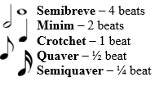  Forte- loud  Piano – quiet  Solo  Background rhythm  Ostinato – repeated rhythm  Musical effect – happy – major sad or spooky minor.  Stave | Tier 1 - Blue  Tier 2 - Green  Tier 3 - Red  All Previous:  Fortissimo – Very loud  Pianissimo – Very quiet  Crescendo – Gradually getting louder  Diminuendo – Gradually getting quieter  Bar  Duet | Tier 1 - Blue  Tier 2 - Green  Tier 3 - Red  All previous:  Diction – style of pronunciation  Ensemble  Stave notation  Time signature 4/4  Bar line  Music in 3 parts  Mezzo forte – Moderately loud  Mezzo Piano – Moderately quiet | Previous:  Musical phrase  Improvisation  Internalise  Culture  Tradition  Music in 4 parts  Pizzicato  Tremolo  Melodic shapes  Harmonics sequences  Rhythmic pattern
*Inter-related dimensions of music to be used throughout each year group.

- PULSE: the steady beat of a piece of a piece of music
- PITCH: the melody and the way the notes change from low to high and vice versa.
- RHYTHM: or duration is the pattern of long and short sounds in a piece of music
- DYNAMICS: Loud and soft
- TEMPO: Fast and slow
- TIMBRE: The type of sound – whisper/hum/sing/talk (examples with the voice) or twinkly/hard/soft (examples with instruments)
- TEXTURE: Layers of sound (number of instruments or voices playing together)
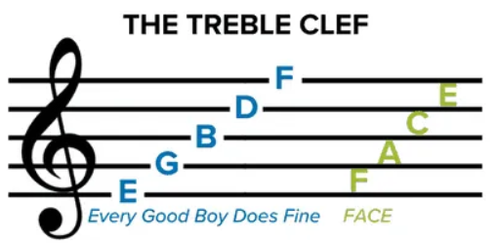
- STRUCTURE: The way the music is laid out –e.g. Verse, chorus, verse.
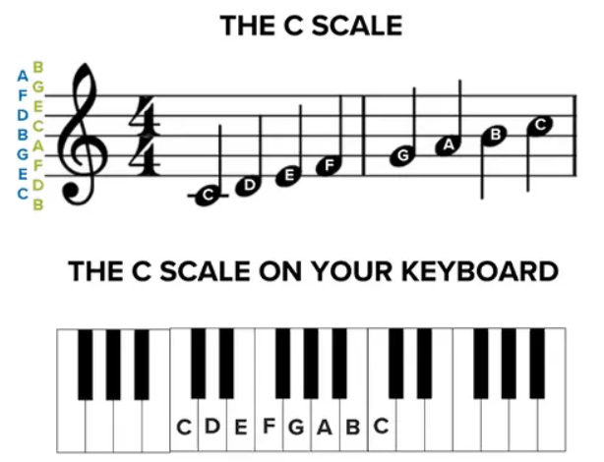

Find detailed music subject knowledge progression at:
www.ashgroveprimaryacademy.co.uk
Find music genre progression at:
www.charanga.com

