Towngate Primary Academy
Writing, Grammar, Punctuation and Spelling Curriculum Policy

Date | Review Date | Coordinator | Nominated Governor
September 2021 | September 2024 | Miss Laura Eke | Mrs Joanne Crook

As part of our Writing, Grammar, Punctuation and Spelling curriculum at Towngate Primary Academy, we strive to provide all children within the Academy with the knowledge, skills and vocabulary to become aspiring authors of the future. We place reading at the center of our writing curriculum, to immerse and engage our pupils in literature-rich environment where they become inspired by the authors of the past and present to develop their own writing style across a range of genres.

Introduction to English
Curriculum Intent:
Writing is an integral part of our curriculum. At Towngate Primary Academy, our writing, grammar, punctuation and spelling curriculum is based upon the National Curriculum programmes of study and Early Years Framework. Across the academy, we use Read, Write Inc. to teach our spellings and Collins to ensure we have a comprehensive coverage in grammar across school.
Teachers plan using the writing, grammar and punctuation progression grid to derive long term plans in the subject; careful consideration is given to the sequence of the curriculum through medium term planning in order to ensure that lessons build towards a piece of writing, showcasing pupils’ acquired knowledge, skills and understanding.
Curriculum Implementation:

Within the classroom, teachers use a consistent approach in the delivery of their lessons using the Rosenshine's approach to cognitive load theory. The teaching sequence within writing, grammar and spelling lessons are built upon a book-led approach where pupils are exposed to a high-quality text, complete grammar work and lead towards unpicking a modelled text which leads to independent writing. Examples of the texts use to stimulate writing include Classic Fiction such as The Hobbit, The Wind in the Willows and The Lion, The Witch and The Wardrobe, alongside an array non-fiction texts, picture books, poetry books and novels. Pupils are taught age-appropriate grammatical vocabulary as part of a daily review and adults in the classroom model and question effectively in order to ensure pupils acquire the necessary knowledge, skills and vocabulary to achieve as they work towards independent writing.

Curriculum Impact:
To measure the impact of our curriculum, we regularly use pupils' books to capture an insight into the effectiveness of our curriculum. Pupils' work demonstrate the effectiveness of the curriculum where age-appropriate grammar knowledge and writing skills are developed over a sequence of lessons which lead towards pupils writing independent pieces. In addition, we regularly collate pupil voice to ensure our curriculum meets the needs of the children at Towngate Primary. As a result, children are exposed to a varied menu of genres and write for a range of audiences and purposes, with high quality models derived from a range of texts used to inspire their own writing. Through pupil interview, children can articulate the resources they have access to in order to improve and establish themselves as authors in their own right. Pupils' gain cultural capital through the carefully crafted choice of texts used as a basis to the book-led curriculum - the exposure to a range of genres, authors and novels allows for pupils to read often and widely and provide a stimulus and high quality model to inspire pupils to have future aspirations as authors, journalists, editors and beyond. Examples of high quality work derived as a result of the writing, grammar, punctuation and spelling are used on our corridors as a learning showcase. This ensures pupils are proud of their work and strive to work towards achieving the same high standards. Impact in the curriculum can also be seen through the Statutory Assessment Tests (SATs for Year 6 pupils) and through termly summative assessments across school which enables pupils' progress and attainment in the subject matter to be evaluated.

Language Acquisition & Vocabulary Development
We endeavour to ensure we provide our pupils with a 'language rich' environment within our school to promote our pupils to foster a love for reading in order to develop a flair and enjoyment for writing; we do through our local links with Ossett Library, the development of our own in-school library and through opportunities to read novels daily with our children to ensure they are exposed to a range of vocabulary. We ensure we have a wide range of texts displayed around our academy, to correlate with our wider curriculum and alongside our learning showcase displays to inspire and promote a love for reading with our children. Within our classrooms, we explore ambitious vocabulary across the wider curriculum to ensure we acquire an understanding of tricky and unfamiliar language across the wider curriculum through the use of our teaching model, flashcards and vocabulary rich environment.

Aims
The overarching aim for English in the national curriculum is to promote high standards of language and literacy by equipping pupils with a strong command of the spoken and written word, and to develop their love of literature through widespread reading for enjoyment. The national curriculum for English aims to ensure that all pupils:
- read easily, fluently and with good understanding
- develop the habit of reading widely and often, for both pleasure and information
- acquire a wide vocabulary, an understanding of grammar and knowledge of linguistic conventions for reading, writing and spoken language
- appreciate our rich and varied literary heritage
- write clearly, accurately and coherently, adapting their language and style in and for a range of contexts, purposes and audiences
- use discussion in order to learn; they should be able to elaborate and explain clearly their understanding and ideas
- are competent in the arts of speaking and listening, making formal presentations, demonstrating to others and participating in debate.

Spoken Language
As stated in the National Curriculum, English reflects the importance of the spoken language in pupils’ development across the whole curriculum - socially, cognitively and linguistically. Spoken language underpins the progress of reading and writing. At Towngate Primary Academy, spoken language is taught and developed through a wide range of opportunities such as performance poetry, discussions and debates within the writing curriculum and the wider curriculum. We use opportunities for whole school drama productions, role play within the classroom and outdoors and develop opportunities for pupils to ‘read aloud’ in order to establish their confidence and ability to speak and articulate in correct Standard English.

Book Led Curriculum
Early Years
Within the Early Years, we develop indoor and outdoor opportunities for pupils to explore writing through the provision in place. Teachers plan for pupils to mark make in the Early Years, using a range of strategies in order to develop fine and gross motor skills. Pupils are then challenged in areas to write for varied purposes, including writing captions, short sentences, shopping lists and instructions. Pupils are taught phonics (Read, Write, Inc.) from Nursery which include the processes of ‘holding a sentence’ and practicing letter and word formation. In both Nursery and Reception, writing is based upon familiar texts including traditional tales which provide a stimulus and excitement for writing for a range of purposes. The environment is supported through lots of vocabulary displayed and adult modelling to promote pupils’ language acquisition from the earliest years.

Key Stage 1
In Key Stage 1, each of our English units of work is based around a specially chosen text; by placing reading at the center of our English curriculum, pupils are frequently exposed to high quality texts and as a result, develop a cohesive understanding and enjoyment for reading as a pre-requisite for writing. In each of our classroom environments, working walls are used to capture

Key Stage 2
Throughout our Key Stage 2 phase, careful and considered planning implements the core skills required of a child in upper school. Through our book-led curriculum, children are provided with an enriched and fulfilling English curriculum, which enables all pupils to achieve and access high quality texts. Across the academic year, children will read and enjoy six age-appropriate texts, ranging from a variety of different genres. Our book-led curriculum incorporates all aspects of speaking and listening, comprehension, writing and composition through a sequence of well-structured teaching opportunities. Pupils build their knowledge and understanding through a unit of work and incorporate newly-acquired techniques and skills into their independent practice. Throughout the week, pupils build up to an outcome of independent written work, centered around their chosen text – incorporating the skills and features developed across the unit of work.

Additional opportunities
The school newspaper offers children opportunities to be involved in reading, writing, publishing and selling their newspaper giving the children a sense of ‘audience’ and ‘purpose’.
Throughout Early Years, Key Stage 1 and Key Stage 2, our writing follows the Book-Led curriculum in place across the academy. Writing opportunities are sourced and developed based on the class text within each year group. Our curriculum allows KS2 children to have the opportunity to explore high-quality texts in depth, enhancing reading comprehension and providing meaningful contexts and purposes for writing. The teaching of this programme is flexible and class teachers are then, in turn, able to apply their own creativity to cover the objectives across Key Stage 2. Teachers clearly model writing skills and document the learning journey through consistent working walls; guided writing sessions are used to target specific needs of both groups and individuals. Children have opportunities to write at length, in extended, independent writing sessions at the end of a unit of work – applying their taught skills to an unsupported piece of writing.

Gifted and Talented Writers
To further challenge writers who demonstrate a particular flair and talent for writing, pupils are provided with additional elements of choice in their writing. At times, able writers may be expected to write from alternate perspectives of a given character or be provided with limited support in comparison to peers with language choice and content. Gifted and Talented pupils are given more autonomy than their peers to explore and experiment with language choices, structure and content.

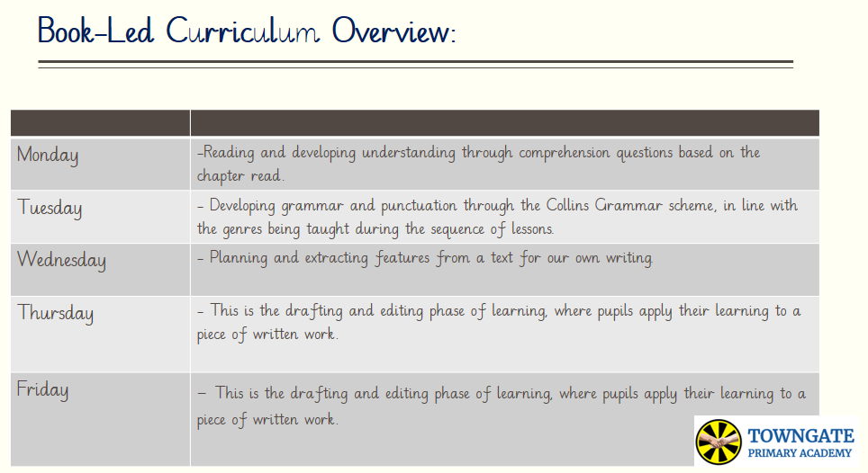
An example of a weekly week of English lessons is:

Emergent writing
Throughout the Foundation Stage and into Year One; there are opportunities for mark making in all areas of provision. We recognise the need to take into account the different experiences of pre-school children and consider each child understands of the purpose of written symbols; their knowledge of letter shapes; their hand-eye co-ordination and fine motor control; and their ability to hold a pencil correctly.

Shared Writing
Through investigating a wide variety of texts, as well as teacher modelling, children are taught to write in a range of styles, for different purposes, organising their work appropriately to suit the intended reader. The teacher demonstrates the process of drafting and reworking writing in order to improve it. Children will be taught to ask themselves questions as they write, and begin to think of themselves as writers, Shared writing also gives children the opportunity to reinforce grammatical corrections, punctuation and spelling techniques. Classrooms promote a creative environment for writing, providing support and writing frames, which encourage independence, and reinforce a culture of quality rather than quantity. Opportunities for writing at age related expectations are identified across the curriculum to consolidate and extend writing taught in the English lesson.

Independent Writing
Independent writing provides an opportunity for children to apply their knowledge in a focused activity. Support may be provided within a small, focused writing group where resources are provided to stimulate and widen language choices. Pupils are actively encouraged to use the working walls in classrooms to guide and scaffold their writing.

Extended writing
During each half term, children have an opportunity to produce two pieces of independent writing that is assessed using the Multi-Academy Trust writing assessment grids. This provides evidence for individual English targets for the children and helps the class teacher in lesson planning, teaching and assessing.

Grammar
As stipulated in the National Curriculum, the grammar of our first language is learnt naturally and implicitly through interactions with other speakers and from reading. Explicit knowledge of grammar is, however, very important, as it gives us more conscious control and choice in our language. Building this knowledge is best achieved through a focus on grammar within the teaching of reading, writing and speaking. Once pupils are familiar with a grammatical concept [for example ‘modal verb’], they should be encouraged to apply and explore this concept in the grammar of their own speech and writing and to note where it is used by others. Grammar lessons are taught weekly and are focused around the grammatical features found in the given genre the children are working towards writing. Within the academy, we use Collins grammar books to support pupils’ practice and acquisition of grammatical skills, before progressing to a ‘reasoning’-style application challenge. Once pupils are au-fair with the technique, they are then encouraged to use this within their shared and independent writing. Pupils are reminded – through the use of flashcards – of the grammatical terms and definitions they are taught.

Punctuation
The teaching of punctuation is taught in relation to age related expectations in the National Curriculum and alongside grammar. Children are taught that the use of punctuation will aid the readers’ comprehension of their work. Each class will display the Punctuation Pyramid in the classroom to support learning. Opportunities across the curriculum will allow children to consolidate punctuation concepts.

Spelling
At Towngate Primary Academy, spelling is taught regularly in focused sessions within each class. Class teachers use Read Write Inc Spelling scheme from Years 2 to 6 to support with the teaching for spelling. Spellings are taught for short sessions daily. Spellings are sent home in each year group as part of the children’s homework; the pupils are then tested on these words in their weekly spelling tests.
Please find attached our long term spelling overview, linked to the National Curriculum English Appendix 1.

Handwriting
Handwriting is taught across the Academy regularly. High expectations, for the presentation of children’s work, are promoted. Handwriting is taught alongside spelling patterns in order to assist spelling. Children in Early Years are encouraged to print their letters in order to secure their fine motor skills and letter formation before beginning Key Stage One. From Year 1 onwards, pupils are encouraged to join their letters for fluency to develop a fluent and legible handwriting style. Children are reminded about correct posture and how to hold a pen or pencil. In order to promote high levels of handwriting legibility, pupils can earn ‘presentation points’ to raise the profile and expectation of presentation.

Role and responsibilities of English coordinator

The Subject Leader is responsible for improving the standards of teaching and learning in English through:

- Monitoring and evaluating pupil progress.
- Provision of English (including Intervention and Support programmes – alongside SEND)
- The quality of the Learning Environment;
- Taking the lead in policy development
- Auditing and supporting colleagues in their CPD
- Purchasing and organising resources
- Keeping up to date with recent English developments
- Maintaining subject file.
- Organisation of events to promote English within the Academy.

Conclusion

This policy also needs to be in line with other school polices and therefore should be read in conjunction with the following school policies:
•
- Teaching and Learning Policy
- Assessment policy
- Guidance and Feedback policy
- Equal Opportunities Policy
- Health and Safety Policy

Review date: September 2024

Person responsible: Writing, Grammar, Punctuation and Spelling Leader – Mrs L Poole

