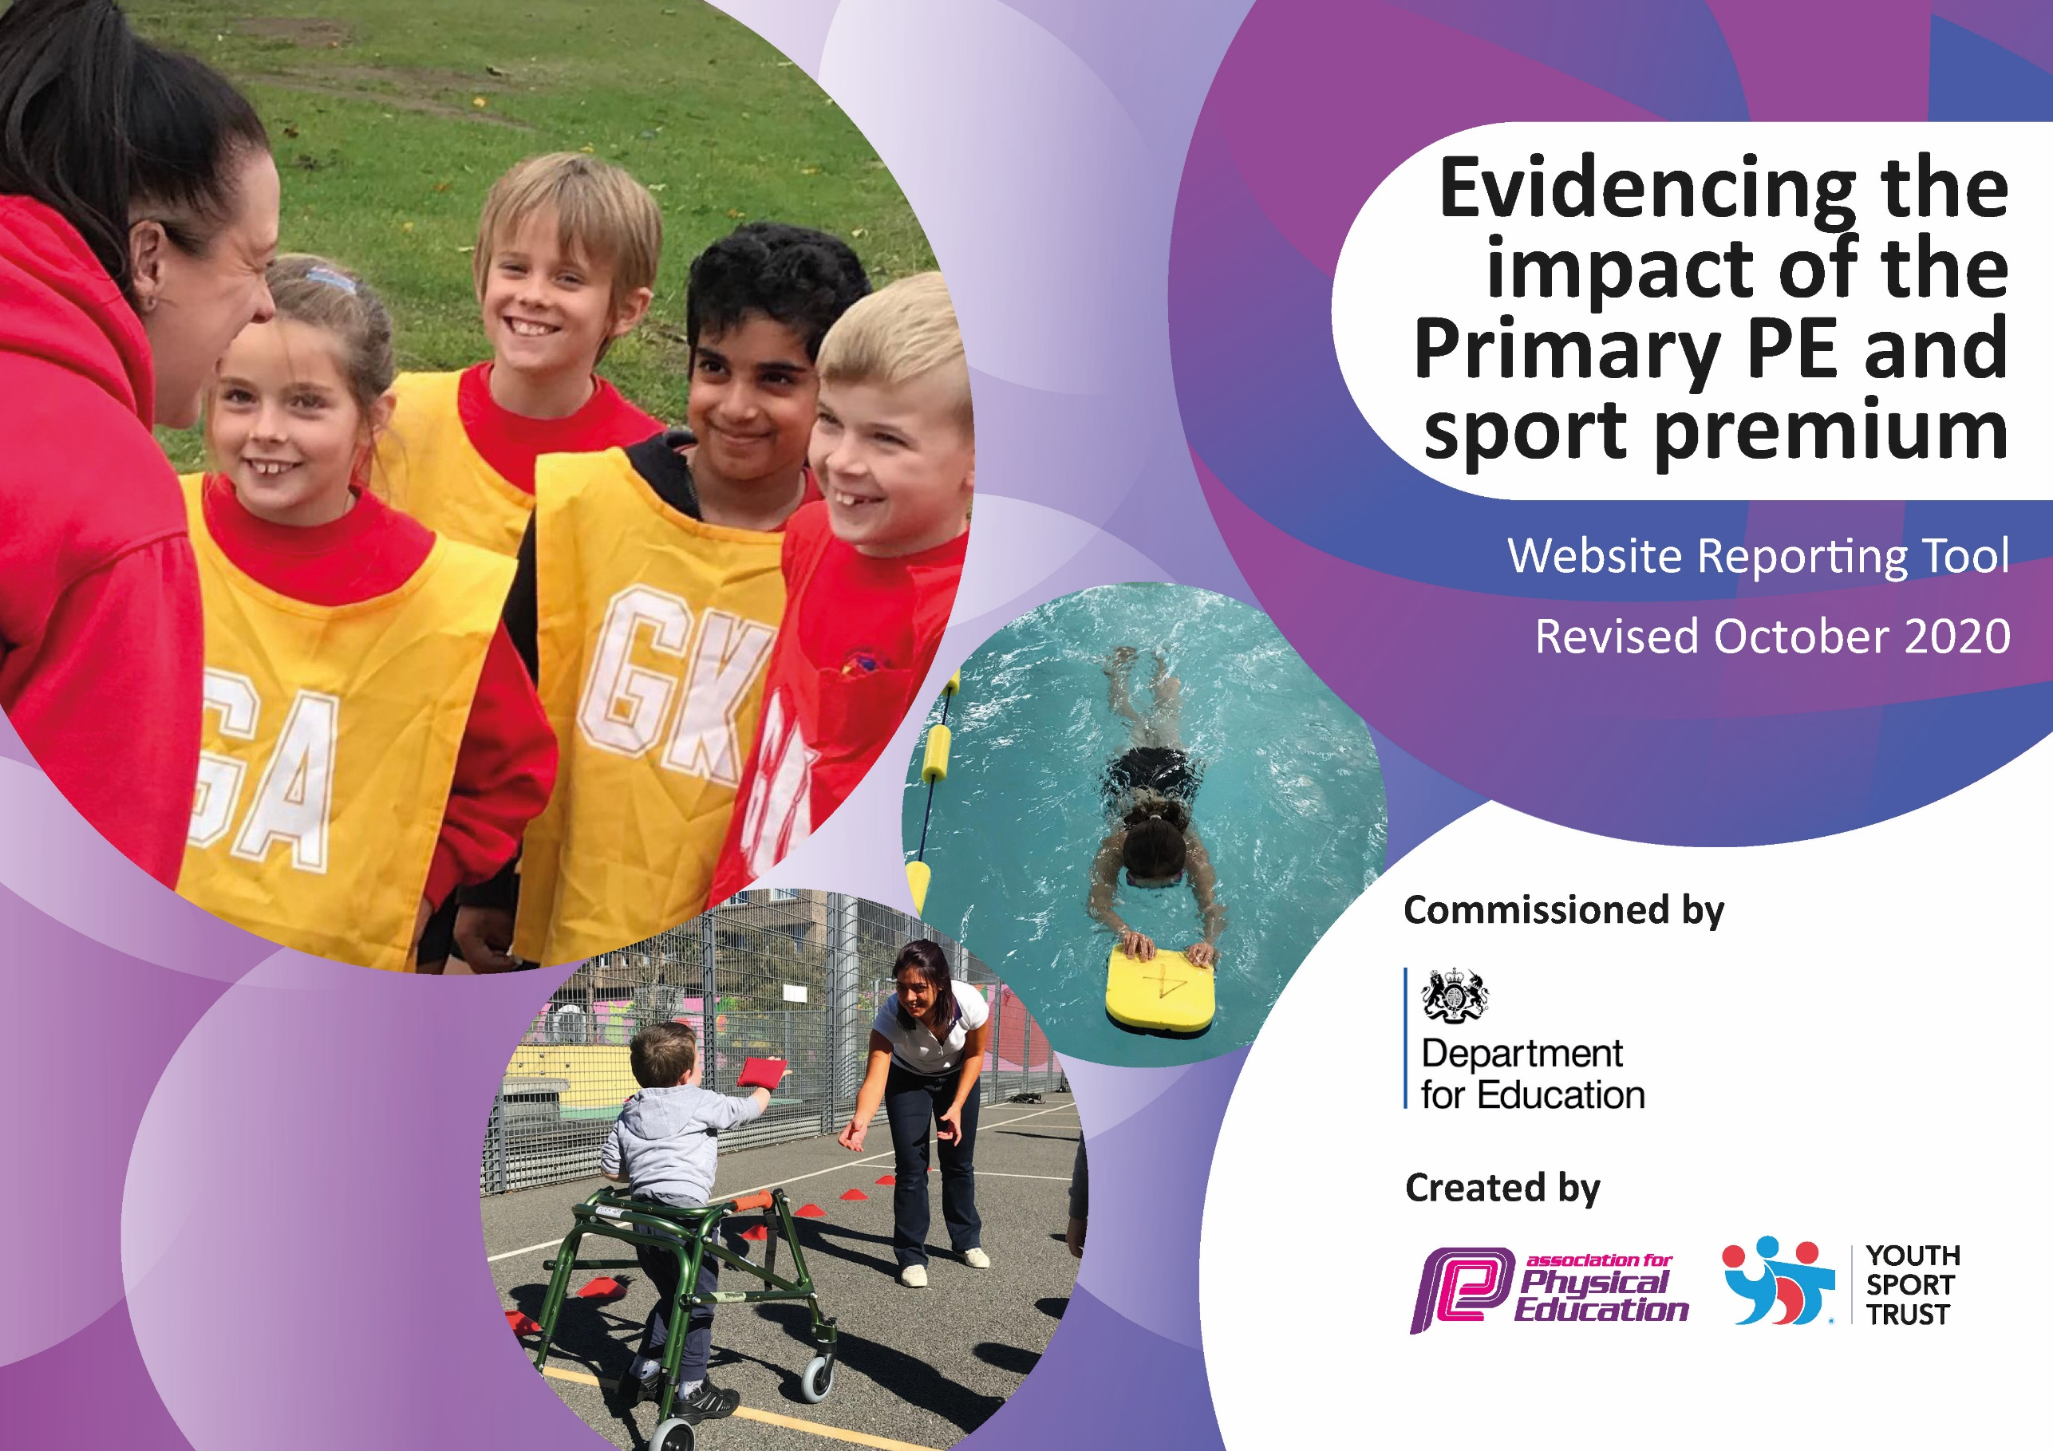
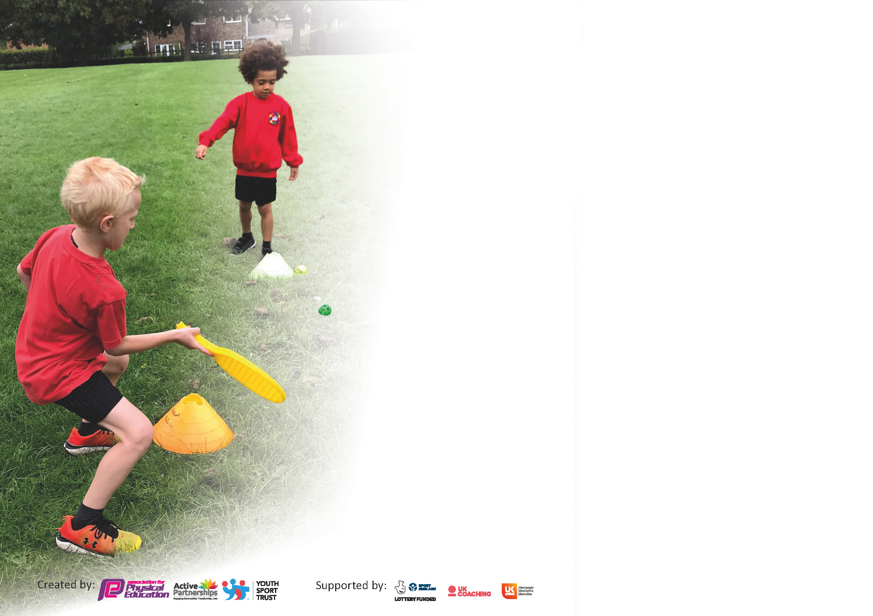

It is important that your grant is used effectively and based on school need. The Education Inspection Framework (Ofsted 2019 p64) makes clear there will be a focus on ‘whether leaders and those responsible for governors all understand their respective roles and perform these in a way that enhances the effectiveness of the school’.

Under the Quality of Education criteria (p41) inspectors consider the extent to which schools can articulate their curriculum (INTENT), construct their curriculum (IMPLEMENTATION) and demonstrate the outcomes which result (IMPACT).

To assist schools with common transferable language this template has been developed to utilise the same three headings which should make your plans easily transferable between working documents.

Schools must use the funding to make additional and sustainable improvements to the quality of Physical Education, School Sport and Physical Activity (PESSPA) they offer. This means that you should use
the Primary PE and sport premium to:

- Develop or add to the PESSPA activities that your school already offer
- Build capacity and capability within the school to ensure that improvements made now will benefit pupils joining the school in future years

Please visit gov.uk for the revised DfE guidance including the 5 key indicators across which schools should demonstrate an improvement. This document will help you to review your
provision and to report your spend. DfE encourages schools to use this template as an effective way of meeting the reporting requirements of the Primary PE and sport premium.

We recommend you start by reflecting on the impact of current provision and reviewing the previous spend.

Schools are required to publish details of how they spend this funding as well as on the impact it has on pupils’ PE and sport participation and attainment by the end of the summer term or by 31st July 2021 at the latest.

** In the case of any under-spend from 2019/20 which has been carried over this must be used and published by 31st March 2021.

We recommend regularly updating the table and publishing it on your website throughout the year. This evidences your ongoing self-evaluation of how you are using the funding to secure maximum, sustainable impact. Final copy must
be posted on your website by the end of the academic year and no later than the 31st July 2021. To see an example of how to complete the table please click HERE.
Created by: Supported by:

Please note: Although there has been considerable disruption in 2020 it is important that you publish details on your website of how you spend the funding - this is a legal requirement.
Support for review and reflection - considering the 5 key indicators from DfE, what development needs are a priority for your setting and your pupils now and why? Use the space below to reflect on previous spend and key achievements and areas for development.

N.B. In this section you should refer to any adjustments you might have made due to Covid-19 and how these will influence further improvement.
Key achievements to date until July 2020: | Areas for further improvement and baseline evidence of need:
- Development of some staff CPD through specialist coaches.  - Sports leaders programme has increased the participation in physical activity.  - Profile of PE raised through the provision offered through Huddersfield Giants and Liquidance partnership. | - To increase the amount of active participation in exercise and physical activity at a playtime, lunchtime and within sports lessons.  - To introduce a school wide 'Daily Mile' - on foot and through cycling.  - To develop the offer of competitive sport at Towngate Primary.

Did you carry forward an underspend from 2019-20 academic year into the current academic year? YES/NO * Delete as applicable

If YES you must complete the following section
If NO, the following section is not applicable to you

If any funding from the academic year 2019/20 has been carried over you MUST complete the following section. Any carried over funding MUST be spent by 31 March 2021.
Academic Year: September 2020 to March 2021 |  | Total fund carried over:  £3000 |  | Date Updated:  October 2020
What Key indicator(s) are you going to focus on?  Key indicator 4: Broader experience of a range of sports and activities offered to all pupils |  |  |  |  |  |  | Total Carry Over Funding:
 |  |  |  |  |  |  | £3,000
Intent |  | Implementation |  |  | Impact
Your school focus should be clear how you want to impact on your pupils. | Make sure your actions to achieve are linked to your intentions: |  | Carry over funding allocated: |  |  | Evidence of impact: How can you measure the impact on your pupils; you may have focussed on the difference that PE, SS & PA have made to pupils re-engagement with school. What has changed?: | Sustainability and suggested next steps and how does this link with the key indicators on which you are focussing this academic year?:
More children to be engaged in after school sports clubs, which offer a broader range of activities and sports for children.  Staff to be more confident and competent in delivering high quality PE lessons which include a broader range of sports and disability sports.  Children to be more aware of alternative ways to exercise and lead healthy lifestyles, in addition to developing technical skills and social skills. | Additional equipment purchased in order to offer a broader range of sports, including disability sports, across school (handball, lacrosse, boccia, boxing).  Monitor engagement in, and uptake of, extracurricular sports clubs offered by both external providers and school staff.  Work in conjunction with professional coaching companies to ensure curriculum map is representative of the broad range of sporting opportunities offered.  Build stronger links with the local community (through networking) to enable children to be signposted to sporting opportunities of interest. |  | £1595 (including goal posts @ £1295) |  |  | An increase in clubs provided to the children has been met with increase participation and engagement from both boys and girls.  Football club increased capacity in order to facilitate additional interest. Girls began to attend football club (N=4).  C-19 removed the possibility of sharing sporting success in assembly. Children reported their achievements via Microsoft Teams meetings and through Seesaw.  Pupil voice indicates children are able to discuss a wider range of games and sports. Children in some classes are able to recognise disability sport and are able to explain how sports can be adapted to allow all to play. | Monitor effective use of equipment across school.  Audit equipment to ensure it is being taken care of appropriately and not being lost/misplaced – ensure children have regular access to a range of equipment.  Ensure staff are developing their own knowledge and skills in a range of sports through CPD offered by external coach.

Meeting national curriculum requirements for swimming and water safety.  N.B Complete this section to your best ability. For example you might have practised safe self-rescue techniques on dry land. | N/A – C-19 prevented any swimming from taking place.
What percentage of your current Year 6 cohort swim competently, confidently and proficiently over a distance of at least 25 metres?  N.B. Even though your pupils may swim in another year please report on their attainment on leaving primary school at the end of the summer term 2021. | N/A – C-19 prevented any swimming from taking place.
What percentage of your current Year 6 cohort use a range of strokes effectively [for example, front crawl, backstroke and breaststroke]? | N/A – C-19 prevented any swimming from taking place.
What percentage of your current Year 6 cohort perform safe self-rescue in different water-based situations? | N/A – C-19 prevented any swimming from taking place.
Schools can choose to use the Primary PE and sport premium to provide additional provision for swimming but this must be for activity over and above the national curriculum requirements. Have you used it in this way? | Yes/No

Action Plan and Budget Tracking
Capture your intended annual spend against the 5 key indicators. Clarify the success criteria and evidence of impact that you intend to measure to evaluate for pupils today and for the future.

Academic Year: 2020/21 | Total fund allocated: £22,340 | Date Updated: October 2020
Key indicator 1: The engagement of all pupils in regular physical activity – Chief Medical Officers guidelines recommend that primary school pupils undertake at least 30 minutes of physical activity a day in school |  |  |  | Percentage of total allocation:
 |  |  |  | 30%
Intent | Implementation |  | Impact
Your school focus should be clear what you want the pupils to know and be able to do and about  what they need to learn and to  consolidate through practice: | Make sure your actions to achieve are linked to your intentions: | Funding allocated: | Evidence of impact: what do pupils now know and what can they now do? What has changed?: | Sustainability and suggested next steps:
Children to be clear on the importance of regular physical activity and ensuring they undertake at least 30 minutes of exercise a day through break time, lunchtime provision and opportunities in the classroom. | - Daily mile in KS2  - Daily cycle / run in KS1  - Development of playground markings; time spent teaching the children to play games and use the markings appropriately.  - Monitor use of markings through play / observation and pupil voice.  - Additional sport equipment to be purchased for use on a play and lunchtime.  - Stage to be built in KS1 to promote active dance sessions and speaker system to promote fitness sessions run by sports leaders. | £2000 KS1 playground markings  £2010 equipment  £2000 stage  £150 speaker | Reduce any possible barriers of pupils being unable to engage in PE due to lack of equipment.  Increased enjoyment in physical activity at playtime and lunchtime.  Increased level of fitness of pupils during the daily mile.  Children are able to articulate (pupil voice) the importance of leading healthy lifestyles and the need to meet required guidelines. | Next steps:  Lunchtime staff to continue to observe external sports coaches, who are providing provision for children at break times, in order to develop their own CPD.  Sports leaders to take increased responsibility for leading breaktime activities.  Daily mile completed by all classes by end of spring term.  Continue to use pupil voice to ensure provision is appropriately meeting the needs of children.  Audit of provision to ensure children have access to a range of equipment suited for all interests.
Development of competitive team sports in both football and netball. | - Inter school competitions  - Team sports kits to be purchased for pupils to participate in competitive sport across MAT school and local schools.  - Purchase permanent football nets and netball posts to encourage higher levels of activity daily. | £62.50 netball bibs
Key indicator 2: The profile of PESSPA being raised across the school as a tool for whole school improvement |  |  |  | Percentage of total allocation:
 |  |  |  | 1.8%
Intent | Implementation |  | Impact
Your school focus should be clear what you want the pupils to know and be able to do and about  what they need to learn and to  consolidate through practice: | Make sure your actions to achieve are linked to your intentions: | Funding allocated: | Evidence of impact: what do pupils now know and what can they now do? What has changed?: | Sustainability and suggested next steps:
For children to be able to appreciate and understand the impact of PE and Sport on their own well-being and school life. Staff to represent this ethos and the values alongside PESSPA. (SDP)  For children to understand the benefits of a healthy lifestyle and the importance of raising the heartbeat for high levels of health and fitness.  To challenge the way children think about sport and marginalisation of particular groups within certain sports. | Appointed Sports Leaders to promote PE throughout school, PE leader to provide them with responsibility of providing activities based upon pupil choice – ensuring there is enough challenge (HIIT challenges)  PE leader to organise purchase of certificates/medals for Sports Day.  PE leader to organise purchase of certificates for weekly assembly – most active class.  Allocate daily mile timing for each class to complete on new markings.  ALL staff are to actively promote physical activity on Twitter.  PE leader to enhance Sport and Physical Activity page on the school website, ensuring all key documents and photographs are on the website.  PE leader to display sporting out of school achievements in the hall to share with children/parents.  Lunchtime Supervisors and Playtime duty staff to organise sporting activities and show engagement and enjoyment for activities to encourage pupil participation.  Develop interschool competitions to highlight the importance and benefits of sporting competition. | £100  £200  £100 | Increased proportion of the pupil population being physically active at play and lunchtimes.  A clear increase in enjoyment of physical activity  Children speak positively about playtime and lunchtime  Pupils begin to increase their skills, knowledge and understanding of physical education. | Next year have sports leaders across the school (unable to do this due to C-19)  PE provision to be endorsed through use of assembly time – competitive scores to be shared and external providers to complete assemblies (HGCT)  Create displays of sporting achievements related to school teams and individuals outside school. Invite high achieving children to share their story in assembly.  Further develop the daily mile and ensure all LTS are aware of the process.  Continue to update the website to promote sport within our academy and ensure all documentations are up to date.  Huddersfield Giants sports coach to provide CPD for LTS and LTS to be using the provision modelled.

Key indicator 3: Increased confidence, knowledge and skills of all staff in teaching PE and sport |  |  |  | Percentage of total allocation:
 |  |  |  | 30%
Intent | Implementation |  | Impact
Your school focus should be clear | Make sure your actions to | Funding | Evidence of impact: what do | Sustainability and suggested
what you want the pupils to know | achieve are linked to your | allocated: | pupils now know and what | next steps:
and be able to do and about | intentions: |  | can they now do? What has
what they need to learn and to |  |  | changed?:
consolidate through practice:
Staff to be confident to plan and deliver high quality PE lessons. Staff to ensure lessons are tailored to meet the needs of children.  Correct vocabulary is being used in all lessons. Staff access vocabulary from PE Hub and progression grid in order to ensure coverage.  Principles of instruction being consistently applied to PE lessons across school. Staff are aware of how to structure an effective lesson and how to adapt teaching in response to learners.  External coaching staff to provide high level CPD for staff. | Staff access continued CPD from external coaches providing provision in lesson time, break times and afterschool clubs.  Staff are able to access PE scheme – PE Hub – for effective lesson planning. PE Hub provides staff with knowledge to differentiate lessons in order to meet the needs of learners.  Pupil voice and staff questionnaire to be completed in, order to identify appropriateness of PE provision and monitor staff confidence and competence.  PE lead to observe and monitor lessons across school to observe impact of PE Hub scheme.  PE lead to offer CPD sessions to CRT and SS with regards to structuring effective lessons.  Observation of external coaches to provide staff with effective CPD. | £455 – PE Hub subscription (only implemented in summer 2)  £6436 | Children can identify key vocabulary which specifically related to the lesson/unit they are studying.  Staff are accessing PE Hub to develop their LTP/MTP.  PE Hub has enabled a cohesive spiral curriculum map to be devised to detail where particular units are covered in each year group.  Some lessons have a clear and cohesive structure which allows for new learning to be presented in an effective way. Children are more willing to discuss sports/games at length using the correct vocabulary. | Review effectiveness of PE Hub scheme to ensure all staff are accessing supporting materials and CPD.  Continue to monitor vocabulary of children through pupil voice.  Ensure progression grids continue to reflect PE Hub scheme and LTP/MTP of teachers are representative of these documents.  Consider team teaching between less confident staff and those who are more confident to further raise standards in PE.
Key indicator 4: Broader experience of a range of sports and activities offered to all pupils |  |  |  | Percentage of total allocation:
 |  |  |  | 7.1%
Intent | Implementation |  | Impact
Your school focus should be clear | Make sure your actions to | Funding | Evidence of impact: what do | Sustainability and suggested
what you want the pupils to know | achieve are linked to your | allocated: | pupils now know and what | next steps:
and be able to do and about | intentions: |  | can they now do? What has
what they need to learn and to |  |  | changed?:
consolidate through practice:
More children to be engaged in after school sports clubs, which offer a broader range of activities and sports for children.  Staff to be more confident and competent in delivering high quality PE lessons which include a broader range of sports and disability sports.  Children to be more aware of alternative ways to exercise and lead healthy lifestyles, in addition to developing technical skills and social skills. | Additional equipment purchased in order to offer a broader range of sports, including disability sports, across school (handball, lacrosse, boccia, boxing).  Monitor engagement in, and uptake of, extracurricular sports clubs offered by both external providers and school staff.  Work in conjunction with professional coaching companies to ensure curriculum map is representative of the broad range of sporting opportunities offered.  Build stronger links with the local community (through networking) to enable children to be signposted to sporting opportunities of interest. | £1595 (including goal posts @ £1295) | An increase in clubs provided to the children has been met with increase participation and engagement from both boys and girls.  Football club increased capacity in order to facilitate additional interest. Girls began to attend football club (N=4).  C-19 removed the possibility of sharing sporting success in assembly. Children reported their achievements via Microsoft Teams meetings and through Seesaw.  Pupil voice indicates children are able to discuss a wider range of games and sports. Children in some classes are able to recognise disability sport and are able to explain how sports can be adapted to allow all to play. | Monitor effective use of equipment across school.  Audit equipment to ensure it is being taken care of appropriately and not being lost/misplaced – ensure children have regular access to a range of equipment.  Ensure staff are developing their own knowledge and skills in a range of sports through CPD offered by external coach.

Key indicator 5: Increased participation in competitive sport |  |  |  | Percentage of total allocation:
 |  |  |  | 0 %
Intent | Implementation |  | Impact
Your school focus should be clear | Make sure your actions to | Funding | Evidence of impact: what do | Sustainability and suggested
what you want the pupils to know | achieve are linked to your | allocated: | pupils now know and what | next steps:
and be able to do and about | intentions: |  | can they now do? What has
what they need to learn and to |  |  | changed?:
consolidate through practice:
To introduce competitive fixtures in a range of sports in order to raise the profile of sport across school and inspire excellence.  To ensure children are confident and competent in competitive situations.  To ensure children are aware of the values attributed to competitive sport (such as fair play and sportsmanship).  To allow children to demonstrate their abilities on a broader scale and compete with children from varied socio-economic backgrounds. | Purchase new equipment to ensure competitive sport can take place in school.  Ensure children are appropriately equipped to represent the school effectively (new sports kits).  Ensure risk assessments for competitive sporting events are in place.  Ensure transport for away fixtures is available.  Network with local school to determine interest in competitive sporting events. Liaise with PE leaders across other schools to organise and arrange details. | Accounted for in equipment funding (see key indicator | Interest in competitive sport was high. However C-19 meant no competitive sport could take place this academic year. | C-19 meant that plans did no go ahead as proposed. Competitive sport needs to be relaunched - see ‘intent’.

Signed off by
Head Teacher:
Date:
Subject Leader:
Date:
Governor:
Date:

