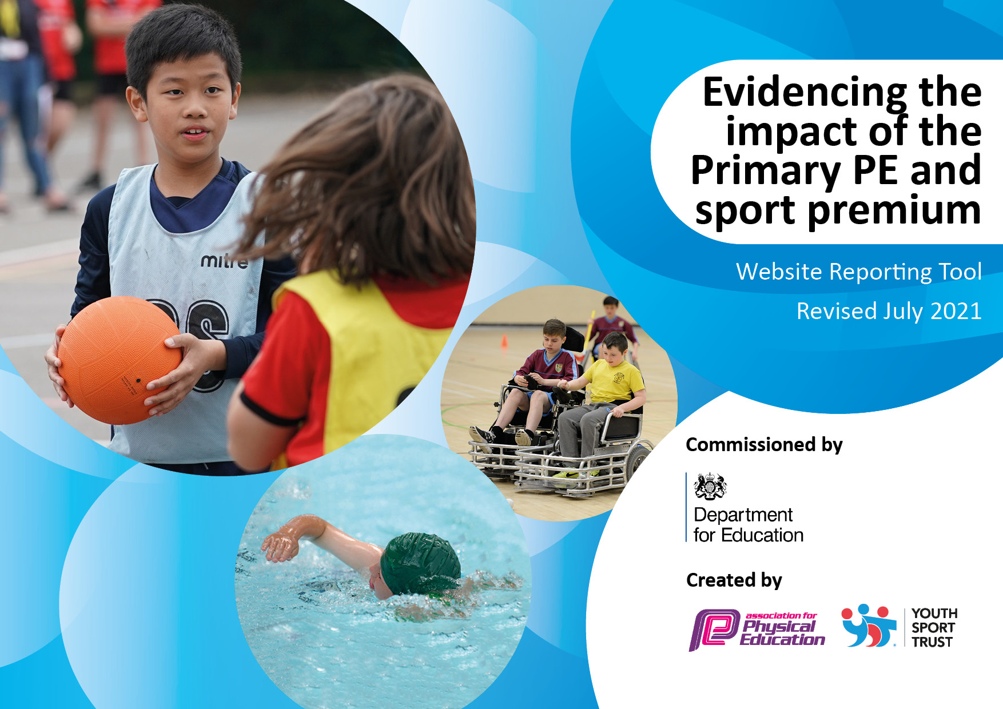
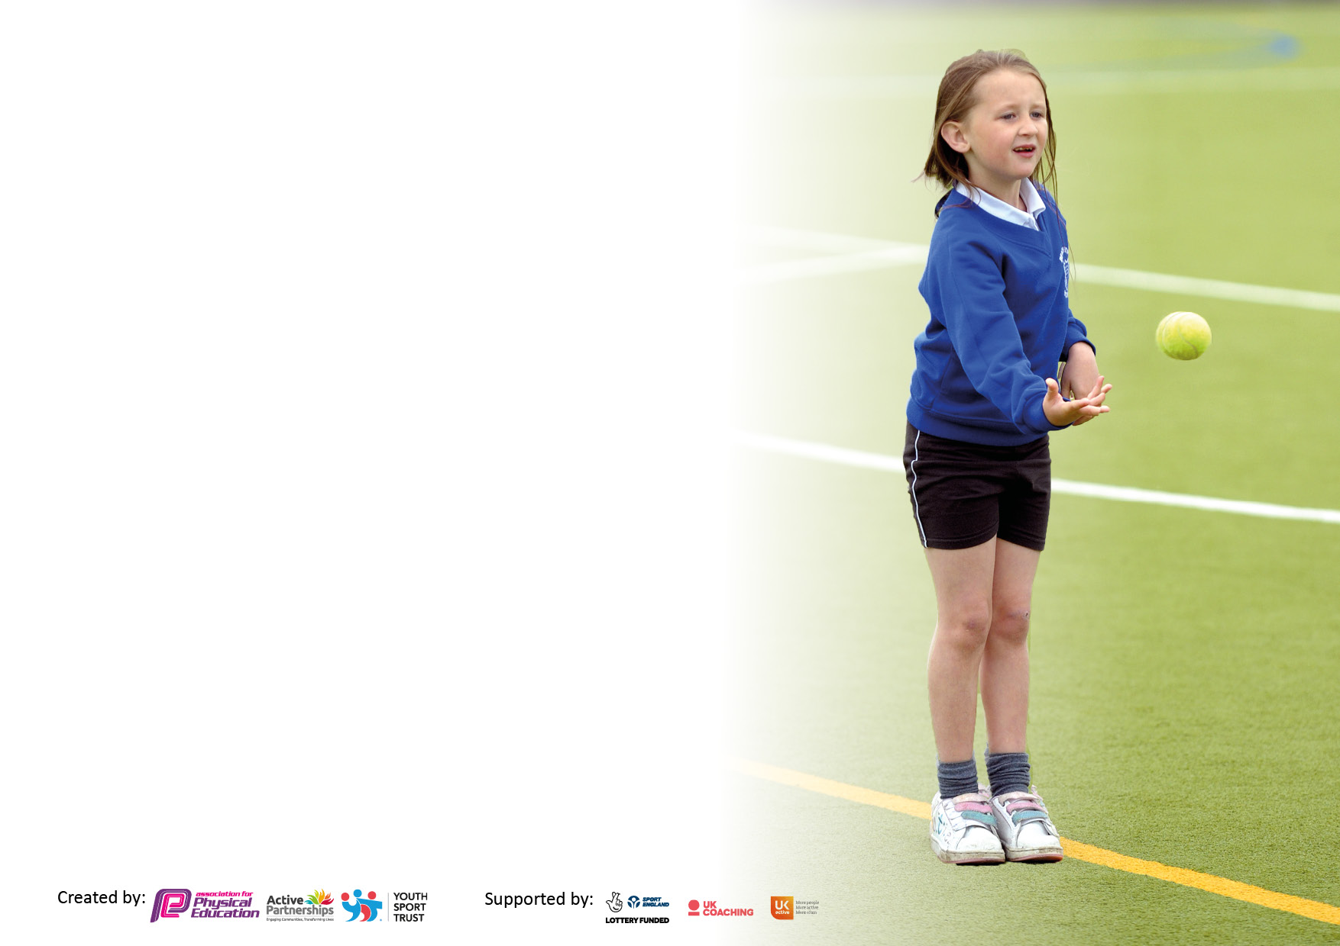

It is important that your grant is used effectively and based on school need. The Education Inspection Framework makes clear there will be a focus on ‘whether leaders and those responsible for governors all understand their respective roles and perform these in a way that enhances the effectiveness of the school’.

Under the Quality of Education Ofsted inspectors consider:
Intent - Curriculum design, coverage and appropriateness
Implementation - Curriculum delivery, Teaching (pedagogy) and Assessment
Impact - Attainment and progress

To assist schools with common transferable language this template has been developed to utilise the same three headings which should make your plans easily transferable between working documents.

Schools must use the funding to make additional and sustainable improvements to the quality of Physical Education, School Sport and Physical Activity (PESSPA) they offer. This means that you should use the Primary PE and sport premium to:

- Develop or add to the PESSPA activities that your school already offer
- Build capacity and capability within the school to ensure that improvements made now will benefit pupils joining the school in future years
- The Primary PE and sport premium should not be used to fund capital spend projects; the school’s budget should fund these.

Pleasevisitgov.ukfortherevisedDfEguidanceincludingthe5keyindicatorsacrosswhichschoolsshoulddemonstrate animprovement.Thisdocumentwillhelpyoutoreviewyourprovisionandtoreportyourspend.DfEencouragesschools to use this template as an effective way of meeting the reporting requirements of the Primary PE and sport premium.

We recommend you start by reflecting on the impact of current provision and reviewing the previous spend.

Schools are required to publish details of how they spend this funding, including any under-spend from 2019/2020, as well as on the impact it has on pupils’ PE and sport participation and attainment. All funding must be spent by 31st July 2022.

We recommend regularly updating the table and publishing it on your website throughout the year. This evidences your ongoing self-evaluation of how you are using the funding to secure maximum, sustainable impact. Final copy must be posted on your website by the end of the academic year and no later than the 31st July 2021. To see an example of how to complete the table please click HERE.

Details with regard to funding
Please complete the table below.

Total amount carried over from 2019/20 | £3,000
Total amount allocated for 2020/21 | £22,340
How much (if any) do you intend to carry over from this total fund into 2021/22? | £0
Total amount allocated for 2021/22 | £18,834
Total amount of funding for 2021/22. To be spent and reported on by 31st July 2022. | £26,834
Swimming Data
Please report on your Swimming Data below.

Meeting national curriculum requirements for swimming and water safety.

N.B. Complete this section to your best ability. For example, you might have practised safe self-rescue techniques on dry land which you can then transfer to the pool when school swimming restarts.
Due to exceptional circumstances priority should be given to ensuring that pupils can perform safe self-rescue even if they do not fully meet the first two requirements of the NC programme of study
What percentage of your current Year 6 cohort swim competently, confidently and proficiently over a distance of at least 25 metres?  N.B. Even though your pupils may swim in another year please report on their attainment on leaving primary school at the end of the summer term 2020.  Please see note above | 86%
What percentage of your current Year 6 cohort use a range of strokes effectively [for example, front crawl, backstroke and breaststroke]?  Please see note above | 81%
What percentage of your current Year 6 cohort perform safe self-rescue in different water-based situations? | 100%
Schools can choose to use the Primary PE and sport premium to provide additional provision for swimming but this must be for activity over and above the national curriculum requirements. Have you used it in this way? | Yes/No

Action Plan and Budget Tracking
Capture your intended annual spend against the 5 key indicators. Clarify the success criteria and evidence of impact that you intend to measure to evaluate for pupils today and for the future.

Academic Year: 2020/21 | Total fund allocated: | Date Updated:
Key indicator 1: The engagement of all pupils in regular physical activity – Chief Medical Officers guidelines recommend that primary school pupils undertake at least 30 minutes of physical activity a day in school |  |  |  | Percentage of total allocation:
 |  |  |  | 74%
Intent | Implementation |  | Impact
Your school focus should be clear what you want the pupils to know and be able to do and about  what they need to learn and to  consolidate through practice: | Make sure your actions to achieve are linked to your intentions: | Funding allocated: | Evidence of impact: what do pupils now know and what can they now do? What has changed? | Sustainability and suggested next steps:
To ensure children continue to understand the importance of regular physical activity as recommended by CMO guidelines.  To encourage children to participate in physical activity during break times and lunch times.  To ensure all classes are utilising the new daily mile running track due to be installed on KS2 playground.  To increase participation in active commuting through Wakefield Walk Once a Week (WOW) scheme. | Active lifestyles to be continued to be discussed in PE lessons and extra-curricular clubs. External coaches (HGCT/Elite) to deliver assemblies focussing on active lifestyles and importance of CMO guidelines.  Procure additional break time/lunch time equipment and ensure pastoral team and SS are confident in activities to offer for children.  Introduce daily mile track through assembly time and develop a timetable to allow each class a slot to complete the daily mile. Promote incentives for children to complete daily mile.  Launch WOW scheme in classes and through assembly time. | £ 13,405.33  £3,982.95  £2,547  £700 | Children have a better understanding of what constitutes an active lifestyle. They are more aware of healthy eating behaviours and are making better choices regarding maintaining active, healthy lifestyles.  Children are engaged in active break times more regularly. Support staff facilitate activities which allow children to join in with more physically active breaks.  All classes complete daily mile. Children have increased motivation to participate in the daily mile and behaviour in classes has improved. | Continue to provide children with the knowledge and understanding required to maintain active and healthy lifestyles. Elite to continue to work along side teachers to develop confidence and competence of teachers to deliver content themselves.  Cancelling of contract with HGCT to ensure teachers are developing their own practice.  Ensure breaktime equipment is looked after well by break time supervisors and children/sports leaders. Purchase any equipment that has been lost or broken.
Key indicator 2: The profile of PESSPA being raised across the school as a tool for whole school improvement |  |  |  | Percentage of total allocation:
 |  |  |  | 1.8%
Intent | Implementation |  | Impact
Your school focus should be clear what you want the pupils to know and be able to do and about  what they need to learn and to  consolidate through practice: | Make sure your actions to achieve are linked to your intentions: | Funding allocated: | Evidence of impact: what do pupils now know and what can they now do? What has changed?: | Sustainability and suggested next steps:
Competitive sporting fixtures to be regularly occurring for football team.  Feedback from matches (MoTM award, score, match report) shared in assemblies.  Ensure that values, which are fundamental to the school (i.e. resilience), are developed through PE lessons, extra-curricular clubs, external coaching, forest school to act as a model for whole school behaviour.  Ensure that sports leaders are used to support SS/pastoral staff with providing break time activities and act as role model for all children. | Contact local schools to arrange competitive fixtures for sports teams. Discuss possibility of creating a league format and creating website.  Appoint Y5/6 children to feedback match results and awards to rest of school during assembly time.  Remind teaching staff to ensure they promote the school values during lessons/ASC/break times.  Reinstate sports leaders and provide them with the required knowledge and experience to fulfil the role to a high level. | £325  £0  £0  £150 | Children from across all year groups look forward to competitive sporting fixtures. Children have developed their appreciation of sportsmanship and fair play through competitive fixtures which have been arranged.  Match results shared in KS assemblies continues to motivate children to want to compete competitively. Take up of after school football club has increased as a result. | Further fixtures to be arranged EM to email/call schools in the locality to arrange increased number of competitive sports fixtures.

Key indicator 3: Increased confidence, knowledge and skills of all staff in teaching PE and sport |  |  |  | Percentage of total allocation:
 |  |  |  | 54%
Intent | Implementation |  | Impact
Your school focus should be clear | Make sure your actions to | Funding | Evidence of impact: what do | Sustainability and suggested
what you want the pupils to know | achieve are linked to your | allocated: | pupils now know and what | next steps:
and be able to do and about | intentions: |  | can they now do? What has
what they need to learn and to |  |  | changed?
consolidate through practice:
All staff can identify their development needs and are able to provide high quality first wave teaching in PE.  All staff follow curriculum map for each year group and are confident in breaking units for learning down into individual lessons (from PE Hub).  Staff are confident in assessing the whole child in PE (physically, socially, emotionally and cognitively).  All staff are adhering to committing 2 hours per week of curriculum time to high quality PE. | Ensure regular monitoring is taking place. Subject leader to observe across all phases and – where necessary – co-teach lessons to ensure staff increase K&S. Elite sports coaching and HGCT to be observed delivering.  Identify current CPD needs of teaching staff through distributing competence and confidence questionnaire.  All staff access the assessment tool provided by PE PRO and refer to development of children with regards to PSEC. | £ 13,405.33 (as stated above)  £0  £1250 | Children know more and remember more as evidenced in pupil voice across all stages in school. High quality first wave teaching lead by external coaches and teaching staff has developed the physical literacy of children as evidenced in PE PRO assessments for each class.  Children are assessed at week 1, week 18 and week 36. Children are assessed in locomotor, object control and stability. Results indicate where gaps in learning are present and highlights how different groups of children have progressed or regressed. Subject leader is able to analyse physical literacy of all classes across school. | Continue to develop the use of PE PRO across school and ensure all teachers are confident in accessing the assessment tool.  Ensure all teachers are consistently assessing children at the three assigned weeks. Use results to inform curriculum map for subsequent year.
Key indicator 4: Broader experience of a range of sports and activities offered to all pupils |  |  |  | Percentage of total allocation:
 |  |  |  | 20.6%
Intent | Implementation |  | Impact
Your school focus should be clear | Make sure your actions to | Funding | Evidence of impact: what do | Sustainability and suggested
what you want the pupils to know | achieve are linked to your | allocated: | pupils now know and what | next steps:
and be able to do and about | intentions: |  | can they now do? What has
what they need to learn and to |  |  | changed?:
consolidate through practice:
Additional achievements:  All teachers provide a broad range of experiences, sports and activities for children as per PE Hub scheme, PE PRO and progression grid.  Children are given sufficient depth of learning for each sport/activity they are taught to maintain quality of teaching.  Children identify sports and activities they would like to see provided within the curriculum and make suggestions for ways to vary the range of sports offered.  Equipment is accessible for all children for all sports and activities they are offered. Children take responsibility for maintaining equipment. | Continue to familiarise staff with PE PRO platform.  Provide CPD for newer activities to the curriculum, for example lacrosse and handball.  Lesson structure is maintained by teaching staff who use high quality resources to supplement the curriculum.  Pupil voice questionnaires identify sports and activities children would like to participate in.  Units of learning created for suggested activities by subject lead.  Audit and order equipment to ensure all sports and activities can be successful taught across all phases. | £ 1,250  £546  £1,250 (as above)  £0  £3741.09 | Children know more and remember more as evidenced in pupil voice across all stages in school. High quality first wave teaching lead by external coaches and teaching staff has developed the physical literacy of children as evidenced in PE PRO assessments for each class.  Lesson observation indicates that children are provided with effective use of lesson time. Pupil voice indicates children are able to communicate lesson structure and can recall information provided to them by teachers and external coaches.  Equipment in provided at break times, in lessons and during extra-curricular clubs. Children have a renewed sense of responsibility to maintaining this equipment. Sports leaders ensure this is looked after appropriately. | Engage in PE PRO CPD opportunities in order to have a contribution to new versions and updates.  Continue to monitor lesson effectiveness through observations and staff confidence questionnaires.  Monitor and audit equipment to replace and renew broken or lost resources.

Key indicator 5: Increased participation in competitive sport |  |  |  | Percentage of total allocation:
 |  |  |  | 14%
Intent | Implementation |  | Impact
Your school focus should be clear | Make sure your actions to | Funding | Evidence of impact: what do | Sustainability and suggested
what you want the pupils to know | achieve are linked to your | allocated: | pupils now know and what | next steps:
and be able to do and about | intentions: |  | can they now do? What has
what they need to learn and to |  |  | changed?:
consolidate through practice:
Sports teams across Y5/6 participate in competitive inter school matches.  Facilities represent the school in a positive manner and are sufficient to host competitive sporting events.  Competitive sport match reports are shared across school and achievements are celebrated in assembly time.  Transport, if required, is provided for children to visit other schools for away fixtures. | Contact local schools to arrange competitive sport fixtures and discuss possibility of creating school league.  Order equipment needed to develop sports facilities at Towngate.  Appoint Y5/6 children to feedback match results and awards to rest of school during assembly time.  Create school sports display to highlight achievements of sports people across school, including out of school achievements in competitive sport.  Discuss arrangements for fixtures with partner schools. Contact schools within MAT to request access to minibus if needed. | £325  £3,741 (as allocated above)  £200 | Competitive fixtures are more frequent events in school. Children can recall match results and enjoy discussing these in assemblies and class groups. Parents are more engaged with competitive fixtures and demonstrate their support – raising the profile of the school in the community.  Sports leaders demonstrate a confidence and pride in reporting match results. Children know who the sports leaders are and what they do in school. | Contact local school and school games organiser to ensure establishment of football league in the next academic year.  Continue to develop the role of sports leaders by allowing them to observe Elite coaches during after school clubs.

Signed off by
Head Teacher:
Date:
Subject Leader:
Date:
Governor:
Date:

