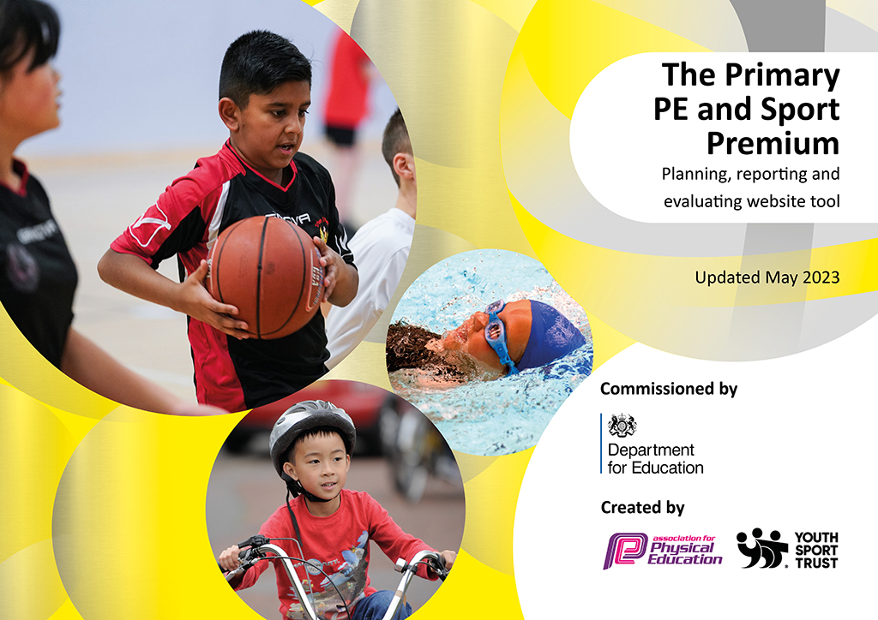
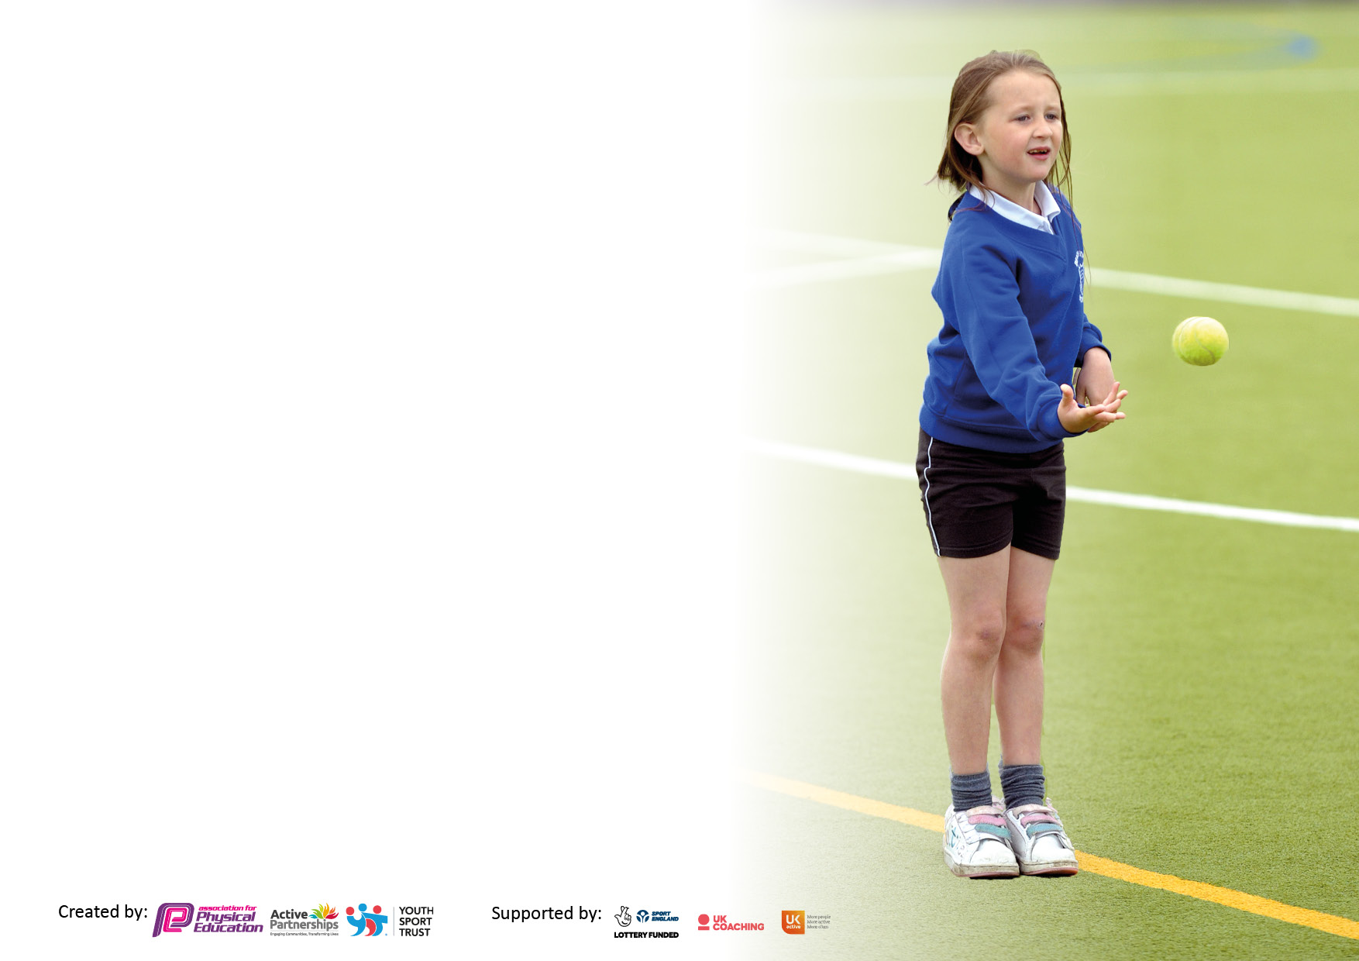

It is important that your grant is used effectively and based on school need. The Education Inspection Framework makes clear there will be a focus on ‘whether leaders and those responsible for governors all understand their respective roles and perform these in a way that enhances the effectiveness of the school’.

Under the Quality of Education Ofsted inspectors consider:
Intent - Curriculum design, coverage and appropriateness
Implementation - Curriculum delivery, Teaching (pedagogy) and Assessment
Impact - Attainment and progress

To assist schools with common transferable language this template has been developed to utilise the same three headings which should make your plans easily transferable between working documents.

Schools must use the funding to make additional and sustainable improvements to the quality of Physical Education, School Sport and Physical Activity (PESSPA) they offer. This means that you should use the Primary PE and sport premium to:

- Develop or add to the PESSPA activities that your school already offer
- Build capacity and capability within the school to ensure that improvements made now will benefit pupils joining the school in future years
- The Primary PE and sport premium should not be used to fund capital spend projects; the school’s budget should fund these.

Please visit gov.uk for the revised DfE guidance including the5keyindicatorsacrosswhichschoolsshoulddemonstrate an improvement. This document will helpyoutoreviewyourprovisionandtoreportyourspend.DfEencouragesschools to use this template as an effective way of meeting the reporting requirements of the Primary PE and Sport Premium.

We recommend you start by reflecting on the impact of current provision and reviewing the previous spend.

Schools are required to publish details of how they spend this funding, including any under-spend from 2021/2022, as well as on the impact it has on pupils’ PE and sport participation and attainment. The funding should be spent by 31st July but the DfE has stated that there will be no clawback of any unspent money so this can be carried forward into 2023/24.

We recommend regularly updating the table and publishing it on your website throughout the year. This evidences your ongoing self-evaluation of how you are using the funding to secure maximum, sustainable impact. Final copy must be posted on your website by the end of the academic year and no later than the 31st July 2023. To see an example of how to complete the table please click HERE.

Details with regard to funding
Please complete the table below.

Total amount carried over from 2021/22 | £ 0
Total amount allocated for 2021/22 | £ 18,834
How much (if any) do you intend to carry over from this total fund into 2022/23? | £ 0
Total amount allocated for 2022/23 | £ 18,834
Total amount of funding for 2022/23. Ideally should be spent and reported on by 31st July 2023. | £ 18,834
Swimming Data
Please report on your Swimming Data below.

Meeting national curriculum requirements for swimming and water safety.

N.B. Complete this section to your best ability. For example you might have practised safe self-rescue techniques on dry land which you can then transfer to the pool when school swimming restarts.
Due to exceptional circumstances priority should be given to ensuring that pupils can perform safe self rescue even if they do not fully meet the first two requirements of the NC programme of study
What percentage of your current Year 6 cohort swim competently, confidently and proficiently over a distance of at least 25 metres?  N.B. Even though your pupils may swim in another year please report on their attainment on leaving primary school at the end of the summer term 2023.  Please see note above | 82%
What percentage of your current Year 6 cohort use a range of strokes effectively [for example, front crawl, backstroke and breaststroke]?  Please see note above | 69%
What percentage of your current Year 6 cohort perform safe self-rescue in different water-based situations? | 94%
Schools can choose to use the Primary PE and sport premium to provide additional provision for swimming but this must be for activity over and above the national curriculum requirements. Have you used it in this way? | Yes/No

Action Plan and Budget Tracking
Capture your intended annual spend against the 5 key indicators. Clarify the success criteria and evidence of impact that you intend to measure to evaluate for pupils today and for the future.

Academic Year: 2022/23 | Total fund allocated: | Date Updated:
Key indicator 1: The engagement of all pupils in regular physical activity – Chief Medical Officers guidelines recommend that primary school pupils undertake at least 30 minutes of physical activity a day in school |  |  |  | Percentage of total allocation:
 |  |  |  | 88%
Intent | Implementation |  | Impact
Your school focus should be clear what you want the pupils to know and be able to do and about  what they need to learn and to  consolidate through practice: | Make sure your actions to achieve are linked to your intentions: | Funding allocated: | Evidence of impact: what do pupils now know and what can they now do? What has changed?: | Sustainability and suggested next steps:
To ensure children continue to understand the importance of regular physical activity as recommended by  CMO guidelines.  To encourage children to participate in physical activity during break times and lunch times.  To share with parents the importance of regular physical activity and the positive impact this has on chn through celebration assembly/newsletter. | Active lifestyles to be continued to be discussed in PE lessons and extra-curricular clubs. External coaches (Elite) to deliver assemblies focusing on active lifestyles and importance of CMO guidelines.  Procure additional break time/lunch time equipment and ensure pastoral team and SS are confident in activities to offer for children.  Bi-weekly celebration assembly time used to share sporting achievements and encourage participation in physical activities outside school. Parents to be signposted to relevant clubs. | £16,420  £200  £0 | Children have a better understanding of what constitutes an active lifestyle. They are more aware of healthy eating behaviours and are making better choices regarding maintaining active, healthy lifestyles.  Children are engaged in active break times more regularly. Support staff facilitate activities which allow children to join in with more physically active breaks.  Increased participation in physical activity outside school. More chn are taking part in a wider range of clubs and sharing their achievements in assembly to inspire others. | Continue to provide children with the knowledge and understanding required to maintain active and healthy lifestyles. Elite to continue to work alongside teachers to develop confidence and competence of teachers to deliver content themselves  Consider staff members utilising speaker at break times to encourage all chn to be active whilst outside. Identify staff members that could lead a wake-up/shake-up style activity on a morning, before school doors open.  Continue to share sporting successes
Key indicator 2: The profile of PESSPA being raised across the school as a tool for whole school improvement |  |  |  | Percentage of total allocation:
 |  |  |  | 2.7%
Intent | Implementation |  | Impact
Your school focus should be clear what you want the pupils to know and be able to do and about  what they need to learn and to  consolidate through practice: | Make sure your actions to achieve are linked to your intentions: | Funding allocated: | Evidence of impact: what do pupils now know and what can they now do? What has changed?: | Sustainability and suggested next steps:
Competitive sporting fixtures to be  regularly occurring for football team and introduction of wider competitive sports teams.  Ensure that values, which are  fundamental to the school (i.e. resilience), are developed through PE lessons, extra-curricular clubs, external coaching, forest school to act as a model for whole school behaviour.  All classes to participate in daily mile. | Contact local schools to arrange competitive fixtures for sports teams. Discuss possibility of creating a league format and creating website.  Attend meeting of schools held at South Dale to arrange sporting calendar for all year groups.  Remind all staff to ensure they promote the school values during lesson/ASC/ break times, awarding dojo points to embed and reinforce.  Relaunch daily mile in KS assemblies and remind parents when watching celebration assemblies of the importance of daily PA. ensure daily mile is maintained and ready for use. | £ 100  £0  £400 | Children from across all year groups look forward to competitive sporting fixtures. Children have developed their appreciation of sportsmanship and fair play through competitive fixtures which have been arranged.  Chn have experience a wider range of sports – whether competitive or not – including trampolining and goalball.  Classes participate in daily mile more frequently. Chn can talk about why they should exercise more often and are aware of the benefits of completing a mile a day. | Liaise with SGO with regards to setting up a meeting for all schools in autumn term to set out a calendar of sporting events for 23/24.  Add events to school calendar to ensure staffing and cover can be supplied when teachers attend games.  Ensure that all markings are clear. Provide chn with a daily mile passport to encourage engagement.

Key indicator 3: Increased confidence, knowledge and skills of all staff in teaching PE and sport |  |  |  | Percentage of total allocation:
 |  |  |  | 5.3%
Intent | Implementation |  | Impact
Your school focus should be clear | Make sure your actions to | Funding | Evidence of impact: what do | Sustainability and suggested
what you want the pupils to know | achieve are linked to your | allocated: | pupils now know and what | next steps:
and be able to do and about | intentions: |  | can they now do? What has
what they need to learn and to |  |  | changed?:
consolidate through practice:
All staff can identify their development needs and are able to provide high quality first wave  teaching in PE – where needed subject leader supports staff in their development in conjunction with Elite sports coaches.  All staff follow curriculum map for  each year group and are confident in  breaking units for learning down into  individual lessons (from PE PRO).  Staff are confident in assessing the  whole child in PE (physically, socially,  emotionally and cognitively) using the PE PRO assessment tool which records data at three key points in the year and provides a comprehensive view of attainment for pupil groups. | Ensure regular monitoring is taking place. Subject leader to observe across all phases and – where necessary – co-teach lessons to ensure staff increase K&S. Elite sports coaching to be observed delivering and feedback provided to WG.  Identify current CPD needs of teaching staff through distributing competence and confidence questionnaire.  All staff access the assessment tool provided by PE PRO and refer to development of children with regards to PSEC. | £16,420 (as seen above)  £1,000 | Children know more and remember more as evidenced in pupil voice across all stages in school. High quality first wave teaching lead by external coaches and teaching staff has developed the physical literacy of children as evidenced in PE PRO assessments for each class.  Children are assessed at week 1, week 18 and week 36. Children are assessed in locomotor, object control and stability. Results indicate where gaps in learning are present and highlights how different groups of children have progressed or regressed. Subject leader is able to analyse physical literacy of all classes across school | Ensure that new teachers are introduced to PE PRO and are confident in using this to supplement the NC for PE.  Ensure all teachers are consistently assessing children at the three assigned weeks. Use results to inform curriculum map for subsequent year.
Key indicator 4: Broader experience of a range of sports and activities offered to all pupils |  |  |  | Percentage of total allocation:
 |  |  |  | 1.6%
Intent | Implementation |  | Impact
Your school focus should be clear | Make sure your actions to | Funding | Evidence of impact: what do | Sustainability and suggested
what you want the pupils to know | achieve are linked to your | allocated: | pupils now know and what | next steps:
and be able to do and about | intentions: |  | can they now do? What has
what they need to learn and to |  |  | changed?:
consolidate through practice:
Additional achievements:  All chn, from each year group, experience a wider range of sports and have the chance to experience these sports at TPA and other facilities.  Children identify sports and activities they would like to see provided within the curriculum and make suggestions for ways to vary the range of sports offered. | Attend meeting with SGO and Wakefield PE and PA consultant (Helen Cartwright) to produce a calendar of diverse sporting events. Ensure chn are encouraged to participate by presenting opportunities in assemblies.  Pupil voice questionnaires identify sports and activities children would like to participate in. Units of learning created for suggested activities by subject lead | £300  £0 | Chn are more familiar with a greater range of sports and PA events. UKS2 chn are aware of different activities they may be able to do in secondary school and are seeking opportunities to participate in these events outside of school.  Chn are more engaged in PA and PE. They see that the curriculum reflects their suggestions and are aware that they have had an input into to design of the curriculum. | Liaise with SGO with regards to setting up a meeting for all schools in autumn term to set out a calendar of sporting events for 23/24. Buy specialist equipment such as goalball and kinballs to ensure sports can be taught effectively in school.  Introduce a highlight sport once per term for all classes to participate in and feedback in assemblies.

Key indicator 5: Increased participation in competitive sport |  |  |  | Percentage of total allocation:
 |  |  |  | 2.1%
Intent | Implementation |  | Impact
Your school focus should be clear | Make sure your actions to | Funding | Evidence of impact: what do | Sustainability and suggested
what you want the pupils to know | achieve are linked to your | allocated: | pupils now know and what | next steps:
and be able to do and about | intentions: |  | can they now do? What has
what they need to learn and to |  |  | changed?:
consolidate through practice:
All year groups provided with the opportunity to engage in competitive sports through various events over the course of the year.  School sports day organized for all KS. Parents invited to come and celebrate participation in competitive sports. | Attend meeting with SGO and Wakefield PE and PA consultant (Helen Cartwright) to produce a calendar of diverse competitive sporting events. Ensure chn are encouraged to participate by presenting opportunities in assemblies.  Ensure that events are added to calendar and that staff are able to be released to attend events with chn. Necessary RA and evolve to be completed to ensure event can take place.  Chn to feedback their experiences in class/assemblies to encourage further participation by as many chn as possible.  Line marker and paint to be bought – subject leader allowed release time to complete marking for events.  All chn to have opportunity – during PE – to practise for all events to increase confidence when taking part on the day.  Subject leader to check all equipment is available and replace any missing equipment by creating an order form. | £300 (as seen above)  £400 | Chn know the value of competitive sports, they are confident to participate and understand the values which govern competition – such as fair play, inclusion and sportsmanship.  Parents and carers have the opportunity to observe their chn participating in competitive sport – school social media demonstrates the high profile of competitive sport at TPA.  Chn are able to communicate the value of competitive sport and understand the principles which underpin it. | Liaise with SGO with regards to setting up a meeting for all schools in autumn term to set out a calendar of sporting events for 23/24.  Look at how sports day can further be developed to include a greater range of sporting activities.

Signed off by
Head Teacher:
Date:
Subject Leader:
Date:
Governor:
Date:

